ỦY BAN NHÂN DÂN THÀNH PHỐ HỒ CHÍ MINH

**TRƯỜNG ĐẠI HỌC SÀI GÒN**

**KHOA CÔNG NGHỆ THÔNG TIN**



**BÁO CÁO ĐỒ ÁN HỌC PHẦN KIỂM THỬ PHẦN MỀM**

**KIỂM THỬ WEBSITE THƯƠNG MẠI ĐIỆN TỬ FAHASA**

Thành viên:

Nguyễn Hoàng Hiếu - 3122411054

Lâm Diệu Quang – 3122411163

Giảng viên hướng dẫn: TS. Đỗ Như Tài

**TP. HỒ CHÍ MINH, 2025 - 2026**

# **DECLARATION**

I hereby declare that the course project entitled “Testing the Fahasa E-commerce Website” is the result of the research and implementation carried out by my group under the guidance of the course instructor. All contents of this project have been studied, compiled, analyzed, and implemented by us based on the knowledge acquired during the course, along with reliable reference materials and sources.

All data, results, and images presented in this project are truthful, obtained during the course of the work, and have not been used or published in any other studies or projects. Should any act of plagiarism, fraud, or copyright infringement be discovered, my group will take full responsibility before the university and the supervising lecturer.

This project was conducted with the aim of applying knowledge of software testing, requirements analysis, and functional testing techniques to evaluate the quality of an e-commerce website selling books. Throughout the implementation process, my group made efforts to study and experiment with testing tools, analyze the results, and draw practical conclusions in order to enhance our understanding of software quality assurance processes.

I would like to express my sincere gratitude to our supervising lecturer, Dr. Do Nhu Tai, for his dedicated guidance, support, and favorable conditions that enabled us to successfully complete this project.

# **TABLE OF CONTENT**

DECLARATION i

TABLE OF CONTENT ii

TERMS, DEFINITIONS, AND ABBREVIATIONS vi

INTRODUCTION 1

CHAPTER 1. OVERVIEW OF THE PROJECT 2

1.1. Project description 2

1.2. Current status analysis 2

1.2.1. Business process 2

1.3. Implementation plan 4

1.3.1. Scope 4

1.3.2. Chiến lược kiểm thử 4

1.4. Business requirement 6

1.4.1. Functional requiremennt 6

1.4.2. Non-functional requirement 8

1.5. Objective 8

CHAPTER 2. SOFTWARE DESIGN AND ARCHITECTURE 9

2.1. Software design 9

2.1.1. Business context 9

2.1.2. Business process 11

2.1.3. System actors 15

2.1.4. Context diagram 16

2.1.5. Use case 17

2.1.6. User story 24

2.1.7. Domain driven design 26

2.1.8. Data model 29

2.1.9. Wireflow 32

2.1.10. Interface 34

2.2. Architecture design 49

2.2.1. Block diagram 49

2.2.2. C4 architecture 50

2.2.3. Communication view 60

2.2.4. Deployment view 61

CHAPTER 3. TEST PLAN 62

3.1. INTRODUCTION 62

3.1.1. Purpose 62

3.1.2. Scope 62

3.2. Test item 62

3.2.1. Function 62

3.2.2. Usability 65

3.2.3. Compatibility 65

3.2.4. Interface 65

3.2.5. Security 65

3.2.6. Database 66

3.2.7. Performance 66

3.2.8. Crowd 66

3.2.9. Regression 66

3.2.10. API 67

3.3. Item not tested 67

3.3.1. Third-party system function 67

3.3.2. Advanced security testing 67

3.3.3. Advanced usability testing 67

3.4. Acceptance testing criteria 68

3.4.1. Test coverage 68

3.4.2. Test case pass rate 68

3.4.3. Number of test cases 68

3.4.4. Defect limit 68

3.4.5. Unit test density 68

3.4.6. Code coverage 68

3.4.7. CI/CD process 69

3.5. Testing strategy 69

3.5.1. Testing approach 69

3.5.2. Type of testing 70

3.5.3. Testing level 73

3.6. Resource 75

3.6.1. Human resource 75

3.6.2. Test schedule 76

3.7. Environment 77

3.7.1. Hardware 77

3.7.2. Software 77

3.7.3. Infrastructure 78

3.8. Handover documentation 78

CHAPTER 4. TEST DESIGN 79

4.1. Introduction 79

4.2. Test design process according to the V-Model 79

4.2.1. Requirement Analysis - 1a 79

4.2.2. System design - 2a 80

4.2.3. Thiết kế kiến trúc - 3a 80

4.2.4. Module design - 4a 80

4.2.5. Unit testing - 1b 81

4.2.6. Integration testing - 2b 82

4.2.7. System testing - 3b 83

4.2.8. Acceptance testing - 4b 84

4.3. Test design techniques 84

4.3.1. Black-box testing 84

4.3.2. White-box testing 89

4.4. Test design method 97

4.4.1. Manual testing 97

4.4.2. Automation testing 97

4.5. Application of GenAI in Test Case generation 99

4.5.1. GenAI input 100

4.5.2. GenAI processing stage 100

4.5.3. Test Case finalization 100

CHAPTER 5. TESTING REPORT 101

5.1. Overview of the testing process 101

5.2. Test case report 101

5.2.1. Introduction 101

5.2.2. Coverage scope 102

5.2.3. Execution results 102

5.3. Error report 103

5.3.1. Error classification by severity 103

5.3.2. Error statistic 104

5.3.3. Error handling process 106

APPENDIX 108

# **TERMS, DEFINITIONS, AND ABBREVIATIONS**

|  |  |  |
| --- | --- | --- |
| **Mục từ** | **Viết tắt** | **Giải nghĩa** |
| BR | Business requirement | Enterprise resource planning / Business requirements |
| UC | Use case | System function |
| US | User story | User requirement |
| HTTP | Hypertext Transfer Protocol | Hypertext transfer protocol |
| HTML | HyperText Markup Language | Hypertext markup language |
| COD | Cash On Delivery | Payment upon delivery |

# **INTRODUCTION**

In the context of the rapid development of information technology today, online business and trading activities have become increasingly popular and play an important role in modern life. E-commerce has brought many outstanding conveniences, enabling consumers to easily search for products, shop, and make payments with just a few simple actions. Among these platforms, the Fahasa online bookstore website contributes to promoting reading culture and makes access to knowledge more convenient and faster.

However, for an e-commerce website to operate stably, efficiently, and provide a good user experience, software testing plays a crucial role. Testing helps detect and fix defects, ensures that system functionalities operate according to requirements, and thereby improves the quality and reliability of the software product.

Stemming from this importance, I chose to carry out the topic “Testing the Fahasa E-commerce Website” with the aim of studying and applying testing techniques and tools to evaluate the quality of the website. The project focuses on requirements analysis, test case design, functional testing, and recording test results.

Through the implementation of this project, I hope to consolidate and expand my knowledge of software testing, while also developing practical working skills, thereby enhancing my professional competence in the field of software development and quality assurance.

I would like to express my sincere gratitude to Dr. Do Nhu Tai for his dedicated guidance and support, which enabled me to successfully complete this project.

# **CHAPTER 1. OVERVIEW OF THE PROJECT**

## **1.1. Project description**

The testing project “Fahasa E-commerce Website” is conducted to evaluate the extent to which the system meets functional requirements and to detect defects that arise during the development process. The testing activities focus on verifying data correctness, operational stability, and the accuracy of the website’s core business functionalities.

The testing process includes requirements analysis, test case design and execution, as well as unit testing, integration testing, system testing, and acceptance testing to ensure that the system operates in accordance with the specified requirements before deployment.

## **1.2. Current status analysis**

### **1.2.1. Business process**

**Shopping cart processing workflow**

After logging in and selecting the desired books, customers can add books to the shopping cart. On the shopping cart interface, the system displays a list of added books along with their images, titles, selling prices, discounts, and purchase quantities. Customers can adjust the quantity or remove books from the cart at any time. Each change is automatically updated by the system to recalculate the total amount, allowing users to easily control their expenses before proceeding to order placement and payment.

**Order placement and payment process**

After customers add books to the shopping cart, the system proceeds to the ordering step and requires them to provide shipping information (full name, phone number, and address) and select a payment method: Cash on Delivery (COD) or MoMo.

If the customer chooses payment via MoMo, the system temporarily stores the order and calls the MoMo payment service to generate a QR code, which is displayed for the customer to scan in order to complete the payment.

Once the system receives a response from MoMo, if the payment is successful and the available book quantity is sufficient, the system automatically updates the order status, reduces the inventory quantity of the corresponding products, and notifies the customer that the order has been placed successfully.

Conversely, if the payment is successful but the available stock is insufficient, the system will automatically refund the customer, display an order failure notification along with the reason, and delete the order to ensure data accuracy.

**System administration process**

The system administration page is designed for system administrators and sales staff to monitor and manage the operation of the website. System administrators have full permissions to perform all functions, while sales staff have restricted permissions and are not allowed to perform user management functions. The main functionalities include:

Book Management: Add, delete, or update book information (book title, author, publisher, price, description, cover image, and available quantity) so that customers can view and purchase desired books.

Category, Author, and Publisher Management: Add, update, or delete book categories, authors, and publishers. This ensures that information is well-organized and supports customers in easily searching for books.

Order Management: System administrators and sales staff can monitor the list of orders and manually update order statuses. For orders paid via MoMo, if an order is canceled or returned, the system will call the MoMo payment service to refund the customer.

Payment Management: Display the list of successful payment transactions and refunds processed through the MoMo payment gateway.

User Management: Only system administrators are allowed to add, delete, update, or lock administrator and customer accounts.

## **1.3. Implementation plan**

### **1.3.1. Scope**

This document serves as the basis for testing, acceptance, and evaluation of the project “Fahasa E-commerce Website”. The testing covers the website’s functions and features, user interface, as well as the validity of data and the database.

### **1.3.2. Chiến lược kiểm thử**

**Human resources**

|  |  |  |  |
| --- | --- | --- | --- |
| **No** | **Member** | **Role** | **Specific taks** |
| 1 | Lâm Diệu Quang | Kiểm thử viên/Lập trình viên | Test planning  System testing execution  Writing CI/CD pipelines using GitHub Actions  Test documentation |
| 2 | Nguyễn Hoàng Hiếu | Kiểm thử viên/Lập trình viên | Test case design  Unit testing and integration testing  Preparing review checklists  Test documentation |

**Environment and Tools**

|  |  |
| --- | --- |
| **Purpose** | **Component** |
| Test documentation | Microsoft Word, Microsoft Excel |
| Browser | Chrome, Firefox, Safari |
| Frontend | Vite, ReactJS, TypeScript |
| Backend | Spring Boot, Maven |
| Source code | GitHub |
| CI/CD | GitHub Actions |
| Production deployment | Frontend và Backend are deployed on Render  Database MySQL is host on Aiven |

## **1.4. Business requirement**

### **1.4.1. Functional requiremennt**

|  |  |  |
| --- | --- | --- |
| **ID** | **Requester** | **Requirement description** |
| **BR1** | **Product management** | |
| BR1.1 | Customer | Search, filter, and sort books by criteria such as price, title, category, author, and publisher View detailed information of each book |
| BR1.2 | Sales staff, System administrator | Manage books (add, delete, or edit books) Manage authors (add, delete, or edit authors) Manage publishers (add, delete, or edit publishers) Manage categories (add, delete, or edit categories) |
| **BR2** | **Cart management** | |
| BR2.1 | Customer | Add products to the shopping cart  View the list of products added to the cart  Modify product quantities or remove products from the cart |
| **BR3** | **Payment management** | |
| BR3.1 | Customer | Receive payment result notifications (successful or failed) |
| BR3.2 | Sales staff, System administrator | Monitor the list of successful payment transactions or refunded transactions |
| **BR4** | **Order management** | |
| BR4.1 | Customer | View the list of placed orders and order details Place new orders |
| BR4.2 | Sales staff, System administrator | Manually update order status Monitor the complete list of orders |
| **BR5** | **Address book management** | |
| BR5.1 | Customer | Add, edit, or delete shipping addresses |
| **BR6** | **Access control** | |
| BR6.1 | System administrator | Add, delete, update, or lock all user accounts in the system (cannot lock or delete their own account) |
| BR6.1 | Customer, Sales staff, System administrator | Log in, register, or log out |

### **1.4.2. Non-functional requirement**

|  |  |
| --- | --- |
| **BR7** | **System deployment** |
| BR7.1 | The software operates in an Internet environment, allowing multiple users to access and use the system simultaneously |
| **BR8** | **Inteface** |
| BR8.1 | The interface is designed in a clear, aesthetic, and harmonious manner, appropriate to the purpose of the software, and compliant with web standards |
| **BR9** | **Security** |
| BR9.1 | All data must maintain integrity constraints, and sensitive data must be encrypted |

## **1.5. Objective**

The objective of testing the Fahasa website is to verify that the system operates in accordance with the specified requirements, to detect defects early during the development process, and to ensure software quality prior to deployment.

The testing process focuses on validating core business functionalities, basic system stability, and compatibility across common browsers and devices.

The testing results serve as a basis for evaluating the system’s level of completeness and provide support for deployment, operation, and maintenance of the software.

# **CHAPTER 2. SOFTWARE DESIGN AND ARCHITECTURE**

## **2.1. Software design**

### **2.1.1. Business context**

The Fahasa e-commerce website provides the following core functionalities: product management, shopping cart, order management, payment, address book, and access control.

For product management, customers can search for and sort books based on criteria such as book title, author, publisher, and category. When clicking on a specific book, customers are redirected to the product detail page, which displays comprehensive information including the book title, author, publisher, content description, detailed information, and illustrative images.  
System administrators or sales staff can add, edit, and delete books, as well as manage authors, categories, and publishers.

For shopping cart management, customers must log in to add any book to the cart from the product detail page. After adding items, customers can view the full list of books in the cart, including book title, price, discount, and quantity. The system allows customers to change quantities or remove books from the cart, and automatically updates the total amount after each action.

For order management, when customers place an order, the system automatically creates an order and records product information, shipping details, and the selected payment method.  
System administrators and sales staff can monitor and update the order status. If an order paid via MoMo is canceled or returned, the system will automatically refund the customer.

For payment management, the system supports cash on delivery and online payment through the MoMo gateway. After a successful payment, the system records the transaction, updates the order status, automatically deducts the corresponding book quantities from inventory, and redirects the customer to the order success notification page. In cases where payment is successful but inventory is insufficient to fulfill the order, the system automatically processes a refund and redirects the customer to the order failure notification page.  
System administrators and sales staff can monitor and search for successful payment and refund transactions.

For address book management, customers can store multiple shipping addresses or enter address information directly during the checkout process. The system allows users to add, edit, or delete addresses to facilitate future orders.

For access control, the system provides login, logout, and user management functionalities. System administrators can add, edit, delete, or lock user accounts, ensuring clear role-based access control and allowing users to perform only actions appropriate to their roles.

### **2.1.2. Business process**

**Shopping cart processing workflow**

After logging in and searching for or selecting books, customers can add books to the shopping cart. On the shopping cart interface, customers can review the list of selected books. They are able to adjust quantities or remove books from the cart. After that, customers proceed to place an order.

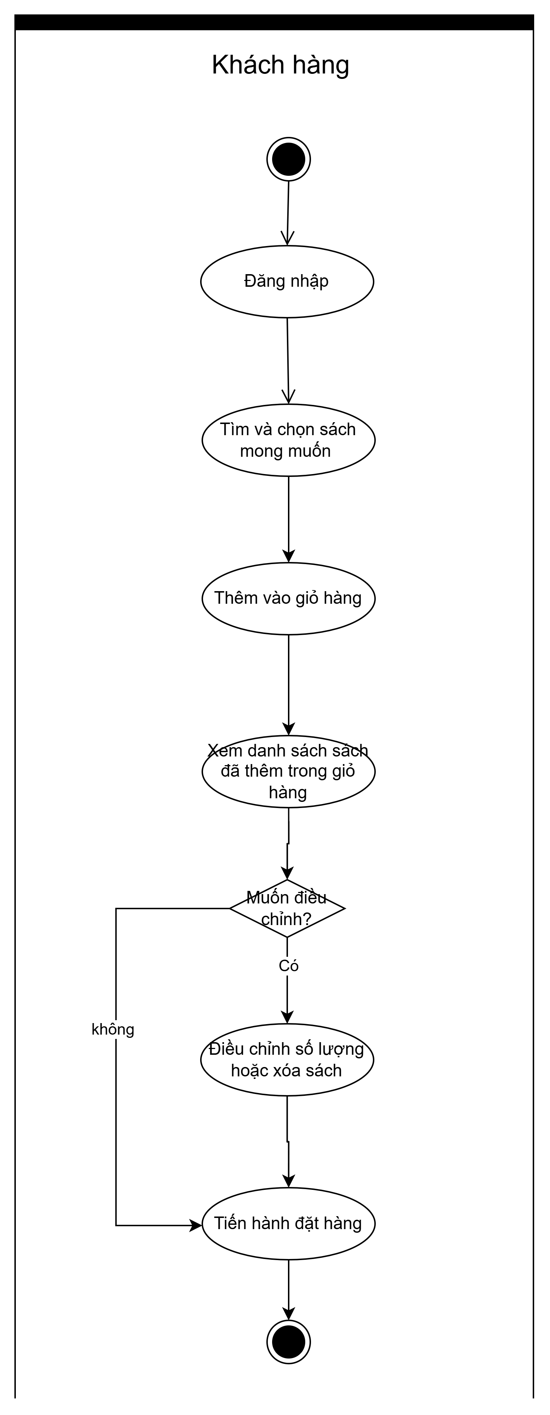

Figure 2.1. Shopping cart processing flow diagram.

**Order placement and payment process**

After entering shipping information, the customer selects a payment method: Cash on Delivery (COD) or MoMo.

For COD payment, the customer proceeds directly to the inventory availability check. If the available stock is sufficient, the order is placed successfully.

For MoMo payment, MoMo generates a QR code for the customer to scan.

* If the payment fails, the customer is redirected to reselect a payment method.
* If the payment is successful, the system continues to check the purchased book quantities. If stock is sufficient, the order is placed successfully. If stock is insufficient, the system automatically calls MoMo to process a refund.

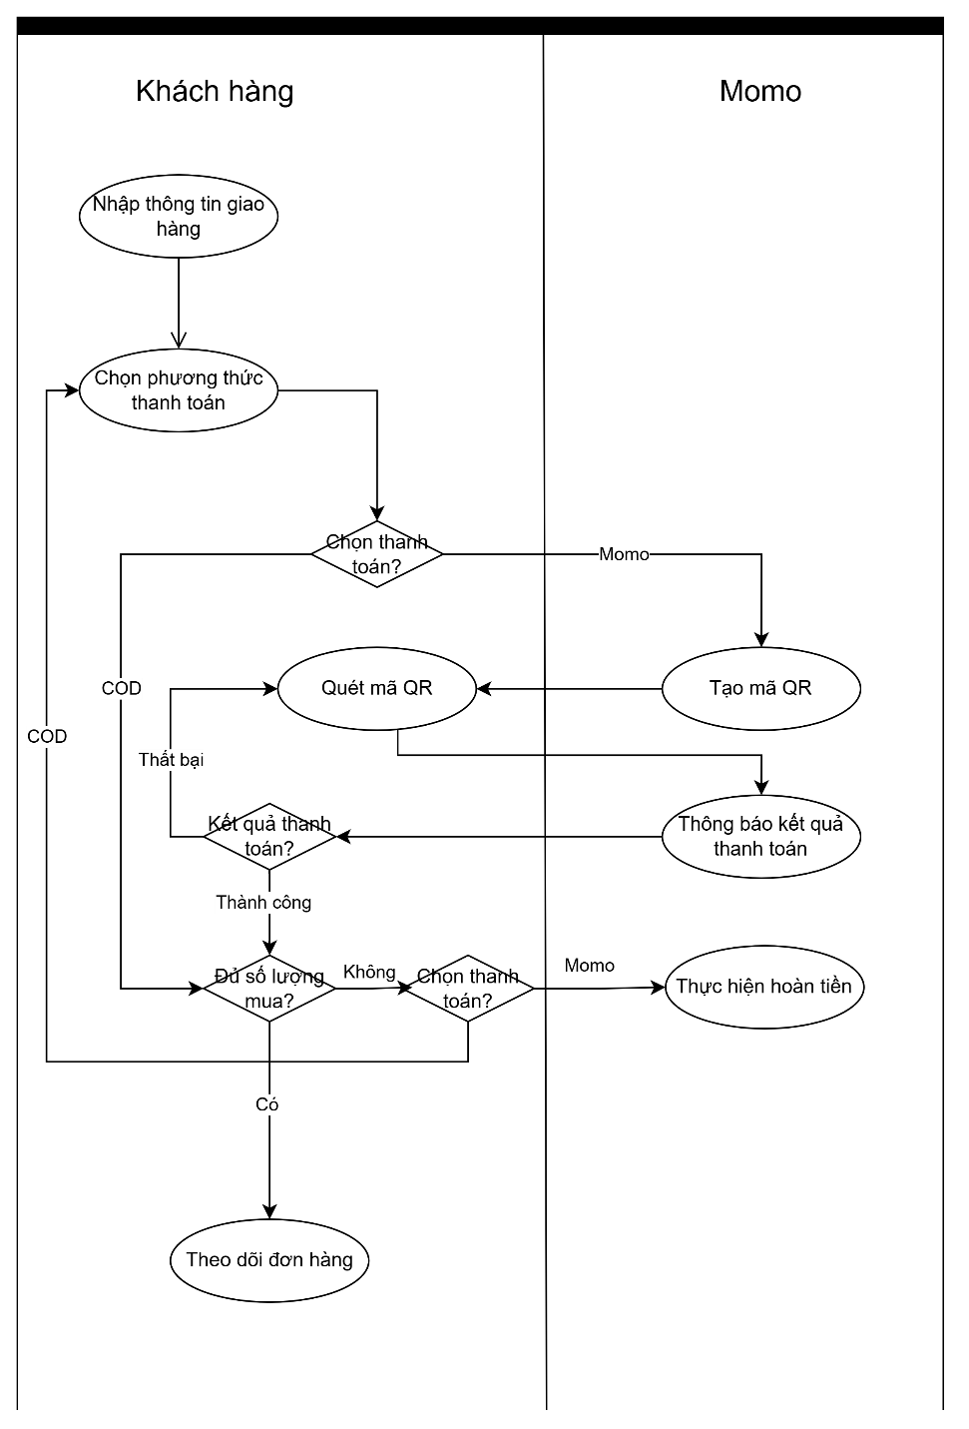

Figure 2.2. Order placement and payment flow diagram.

**System administration workflow**

After logging in, system administrators and sales staff can perform management functions related to categories, authors, publishers, books, orders, and payments. The user management function is exclusively available to system administrators.

During order management, if an order paid via MoMo is updated to a canceled or returned status, the system will automatically send a refund request to MoMo to process the refund transaction.

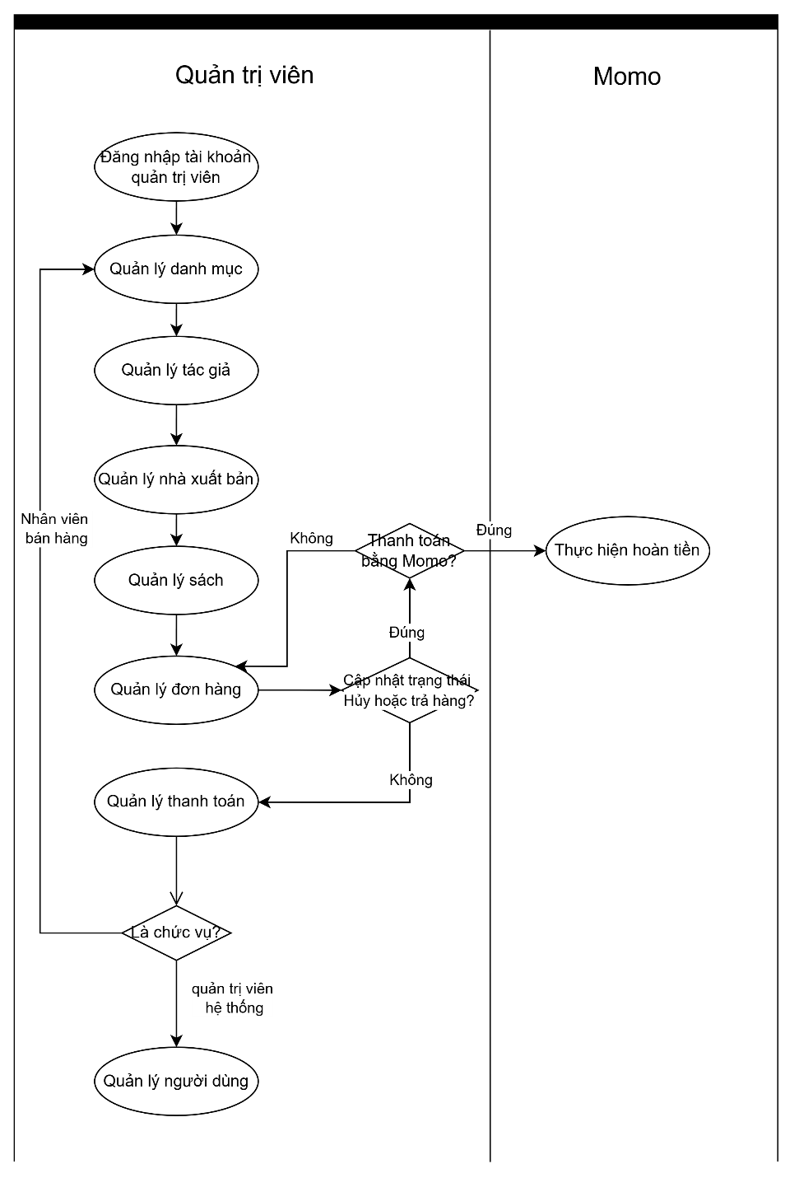

Figure 2.3. System administration workflow diagram.

.

### **2.1.3. System actors**

Customer: The user who interacts with the system to purchase products.

System Administrator: The highest-level administrator of the system, with permission to perform all administrative functions.

Sales Staff: An administrator with more limited permissions than the system administrator and without access to user management functions.

MoMo: A third-party payment gateway integrated into the system.

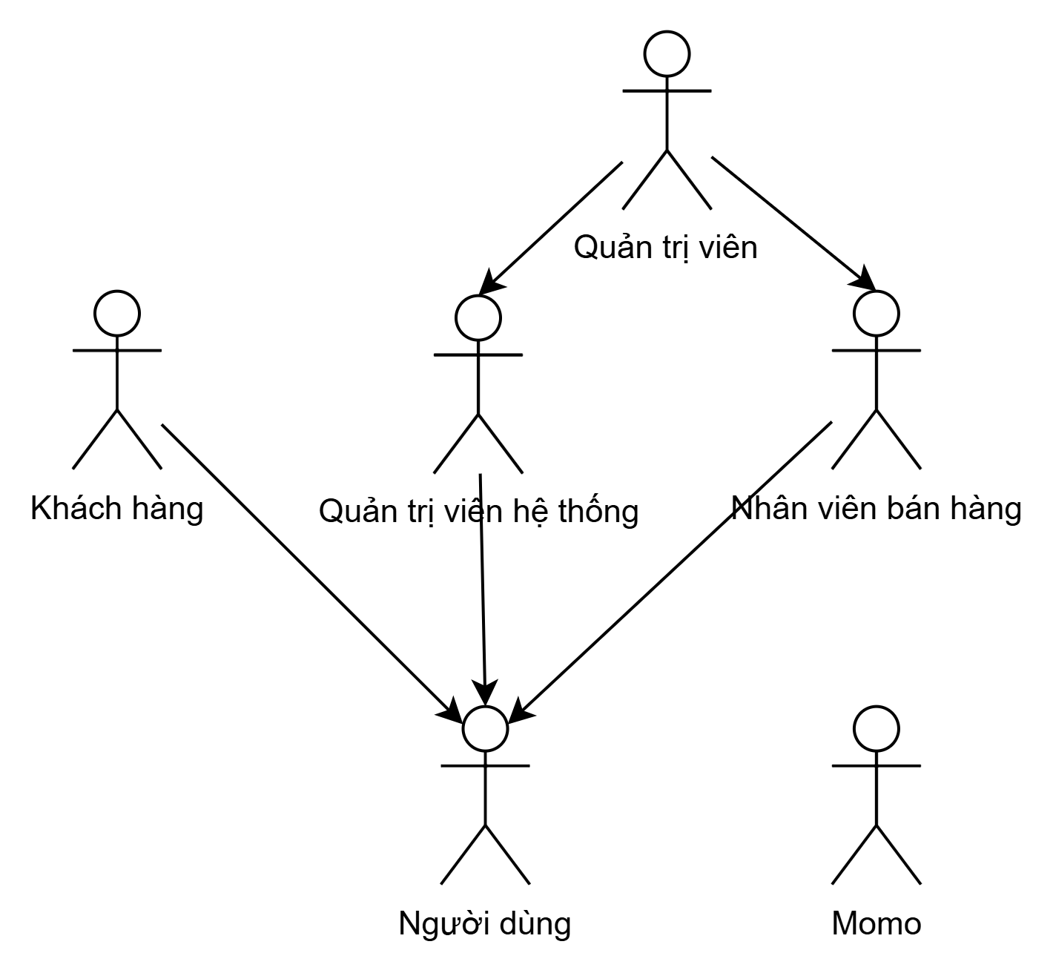

Figure 2.4. System actors diagram.

### **2.1.4. Context diagram**

Customer: Interacts directly with the Fahasa system to receive product lists, log in, manage the shopping cart, place orders, manage the address book, make payments, and view the order list.

MoMo: An external payment gateway that interacts with Fahasa to generate QR codes, process refunds, and return transaction results.

System administrator and Sales Staff: Manage the system through functions such as managing books, categories, authors, orders, and payments; additionally, the system administrator is responsible for user management.

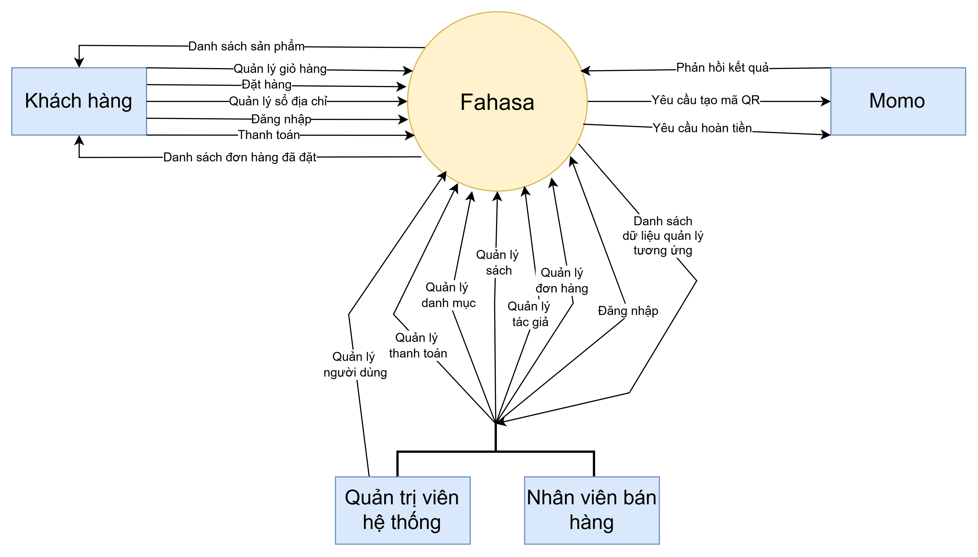 Figure 2.5. System context diagram.

### **2.1.5. Use case**

**Use case summary**

Customer performs the following functions: shopping cart management, address book management, product management (view/search), and access control.

System administrator performs the following functions: product management, payment management, order management, and access control.

Sales Staff performs the following functions: product management, payment management, order management, and access control.

MoMo performs the following function: payment management.

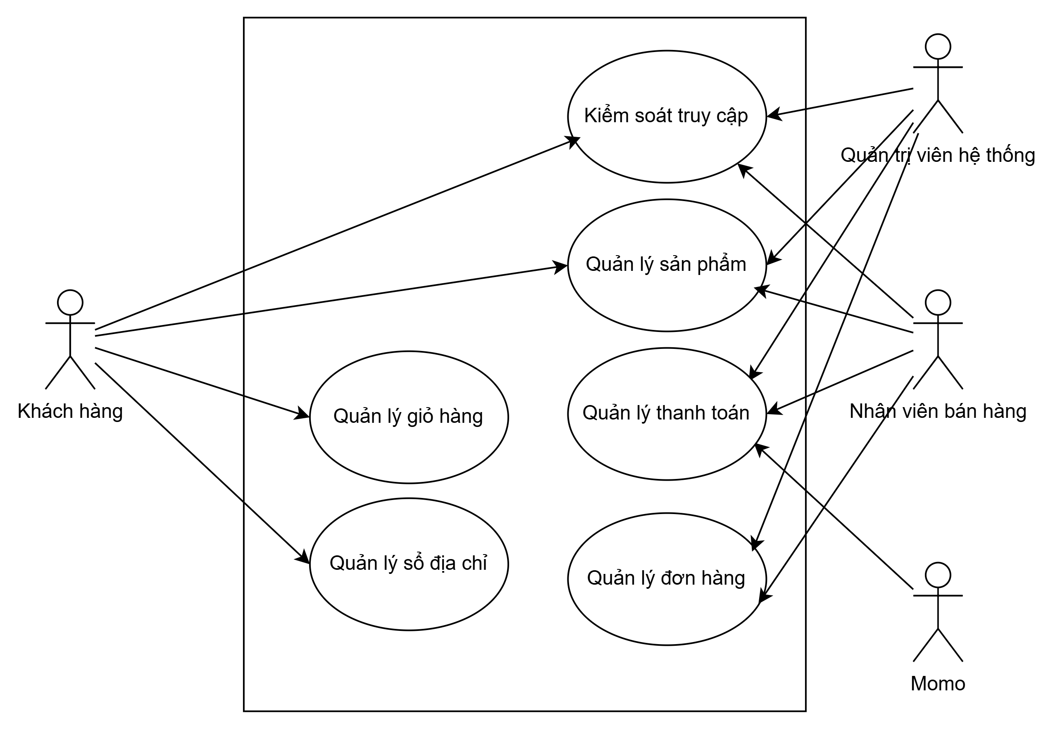Figure 2.6. Use case summary diagram.

**UC1 Product management**

Customers can search for, filter, and sort books, as well as view detailed information about each book.

System administrator and sales staff jointly manage products, including the management of books, categories, authors, and publishers.

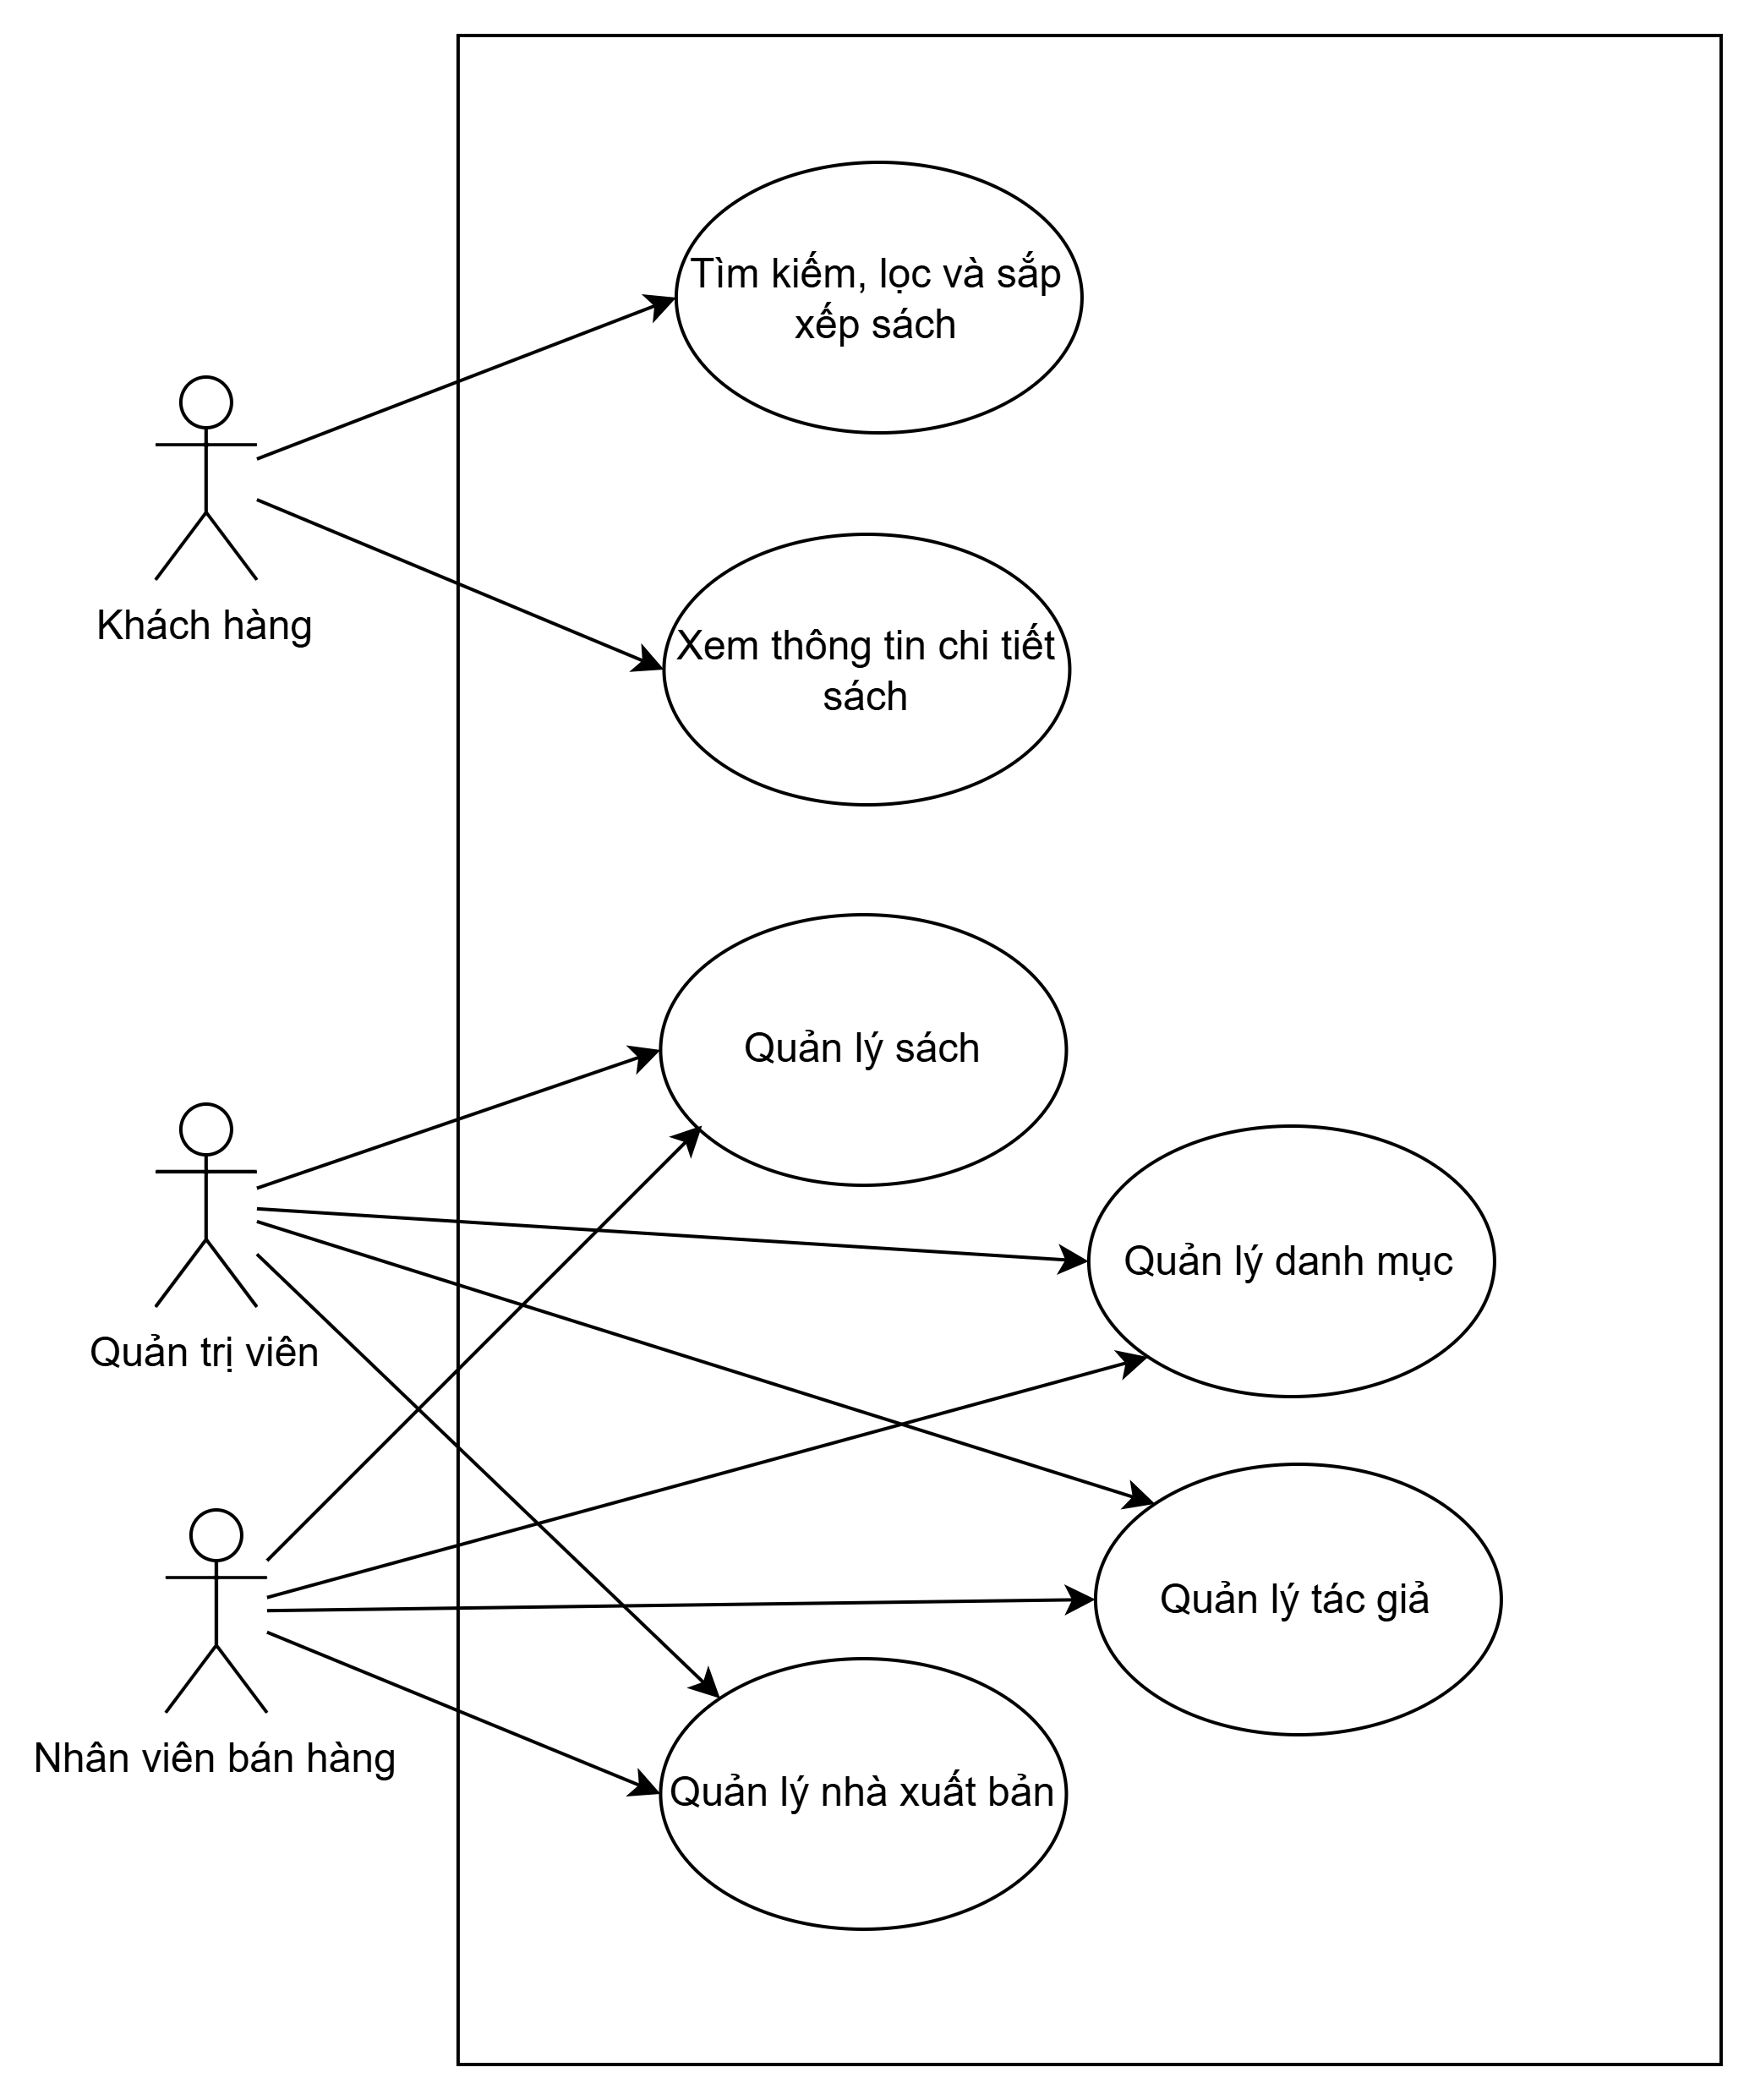

Figure 2.7. Use case product management diagram.

**UC2 Cart management**

Customers can add books to the shopping cart, view the list of books added to the cart, update purchase quantities, and remove books from the cart.

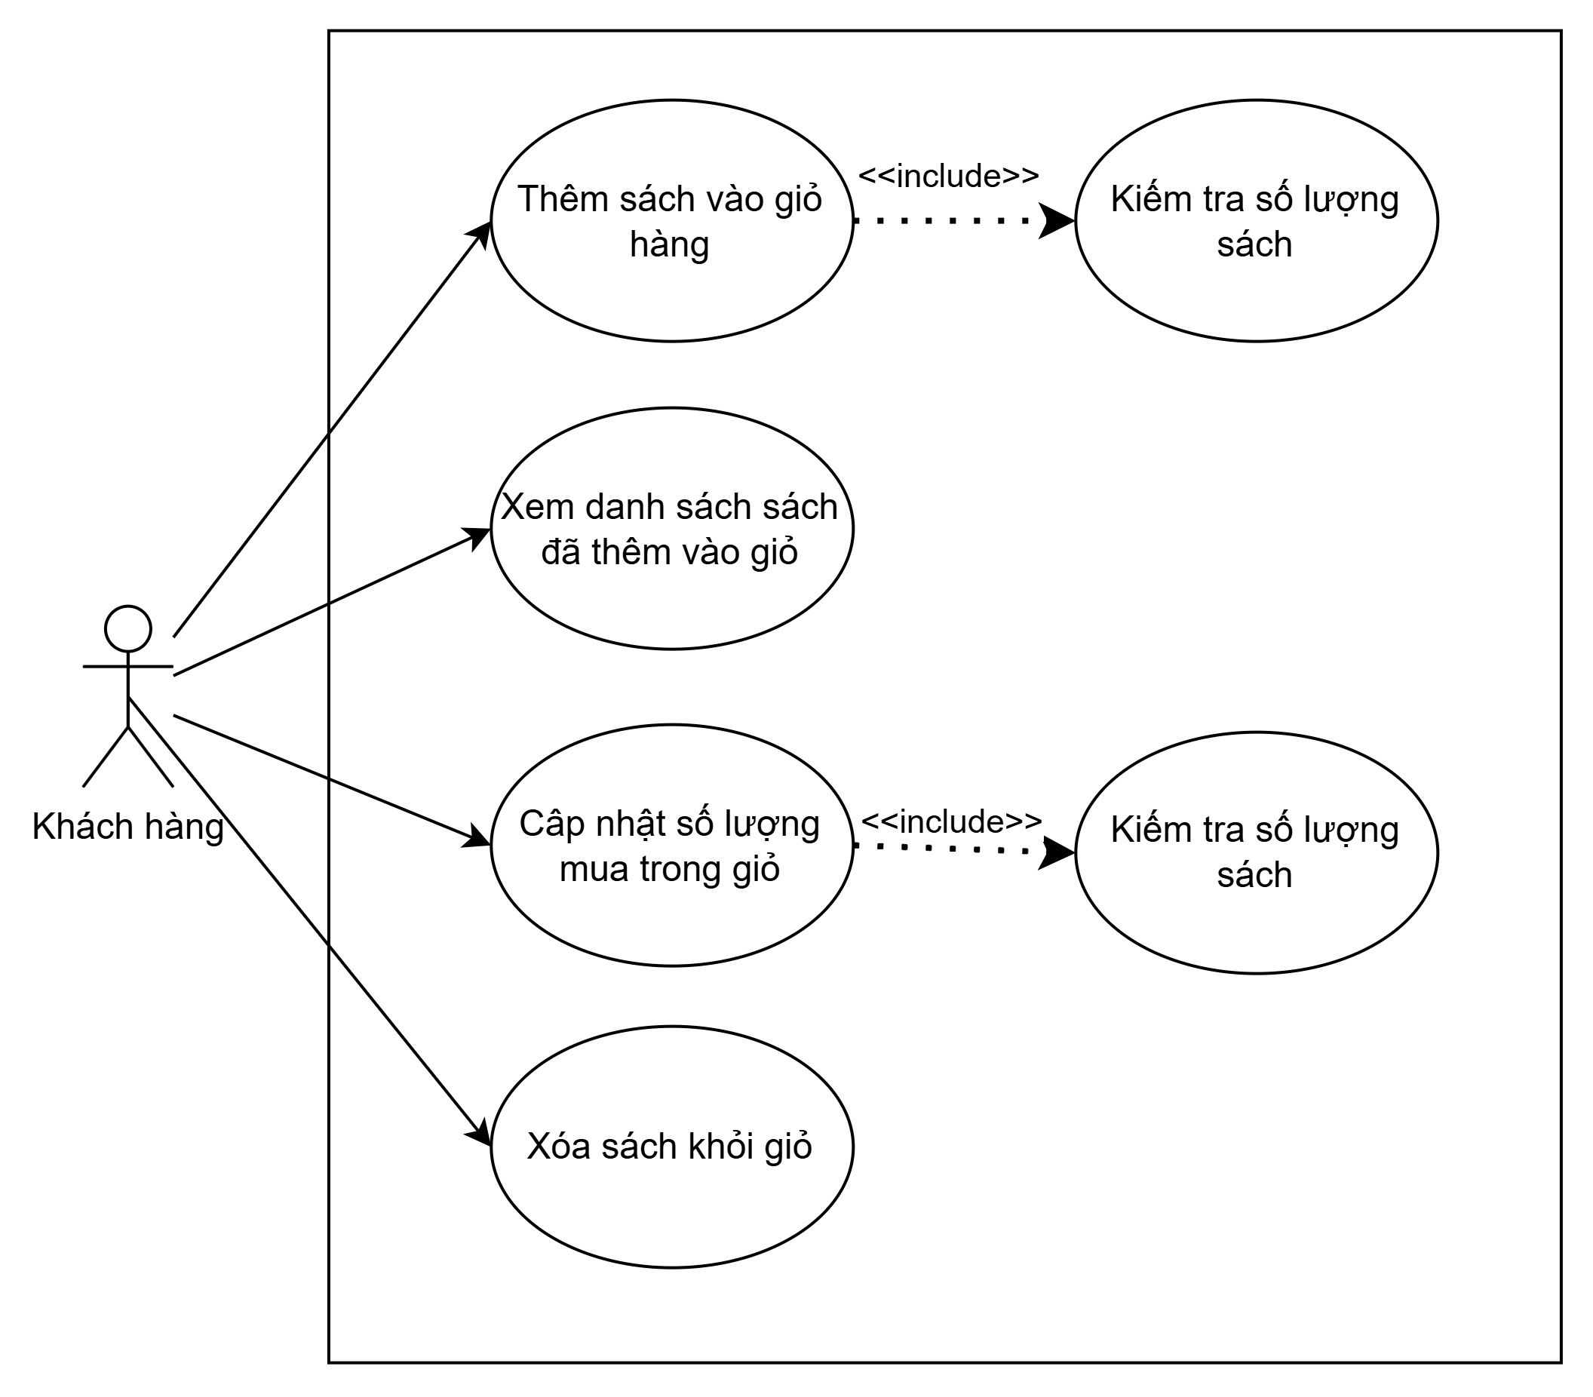Figure 2.8. Use case cart management diagram.

**UC3 Order management**

Customers can place orders and view order details.  
System administrator and sales staff jointly manage orders, including viewing the order list and updating order status.

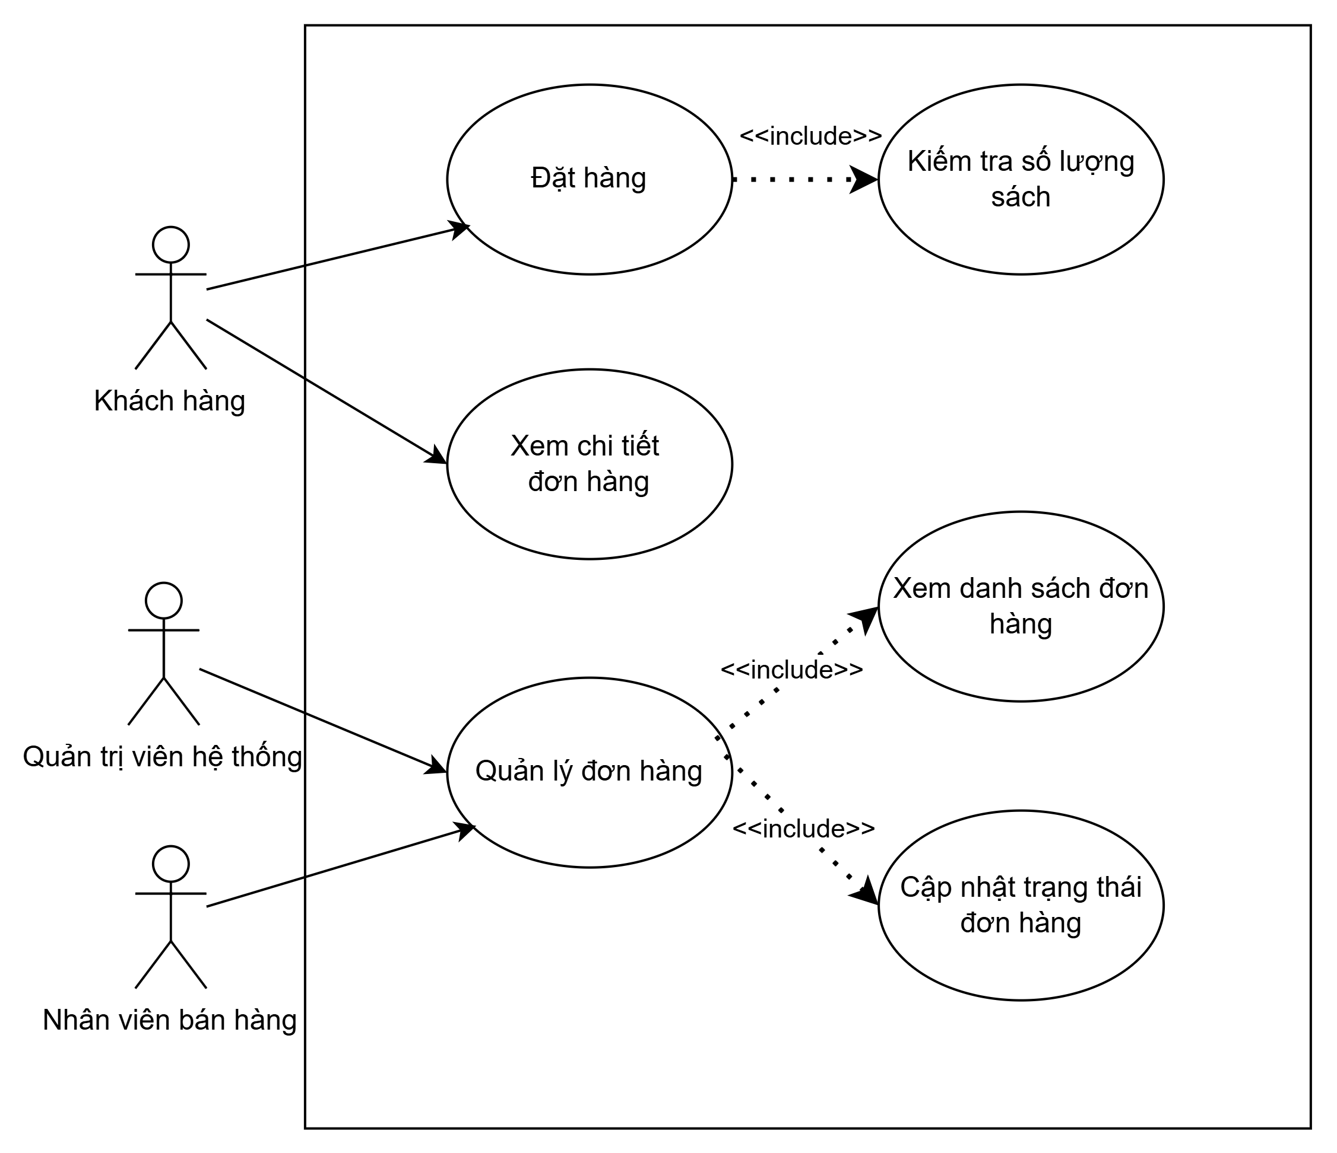Figure 2.9. Use case order management diagram.

**UC4 Payment management**

Customers select MoMo as the payment method and scan the MoMo QR code to complete the payment.  
System administrator and sales staff jointly view the list of transactions from MoMo.  
MoMo is invoked to generate payment QR codes, process refunds, and return payment results.

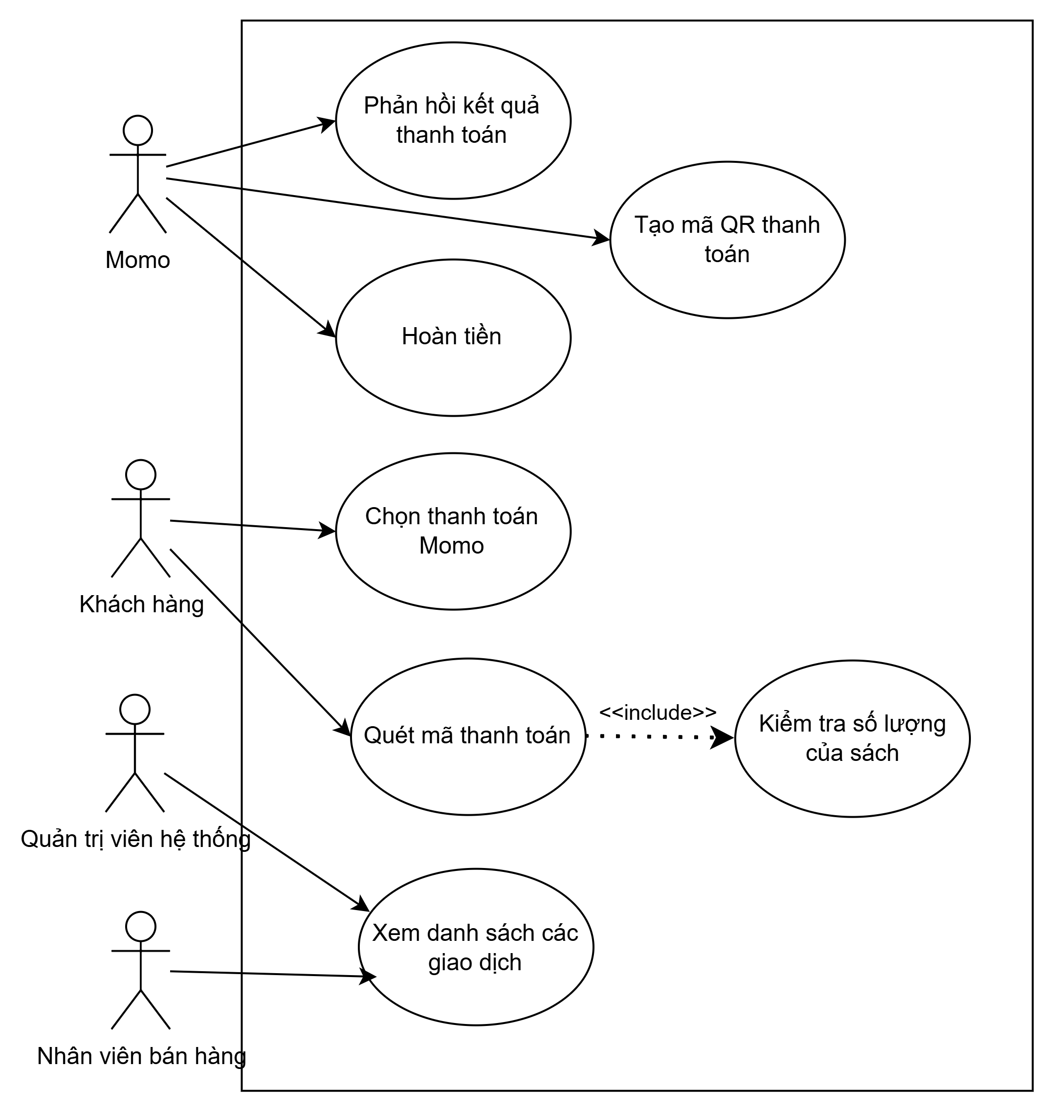

Figure 2.10. Use case payment management diagram.

**UC5 Address book management**

Customers manage the address book by creating, deleting, and updating shipping addresses.

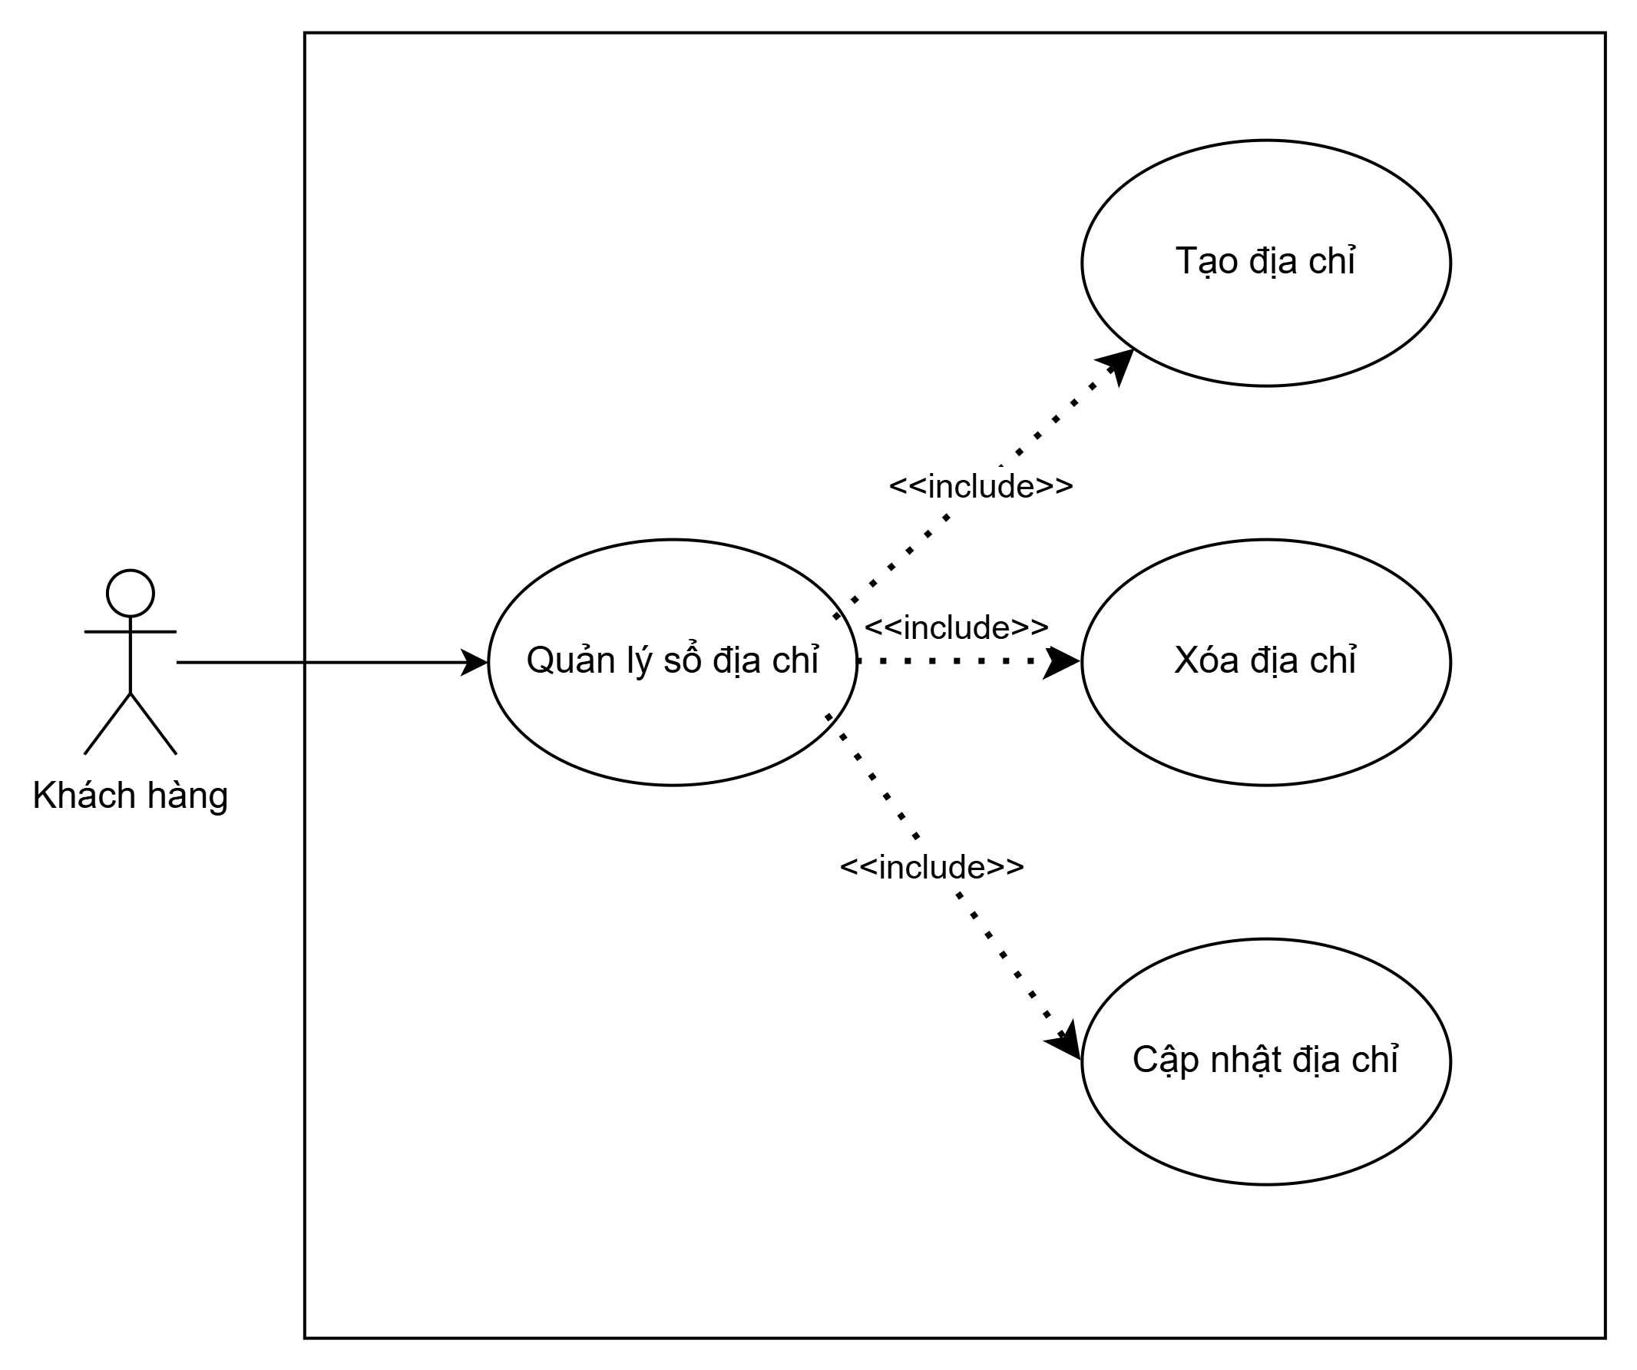Figure 2.11. Use case address book management diagram.

**UC6 Access control**

Customers, System administrator, and sales staff can log in to and log out of the system.  
System administrator manage users, including creating, deleting, and updating user accounts.



Figure 2.12. Use case access control diagram.

### **2.1.6. User story**

**US Product management**

As a customer, I want to view, search, and filter the list of books by title, author, category, or publisher so that I can easily find the book I need.

As a customer, I want to view detailed information about a book to clearly understand its content, price, images, and other details before deciding to purchase.

As a system administrator or sales staff, I want to add, edit, or delete books to ensure that the product catalog is accurate and up to date.

As a system administrator or sales staff, I want to manage categories, authors, and publishers in order to organize books clearly and make them easy to search.

**US Cart management**

As a logged-in customer, I want to add books to the shopping cart from the product detail page so that I can save the books I intend to purchase.

As a customer, I want to review all books in my shopping cart before proceeding to payment.

As a customer, I want to change quantities or remove books from the shopping cart.

**US Payment management**

As a customer, I want to choose MoMo or Cash on Delivery (COD) as the payment method so that I can pay in the most convenient way for me.

As a customer, I want to receive a notification when the payment is successful so that I know my transaction has been recorded.

As a system administrator or sales staff, I want to view and manage the list of successful and refunded transactions.

**US Order management**

As a customer, I want to place an order after adding books to the shopping cart, entering shipping information, and selecting a payment method in order to complete my purchase.

As a customer, I want to view my order list and detailed information of each order.

As a system administrator or sales staff, I want to update order status so that customers can receive accurate information about their orders.

**US Address book management**

As a customer, I want to add, edit, or delete shipping addresses.

As a customer, I want to select a saved address or enter a new address during checkout so that my order can be delivered to the desired location.

**US Access control**

As a visitor, I want to register a new account so that I can log in and use the system’s features.

As a system administrator, I want to add, edit, or delete user accounts.

As a system administrator, I want to lock or unlock user accounts to control access for violating or inactive accounts.

### **2.1.7. Domain driven design**

**Business domain description**

The main reasons for choosing this business domain are as follows:

1. A real-world system already exists for this domain, allowing the implementation to be compared with an actively operating website.
2. The domain is not overly simple; it includes several complex business processes and logic, rather than merely basic CRUD operations.
3. The domain is not overly complex, making it easy to understand, reasonably scoped, and feasible to implement.

The product domain consists of the main entities: Book, Author, Category, and Publisher. Customers can view, search, and filter the list of books. System administrators and sales staff can perform CRUD operations on Books, Categories, Authors, and Publishers.

For the cart, only logged-in customers can add books to the cart. Customers can review the cart, change quantities, or remove books from the cart, and then proceed to order placement and payment.

The order domain includes the main entities Order and Order Detail. After adding products to the cart, customers enter shipping information and select a payment method to create an order. System administrators and sales staff can update the order status.

The payment domain includes the main entities Payment, Payment Method, and Payment Status. Customers can choose MoMo as a payment method. System administrators and sales staff can view the list of payment transactions.

The address book domain has the main entity Address. Customers can add, edit, or delete addresses.

The access control domain includes the main entities User and Role. Users include Customers, System Administrators, and Sales Staff. Each user can log in to and log out of the system. System administrators have the authority to manage user accounts.

**Conceptual model**

Product: Includes Book, Author, Category, and Publisher. Customers can view, search, and filter products, while system administrators and sales staff perform CRUD operations on the data.

Shopping Cart: Logged-in customers can add, edit, and remove products from the cart and proceed to place orders.

Order: Includes Order and Order Detail entities. Customers create orders during checkout, while sales staff and system administrators update order status.

Payment: Includes Payment, Payment Method, and Payment Status. Customers can make payments via MoMo, and sales staff or system administrators can view transaction records.

Address Book: Customers manage their own shipping addresses.

Access Control: Includes User (Customer, Sales Staff, System Administrator) and Role entities. System administrators manage user accounts, and users can log in and log out of the system.

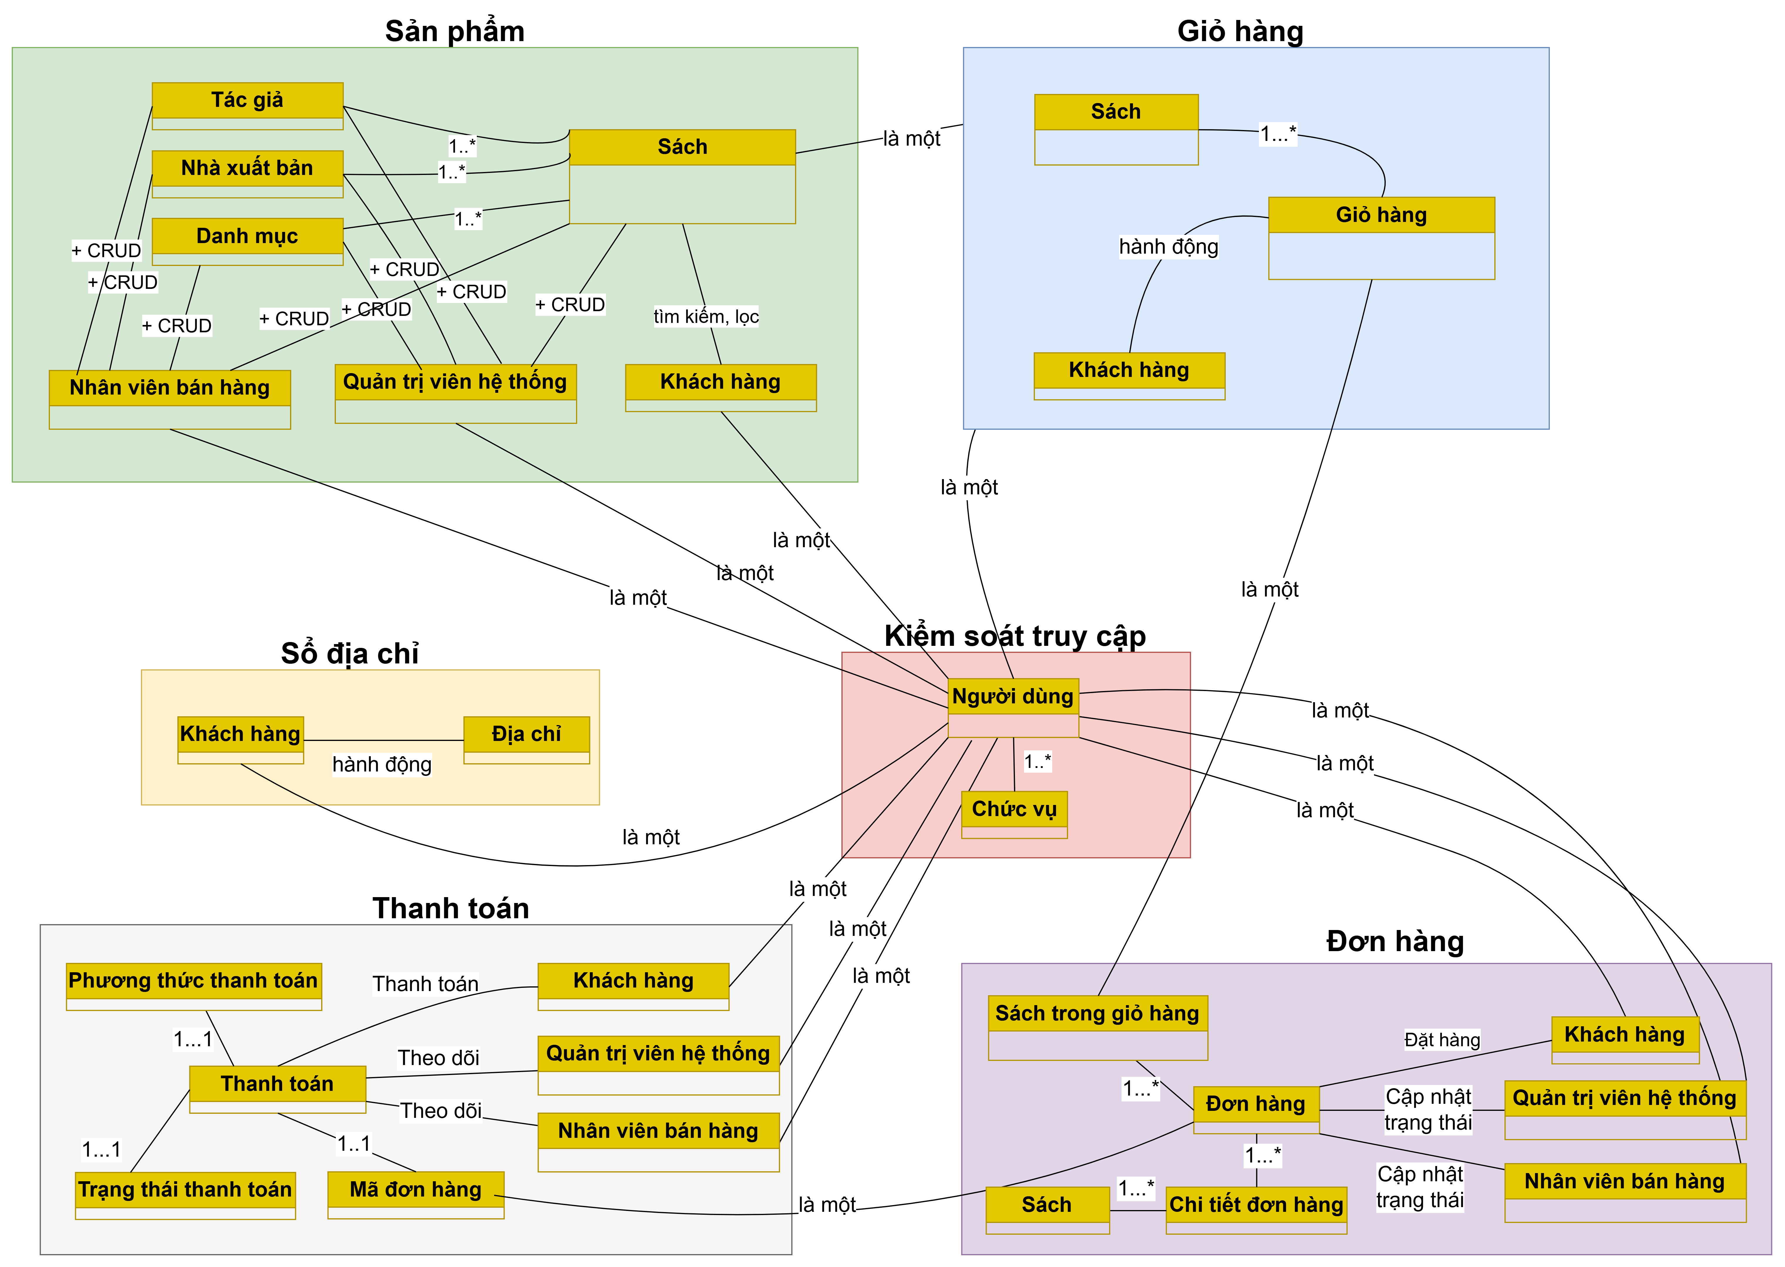

Figure 2.13. Conceptual model diagram..

### **2.1.8. Data model**

The conceptual entity–relationship model describes the main entities, including Book, ImageBook, Publisher, Category, Author, Cart, Order, Address, User, and Payment, as well as the relationships among these entities, such as “belong to” and “have.”

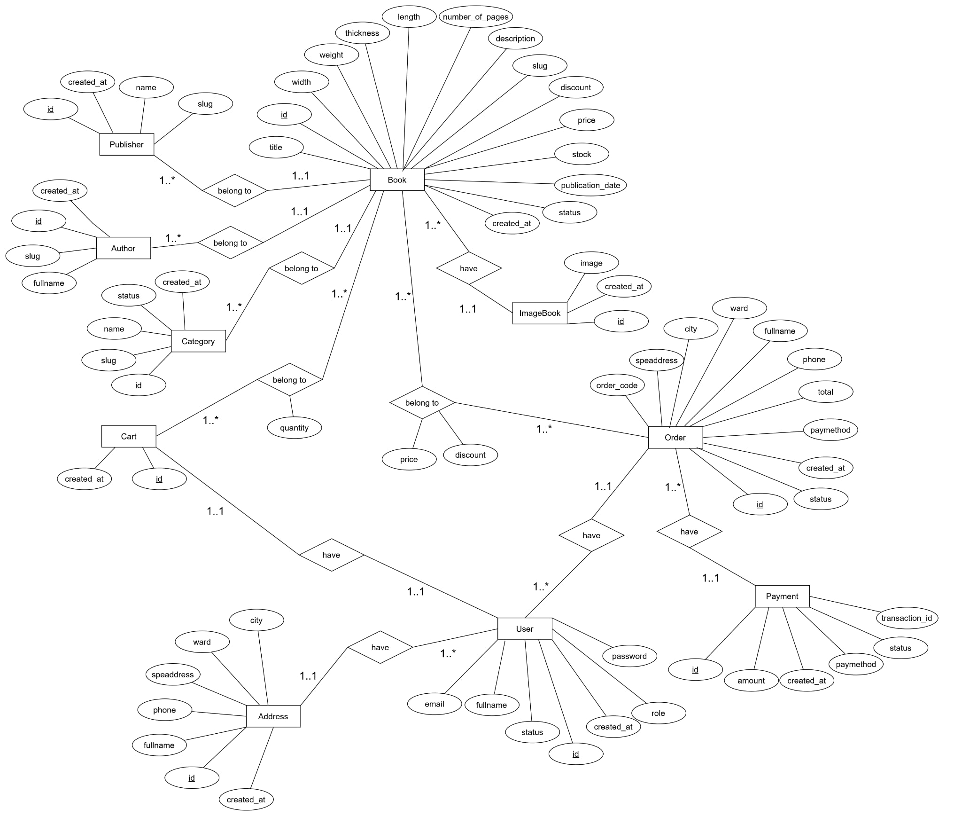Figure 2.14. Conceptual Entity–Relationship Model

The logical entity–relationship model is developed from the conceptual model, in which each entity is concretized into a database table with primary keys (PK), foreign keys (FK), attributes, and relationships between tables.

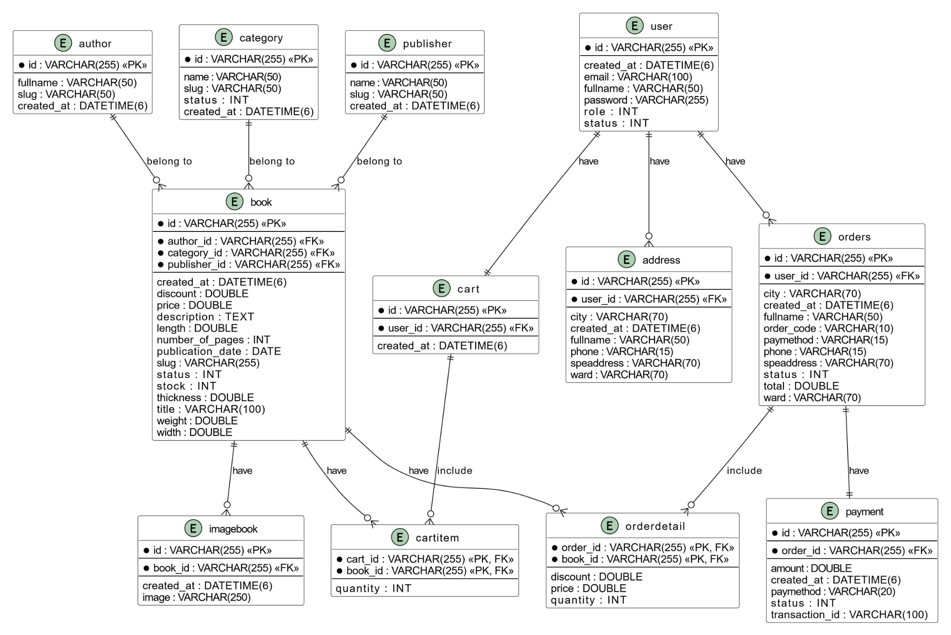

Figure 2.15. Logical Entity–Relationship Model.

The physical entity–relationship model represents the actual data storage structure in the database and is derived from the logical model. It includes tables with attributes, data types, and constraints such as primary keys and foreign keys, which are tightly linked to ensure data integrity and support efficient querying.

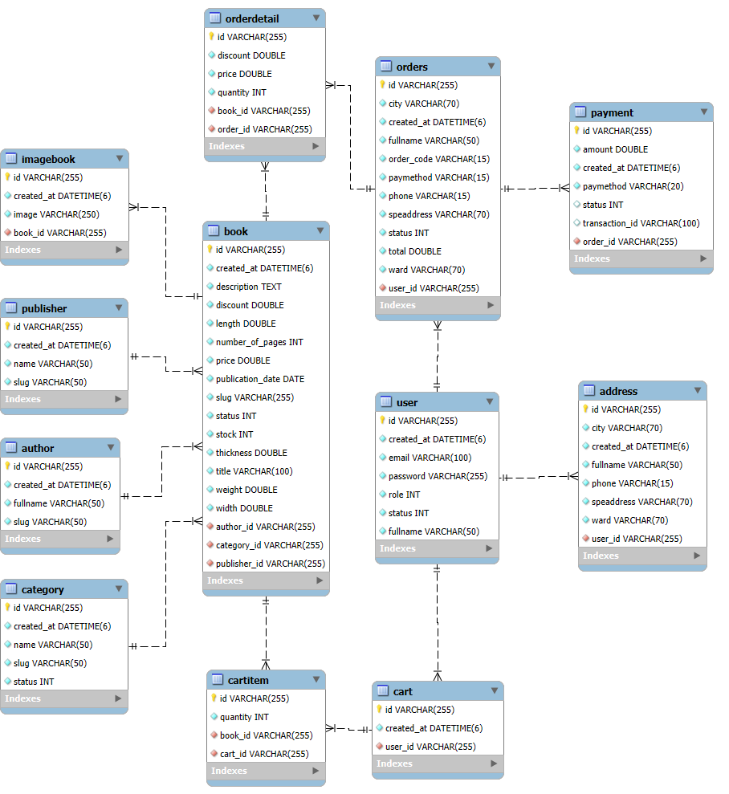

Figure 2.16. Physical Entity–Relationship Model.

### **2.1.9. Wireflow**

Customers access the Fahasa homepage to view categories and featured products, and can search for and select desired books. When clicking on a product, the system displays detailed book information, including price, description, author, and publisher.

If customers wish to make a purchase, they select “Add to Cart.” If they are not logged in, the system will require them to log in before continuing. After logging in, customers can add books to the cart, review the selected items, and adjust quantities if necessary.

Customers then navigate to the shopping cart to review the added books, modify quantities if needed, and click the “Checkout” button to proceed to the next step. On the checkout page, customers must enter shipping information, select a payment method (COD or MoMo), and then place and complete the payment.

The system displays the order result on the order result page. Customers can track their orders by accessing the “Orders” section. By clicking “View Details,” customers can view complete and detailed information about each order.

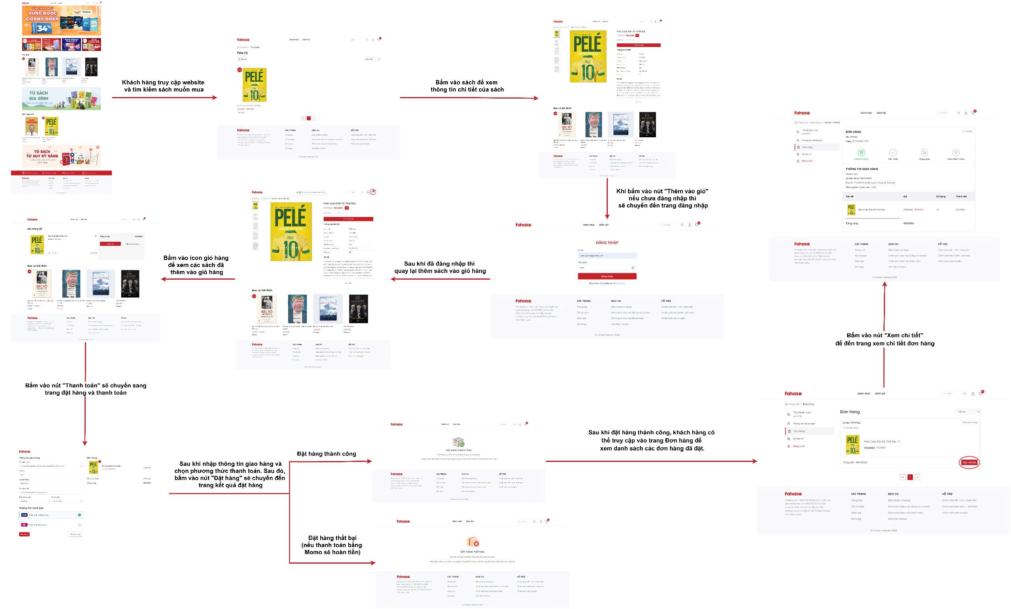Figure 2.17. Wireflow digarm.

### **2.1.10. Interface**

**Customer pages interface**

The homepage is the first page displayed when customers access the Fahasa website.

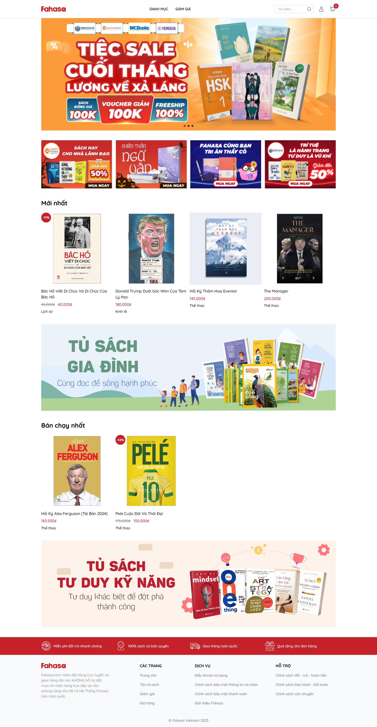

Figure 2.18. Home page.

The customer login page requires customers to enter their email and password in order to purchase products on the Fahasa website. Only customers can log in through this page.

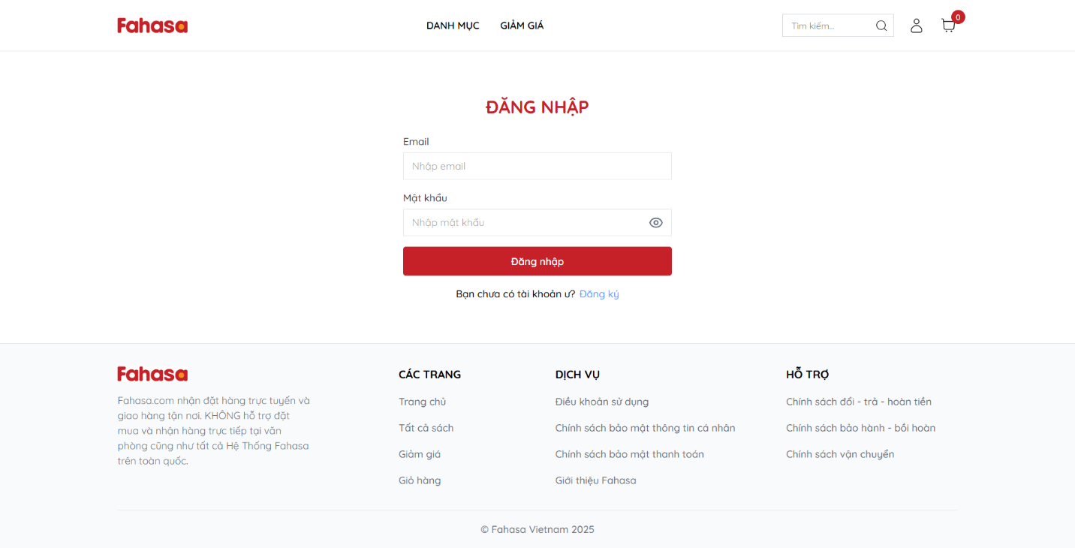Figure 2.19. Customer login page.

The book list page allows customers to search for books using the search bar, select a book category, or click on the “Discount” section to navigate to a page displaying the corresponding list of books.



Figure 2.20. Book líst page.

The book detail page allows customers to view detailed information about a book and select the purchase quantity to add the book to the shopping cart.

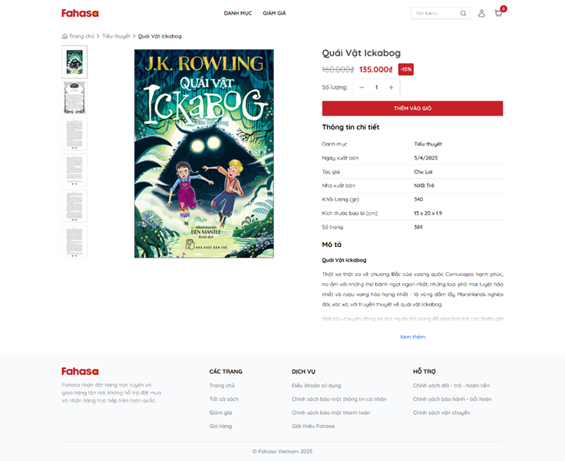

Figure 2.21. Book detail page.

The shopping cart page allows customers, after logging in, to add books to the cart, adjust purchase quantities, or remove books from the cart. Once the selection is complete, customers click the “Checkout” button to place the order and proceed with payment.

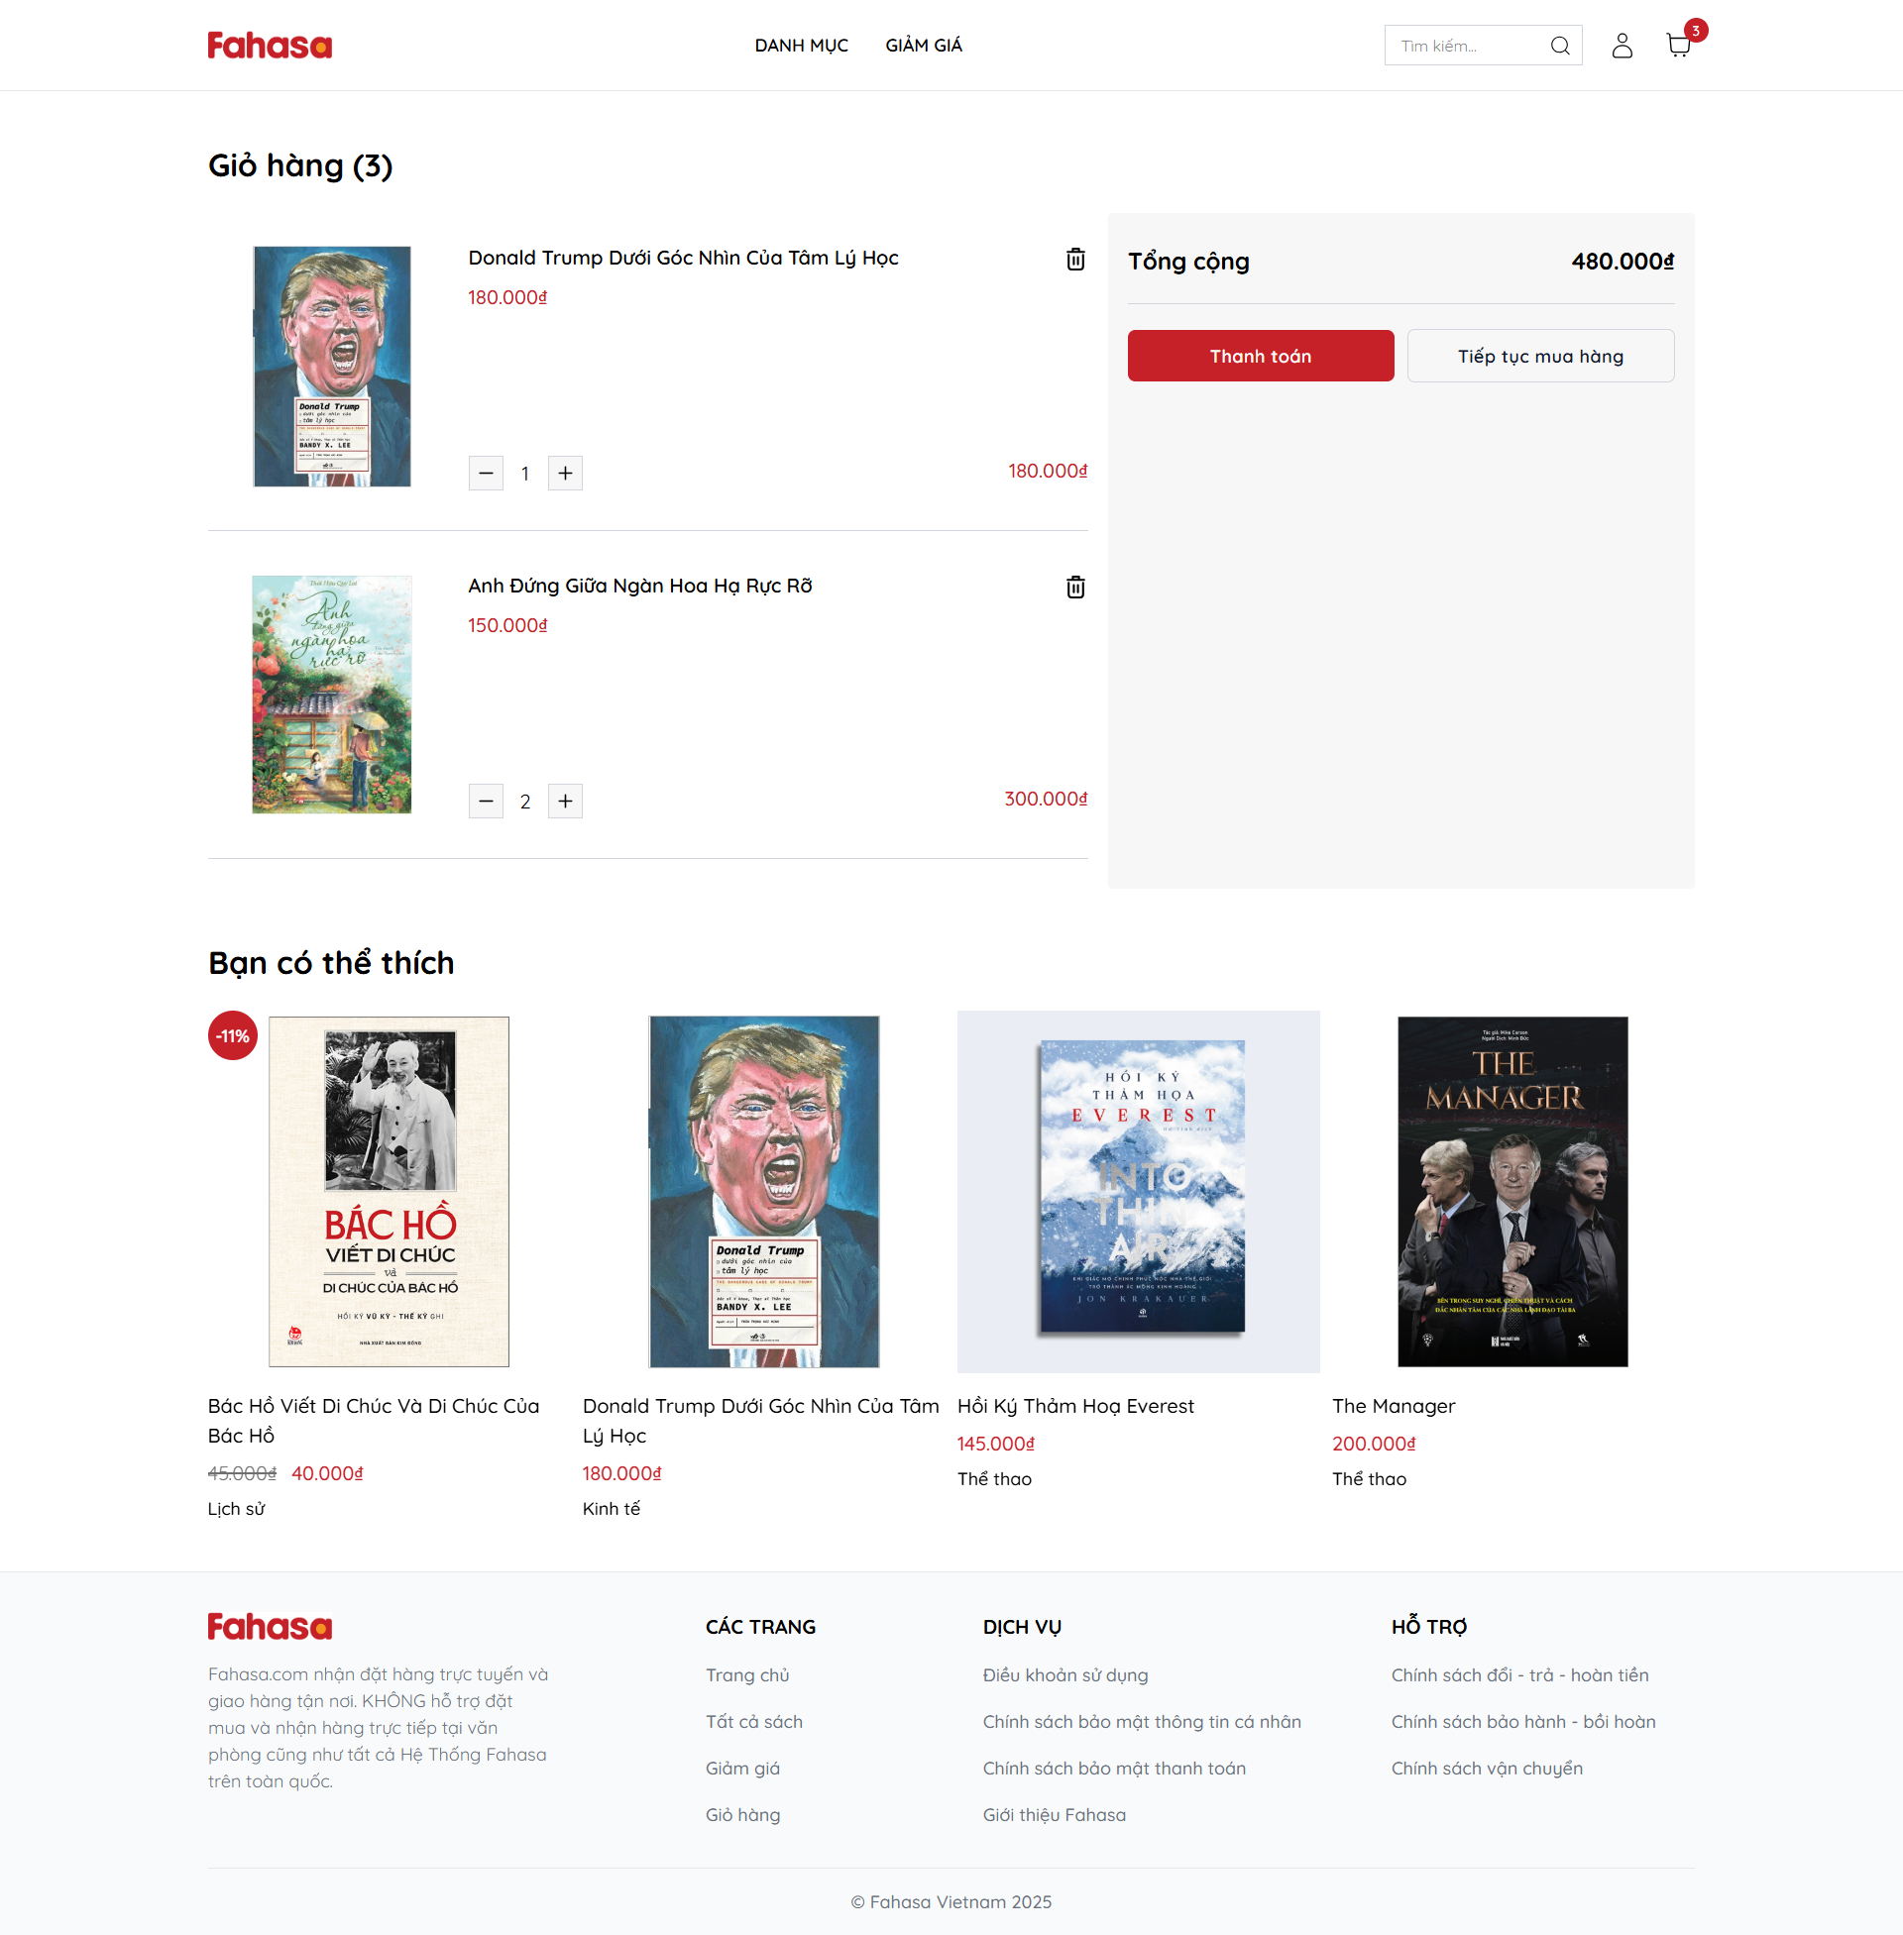Figure 2.22. Shopping cart page.

The checkout page is where customers, after adding products to the shopping cart, proceed to place an order and complete the payment.

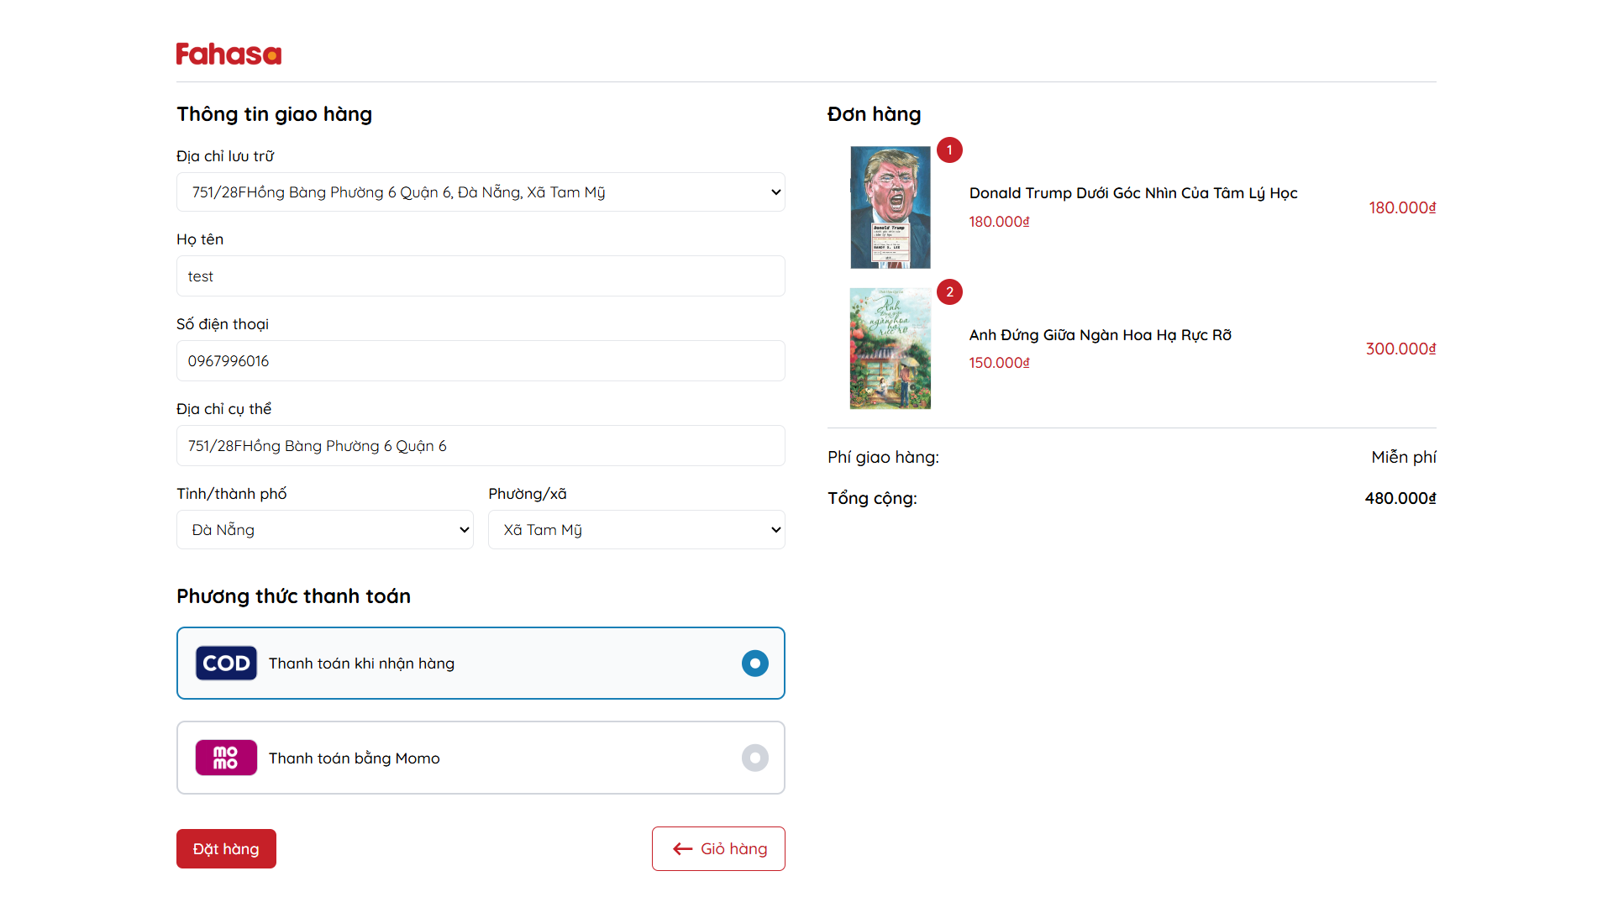Figure 2.23. Checkout page.

The order result page is displayed after customers complete the order and payment process. This page shows the order outcome, indicating whether the order was placed successfully or failed.

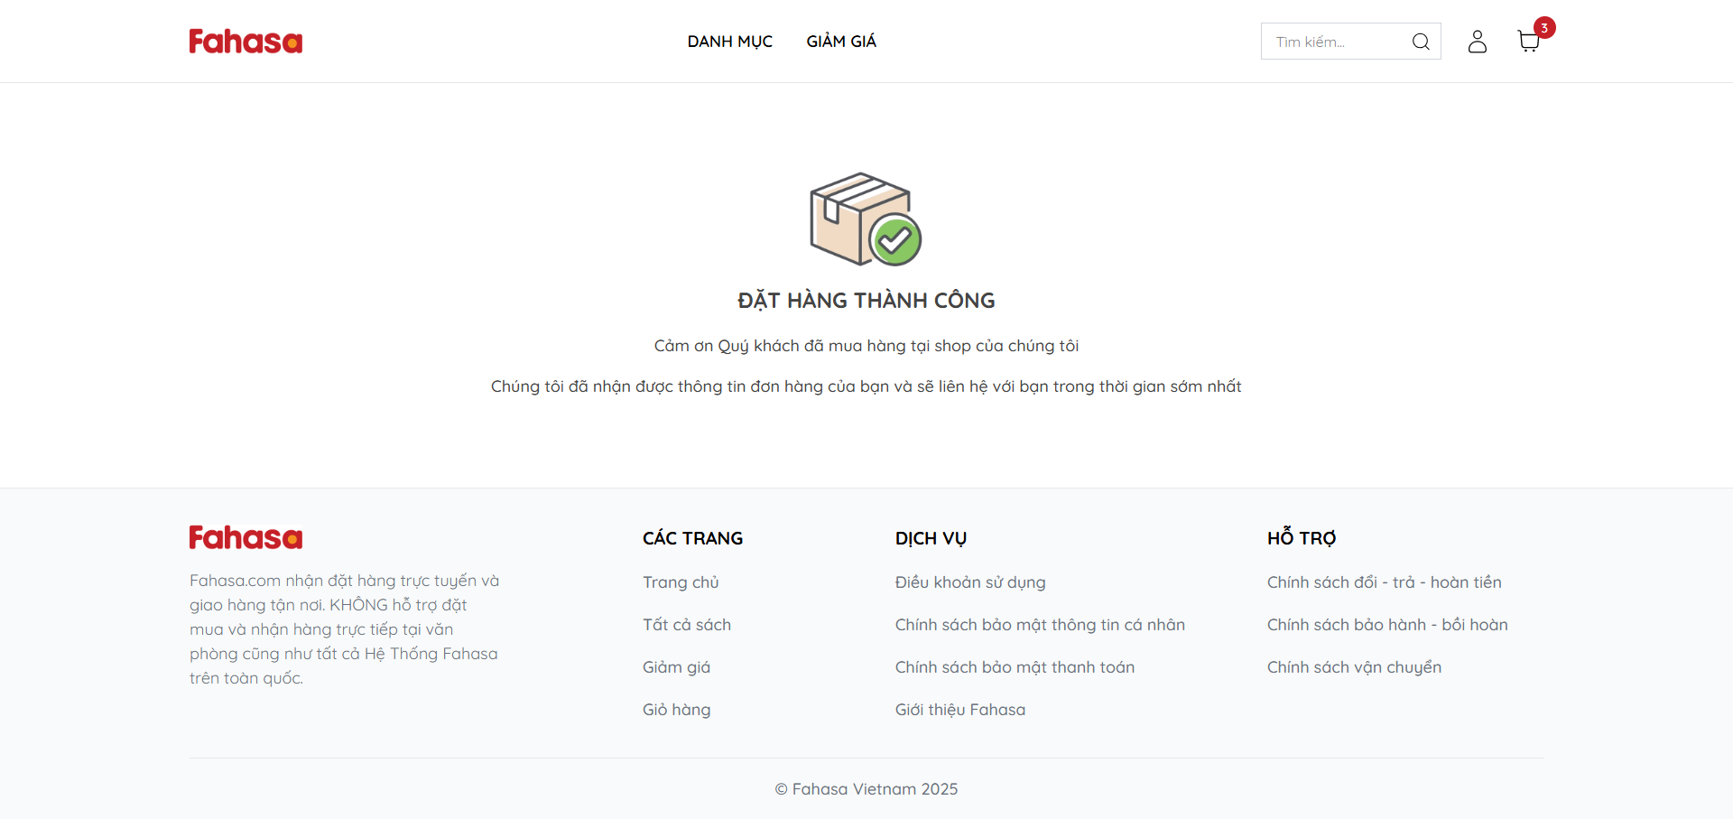Figure 2.24. Order result success page.

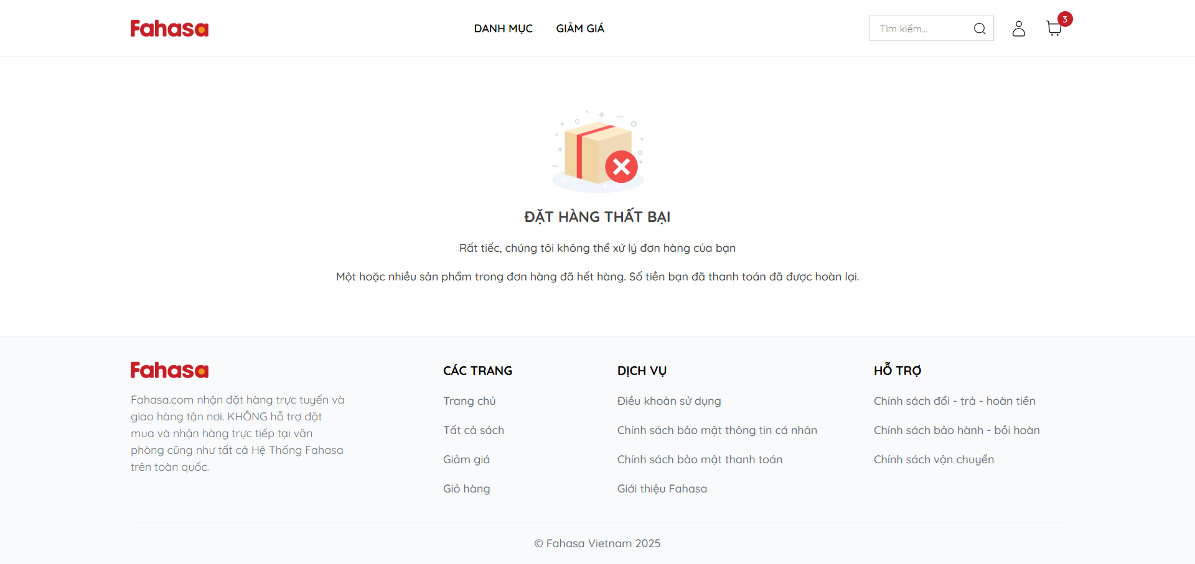Figure 2.25. Order result fail page

The order list page displays all orders that a customer has successfully placed. Successfully placed orders will appear on this page for the customer to view.

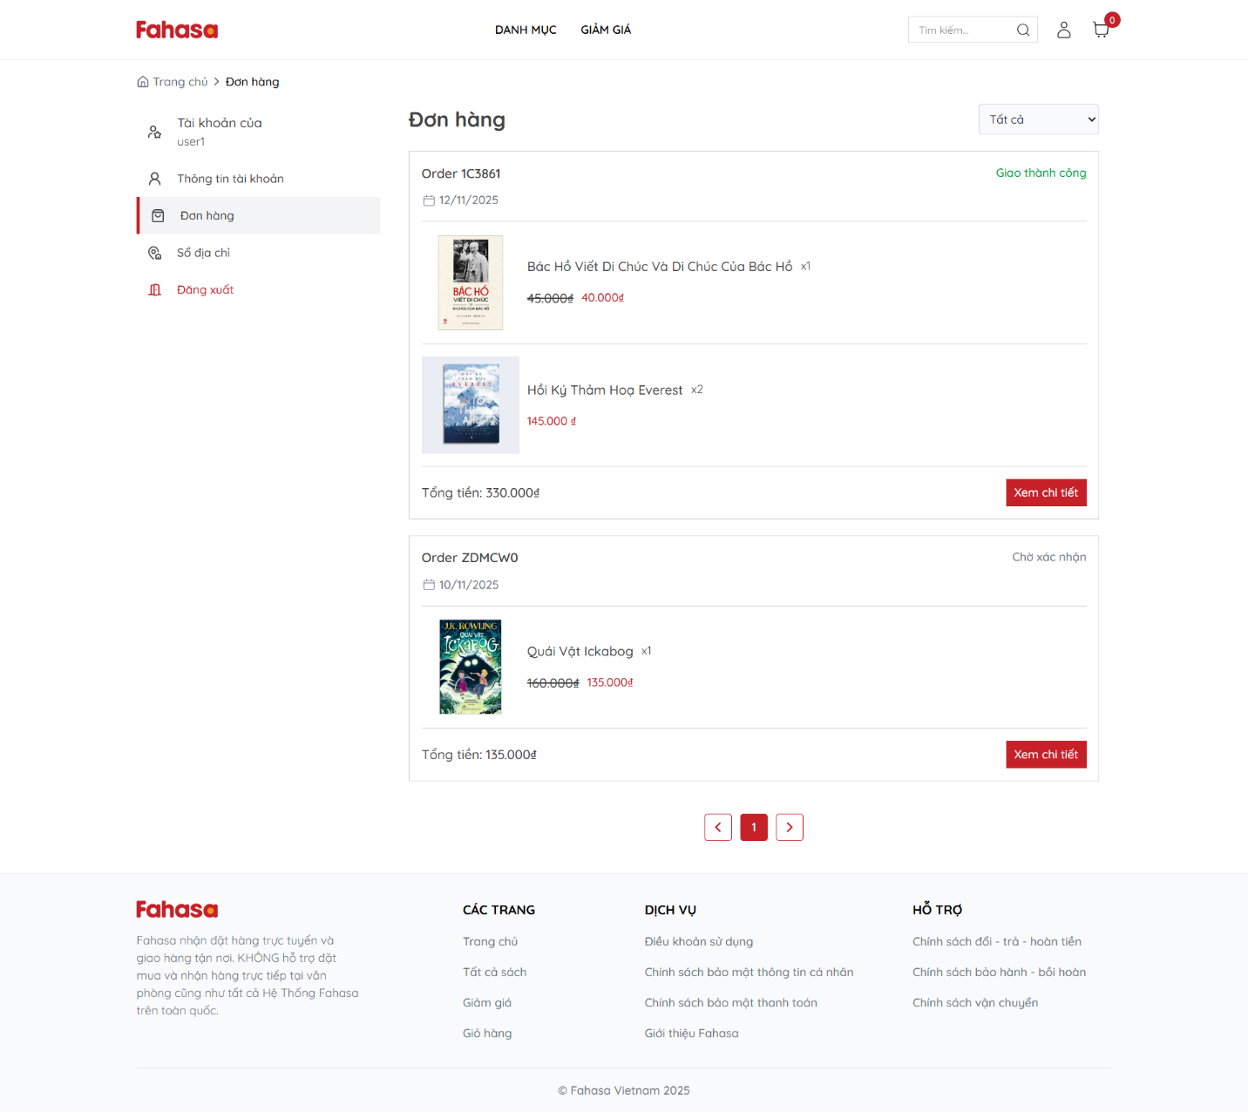Figure 2.26. Order list page.

The order detail page is displayed when a customer clicks the “View Details” button on the order list page. This page provides complete and detailed information about the selected order.

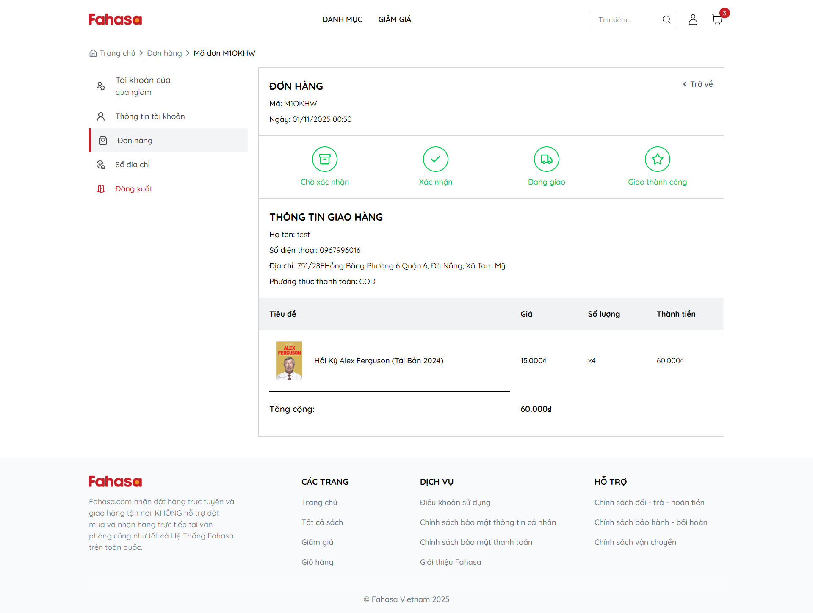

Figure 2.27. Order detail page.

**Admin pages interface**

The admin login page requires administrators (system administrators and sales staff) to enter their email and password to access the Fahasa website administration system. Only authorized administrators are allowed to log in to this page.

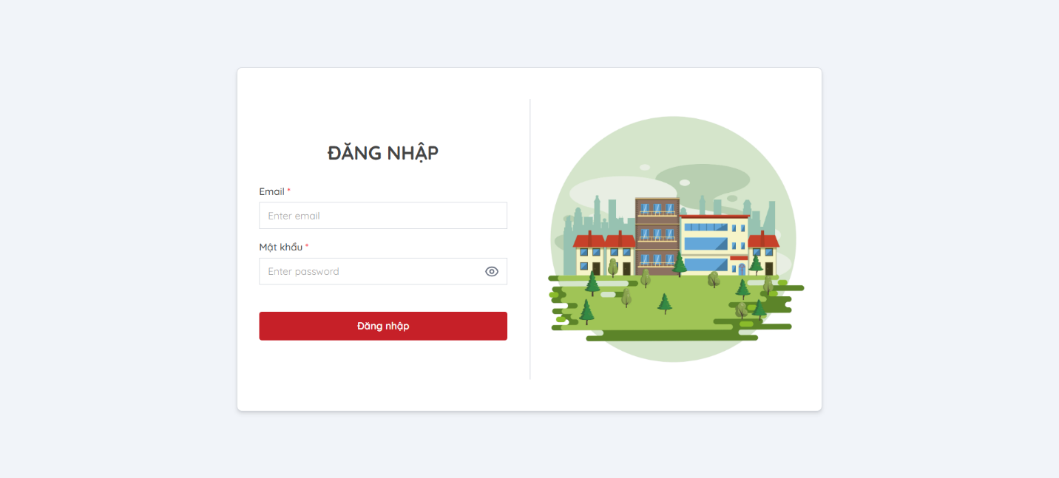Figure 2.28. Login admin page.

The book list page allows system administrators or sales staff to view the list of books, as well as update the status or delete books.

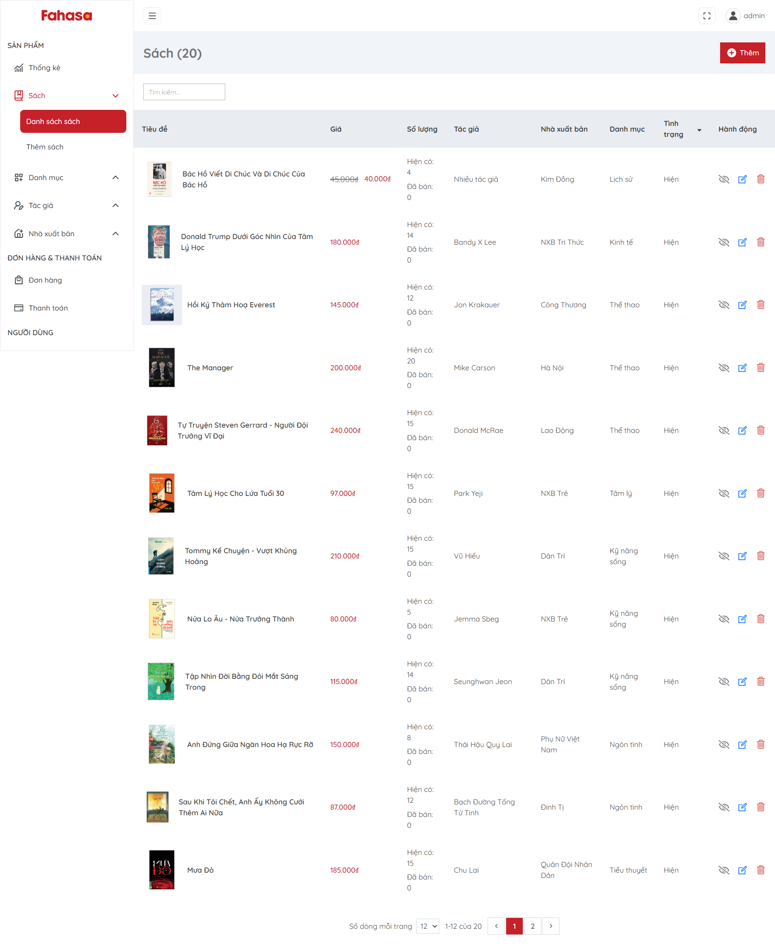

Figure 2.29. Book list page.

The order list page allows system administrators or sales staff to view the list of orders and update the status of each order.

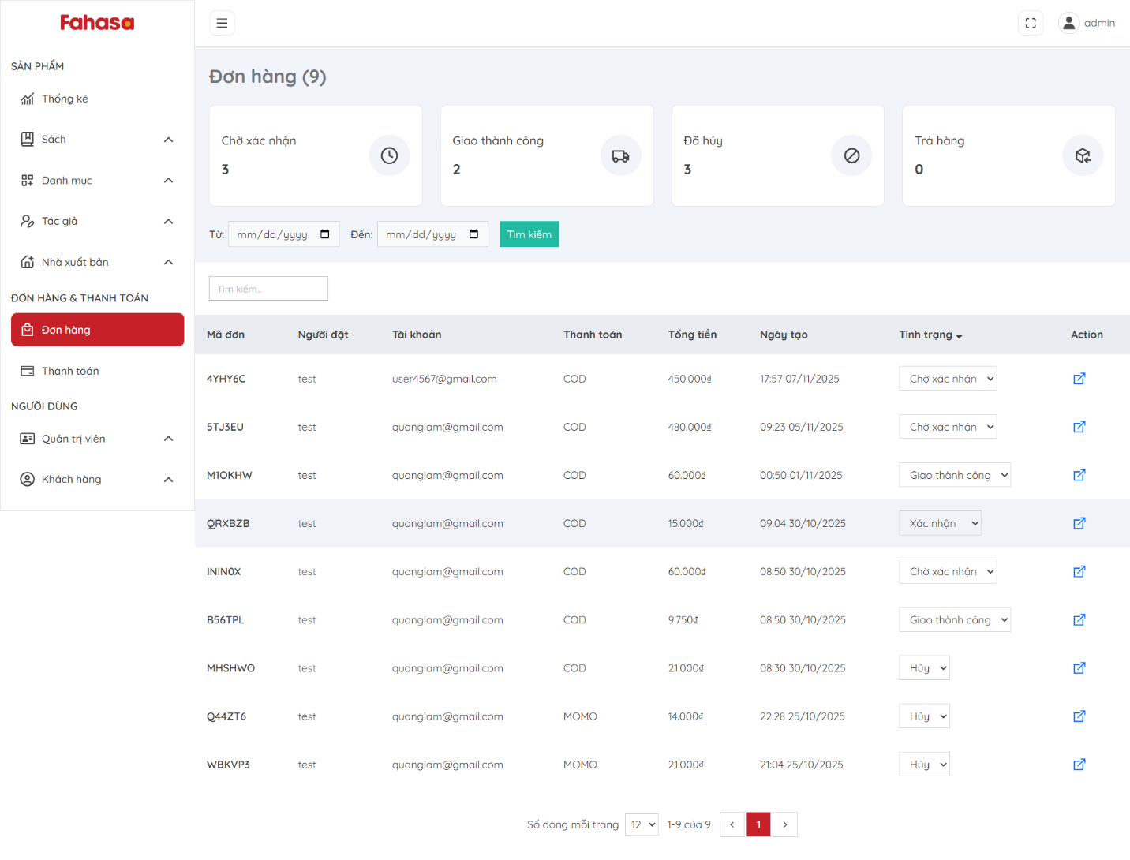Figure 2.30. Order list page.

The order detail page allows system administrators or sales staff to view the complete details of an order.

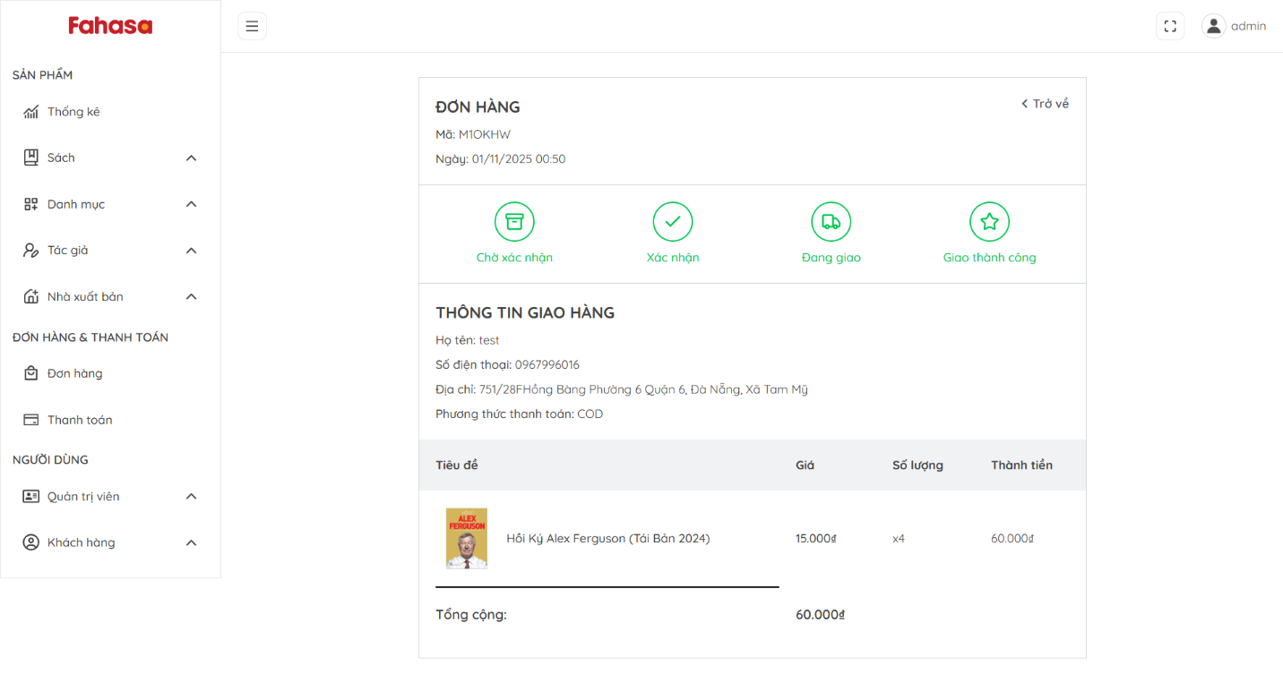Figure 2.31. Order detail page.

The payment list page allows system administrators or sales staff to view the list of payment transactions.

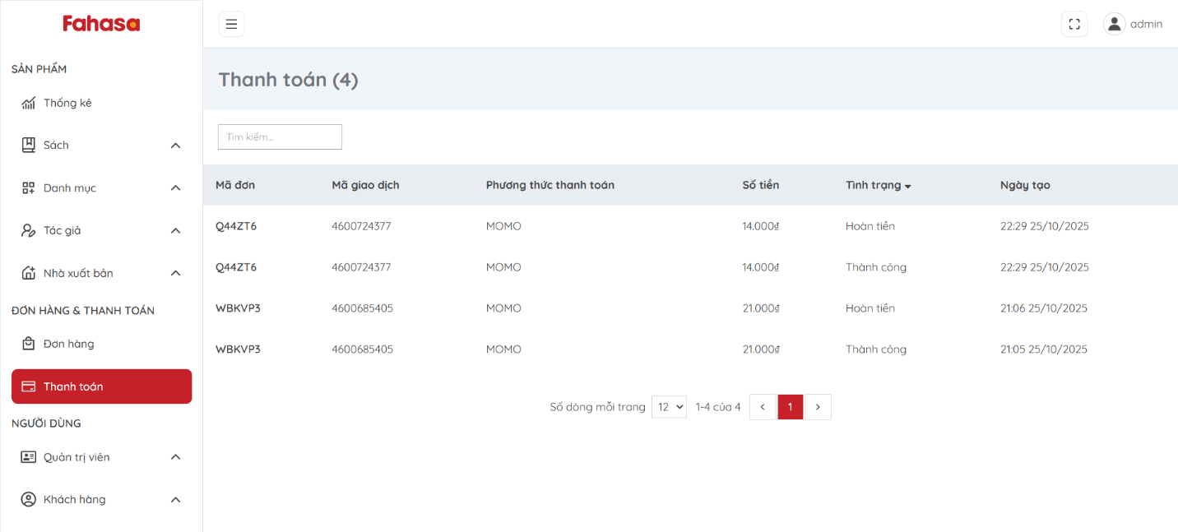Figure 2.32. Payment list page.

The user list page allows system administrators to view the list of administrator and customer accounts, and also lock, unlock, or delete user accounts.

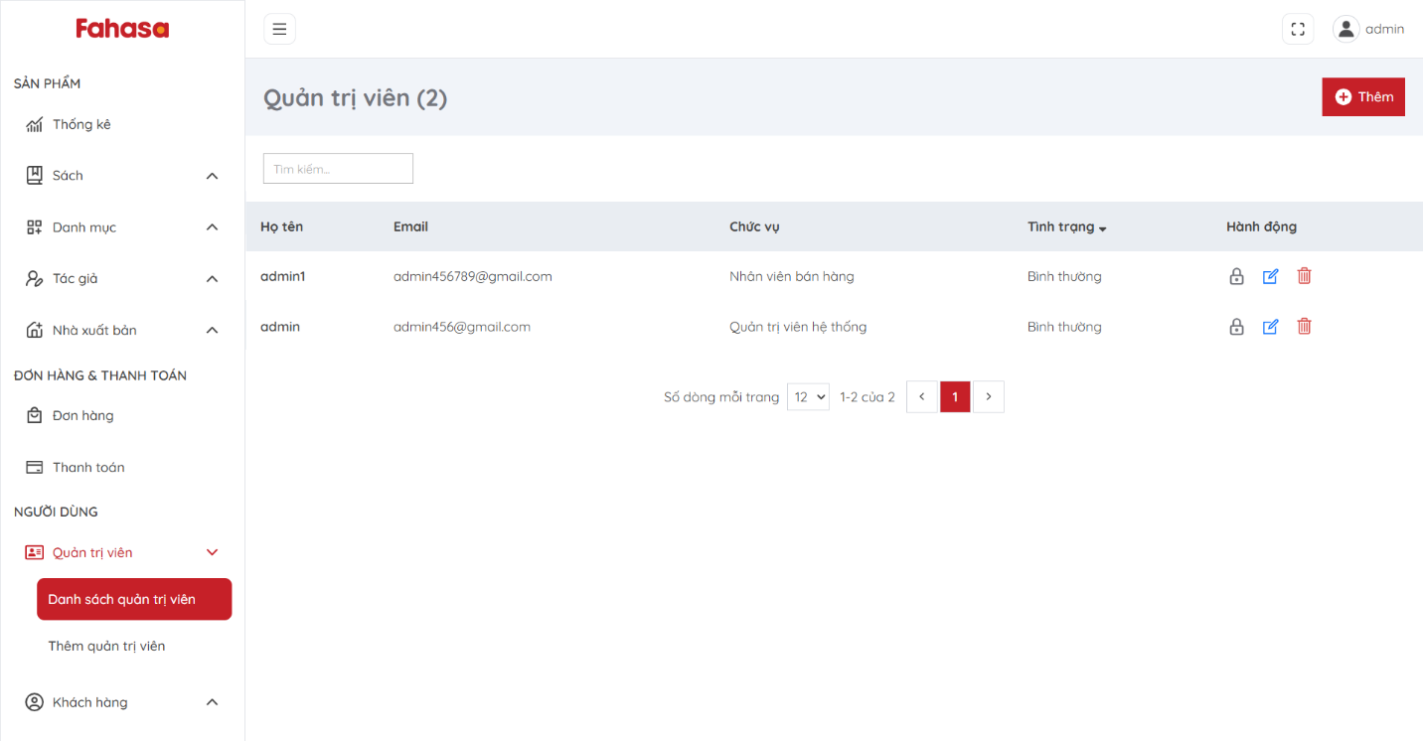Figure 2.33. Admin list page.

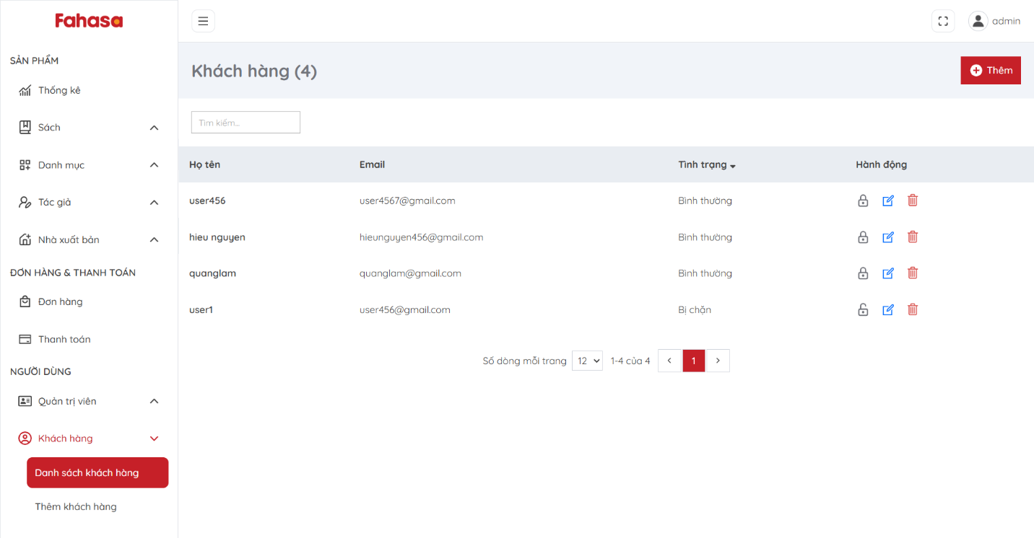Figure 2.34. Customer list page.

## **2.2. Architecture design**

### **2.2.1. Block diagram**

The system has a Frontend built with ReactJS following the SPA model, which receives user requests and is routed through a Reverse Proxy. The Backend is developed with Spring Boot using a three-layer architecture, divided into functional modules and interacting with a MySQL database for data storage and retrieval.

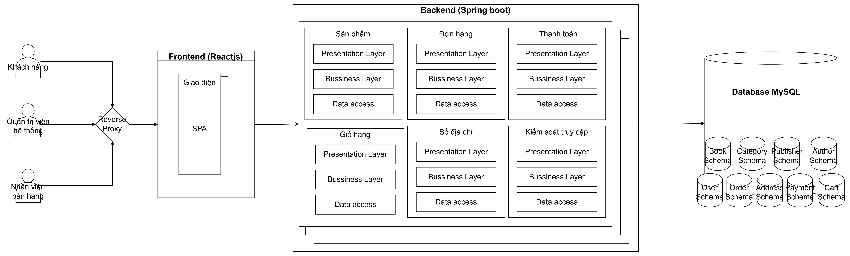Figure 2.35. Block diagram.

### **2.2.2. C4 architecture**

**C1 - System context**

Customers use the system to register/login, search, view details, place orders, and make payments.

System administrators and sales staff log into the system to manage books, categories, authors, publishers, orders, and payments; additionally, administrators can manage user accounts.

The system connects to the Momo payment gateway to process transactions, receive payment results, and display the payment interface to customers.

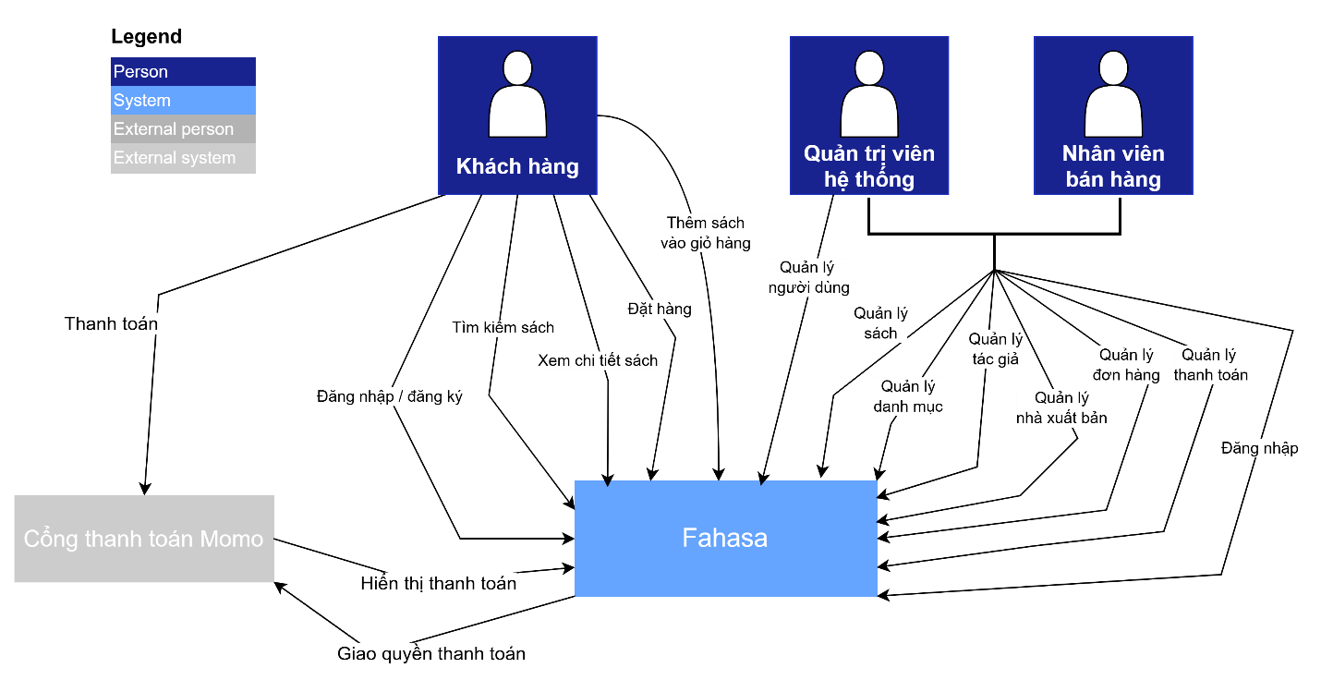Figure 2.36. System context diagram C1.

**C2 – Container**

The ReactJS SPA Container serves as the user interface, accessed by customers, administrators, and sales staff via HTTP. This container sends requests to the Fahasa System API (Spring Boot) to handle business logic.

The Spring Boot Backend Container is responsible for interacting with and querying the MySQL container, which stores information for tables such as Book, Order, Category, etc.

The backend also communicates bi-directionally via HTTP with the Momo Payment Gateway to process payments and receive transaction results.

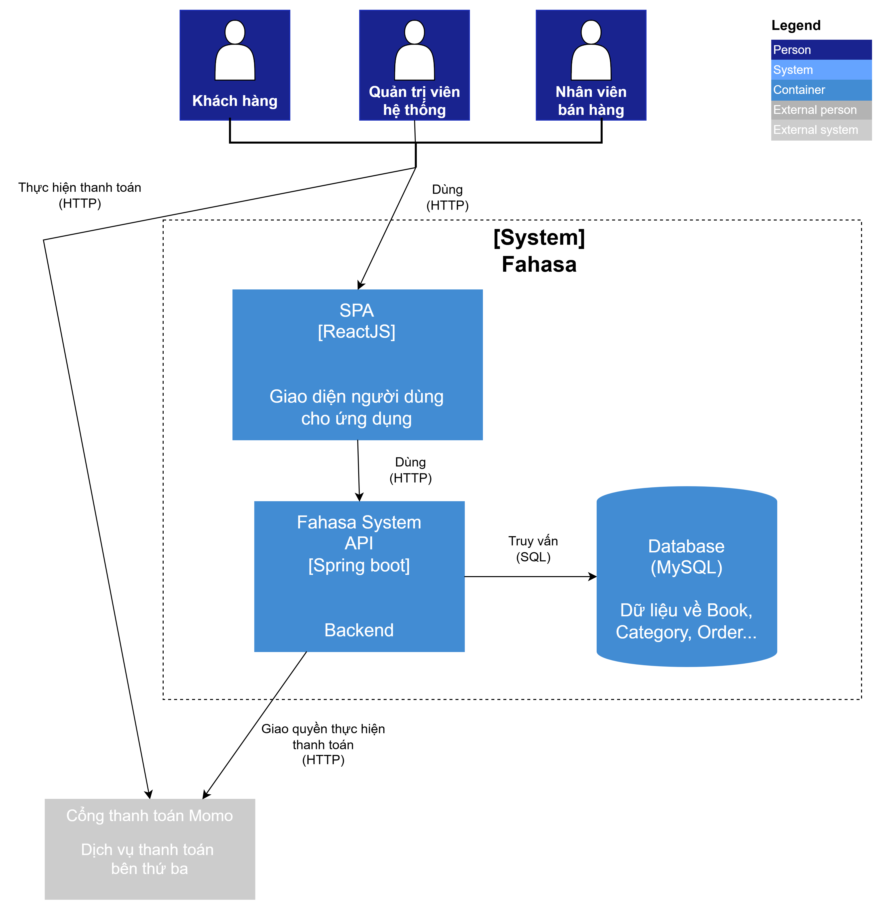

Figure 2.37. Container Diagram C2.

**C3 – Component (high-level)**

The User Interface (ReactJS) connects to the API layer implemented by Spring Boot. The API layer is divided into separate business modules: Product, Cart, Order, Payment, Address Book, and Access Control.

Each module interacts with its own database tables. The system also uses an in-memory Event Bus for asynchronous communication between modules, reducing direct dependencies and improving system scalability.

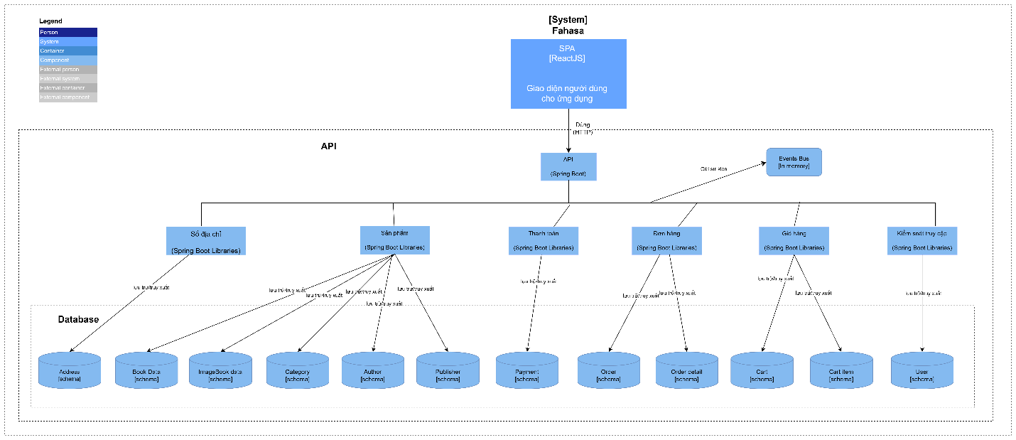Figure 2.38. Component diagram C3.

**C4 – Code**

**Class diagram**

The Class Diagram illustrates the classes in the system: Controller classes handle requests from users, service classes process business logic, repository classes interact with the database for data retrieval and persistence, entity classes represent tables in the database.



Figure 2.39. Class diagram.

**Sequence diagram**

**Product management**

Customer Flow: Customers can access the website and navigate to the Book List page, where the system displays all available books. On this page, customers can search, filter, sort, and view detailed information for each book.

Administrator Flow: Administrators or sales staff must log in first. After logging in, they can access product management functionalities, including managing books, categories, authors, and publishers.

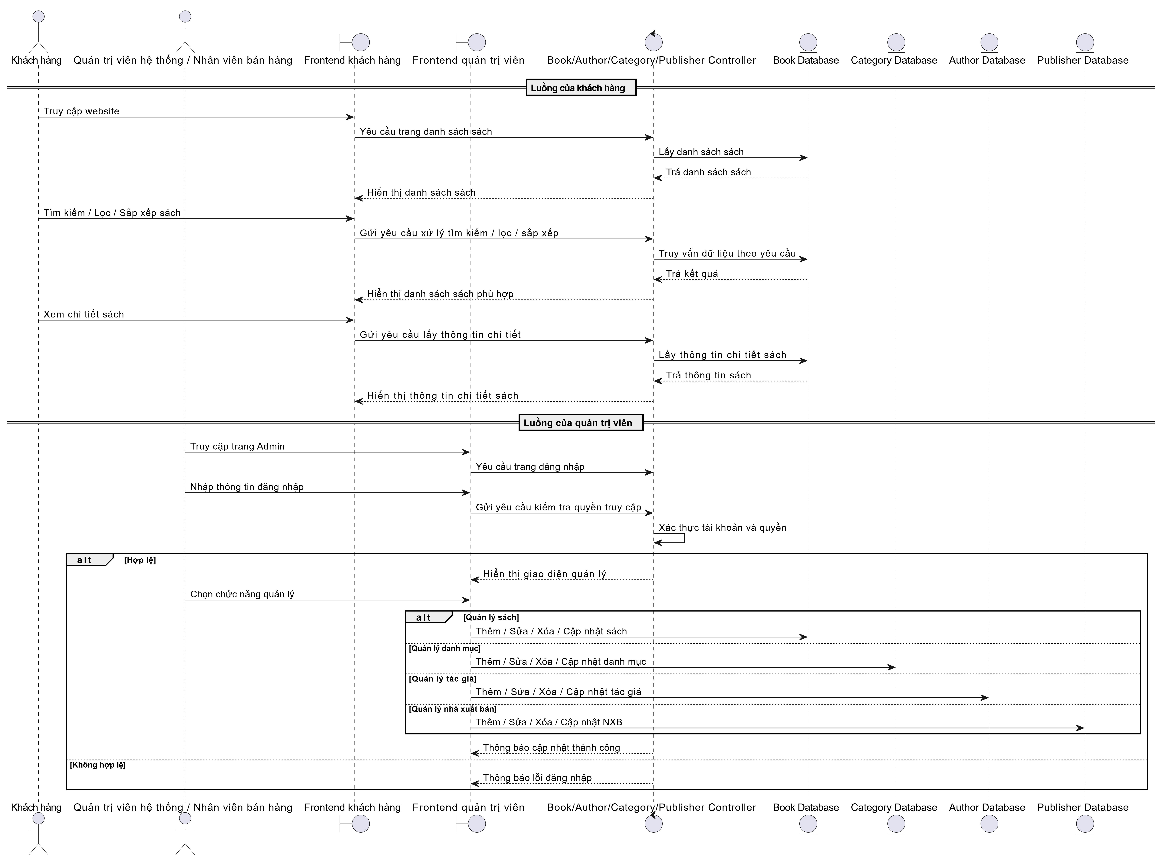

Figure 2.40. Product management sequence diagram.

**Cart management**

When a customer logs in successfully and navigates to the Cart interface, the system displays the list of books added to the cart. On this interface, the customer can update the quantity of each book or remove books from the cart.

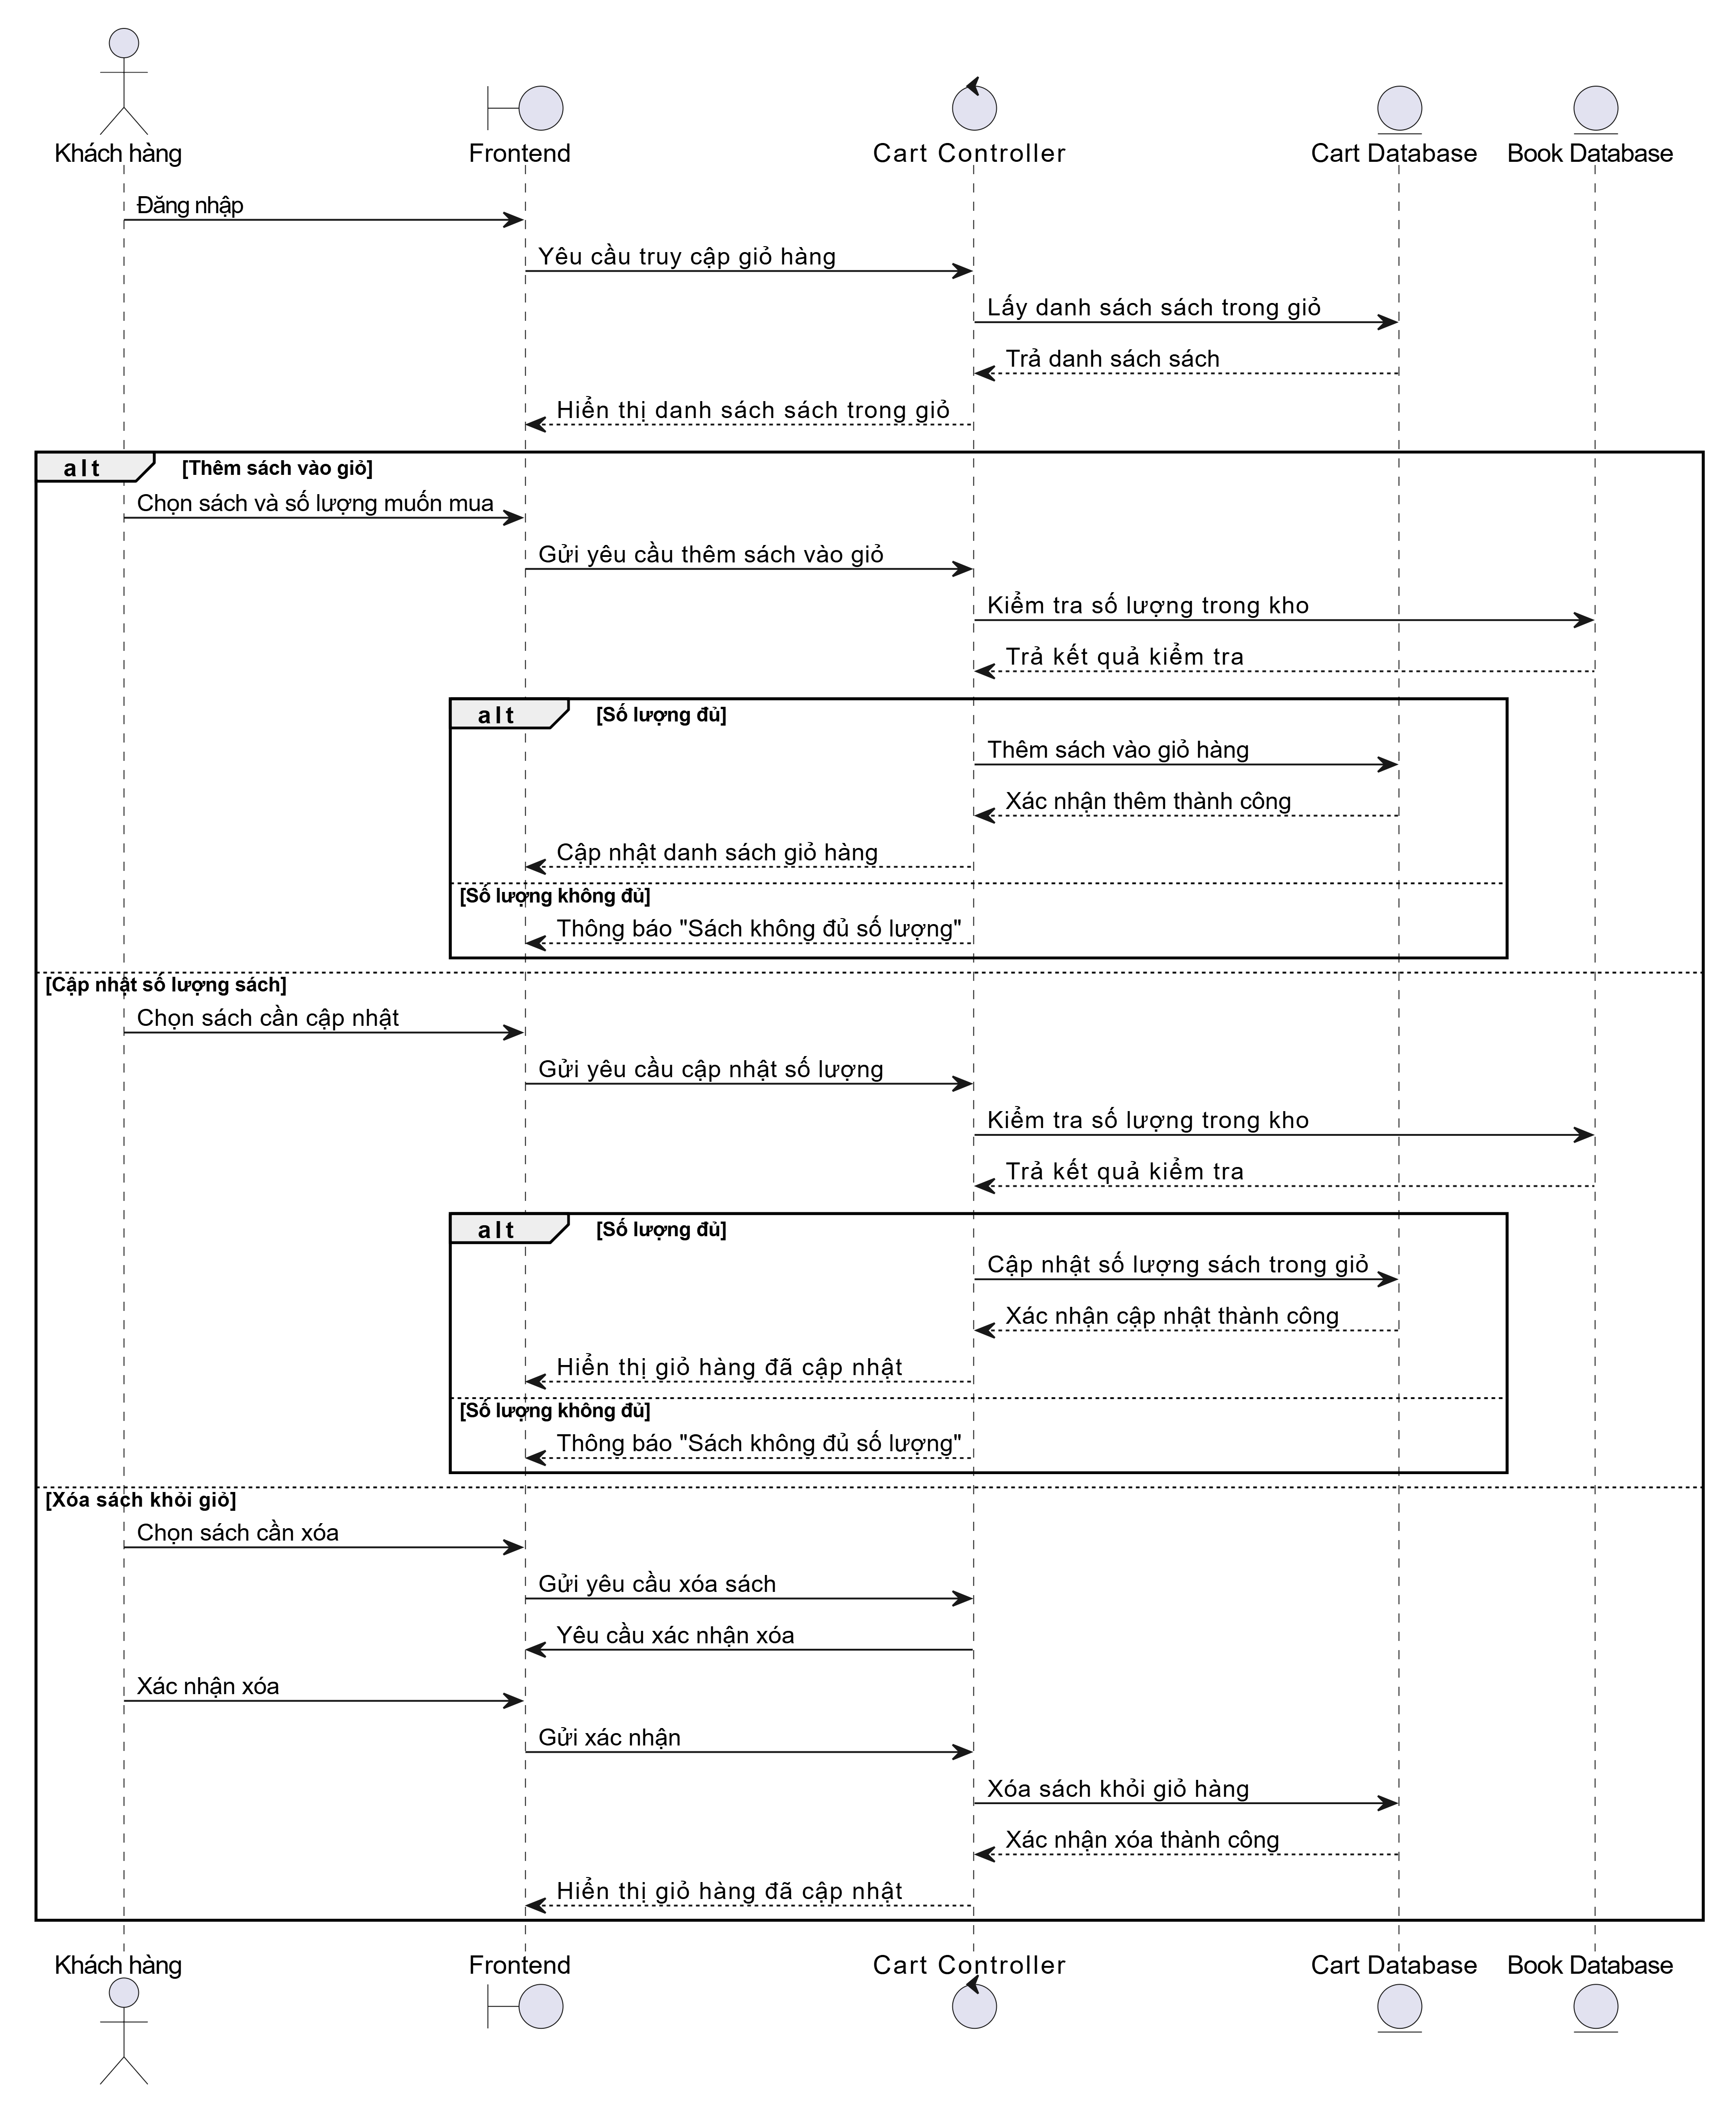

Figure 2.41. Cart management sequence diagram.

**Payment management**

Customer flow: When customers choose the Momo payment method, the system calls the Momo gateway to generate a QR code. Customers scan the QR code and Momo returns the transaction result. If the payment is successful, the system checks the book quantities; if sufficient, it updates the order status and reduces the purchased quantity; if insufficient, it displays an error message.

Administrator flow: After logging in, administrators access the Transaction Management feature to view the list of transactions.

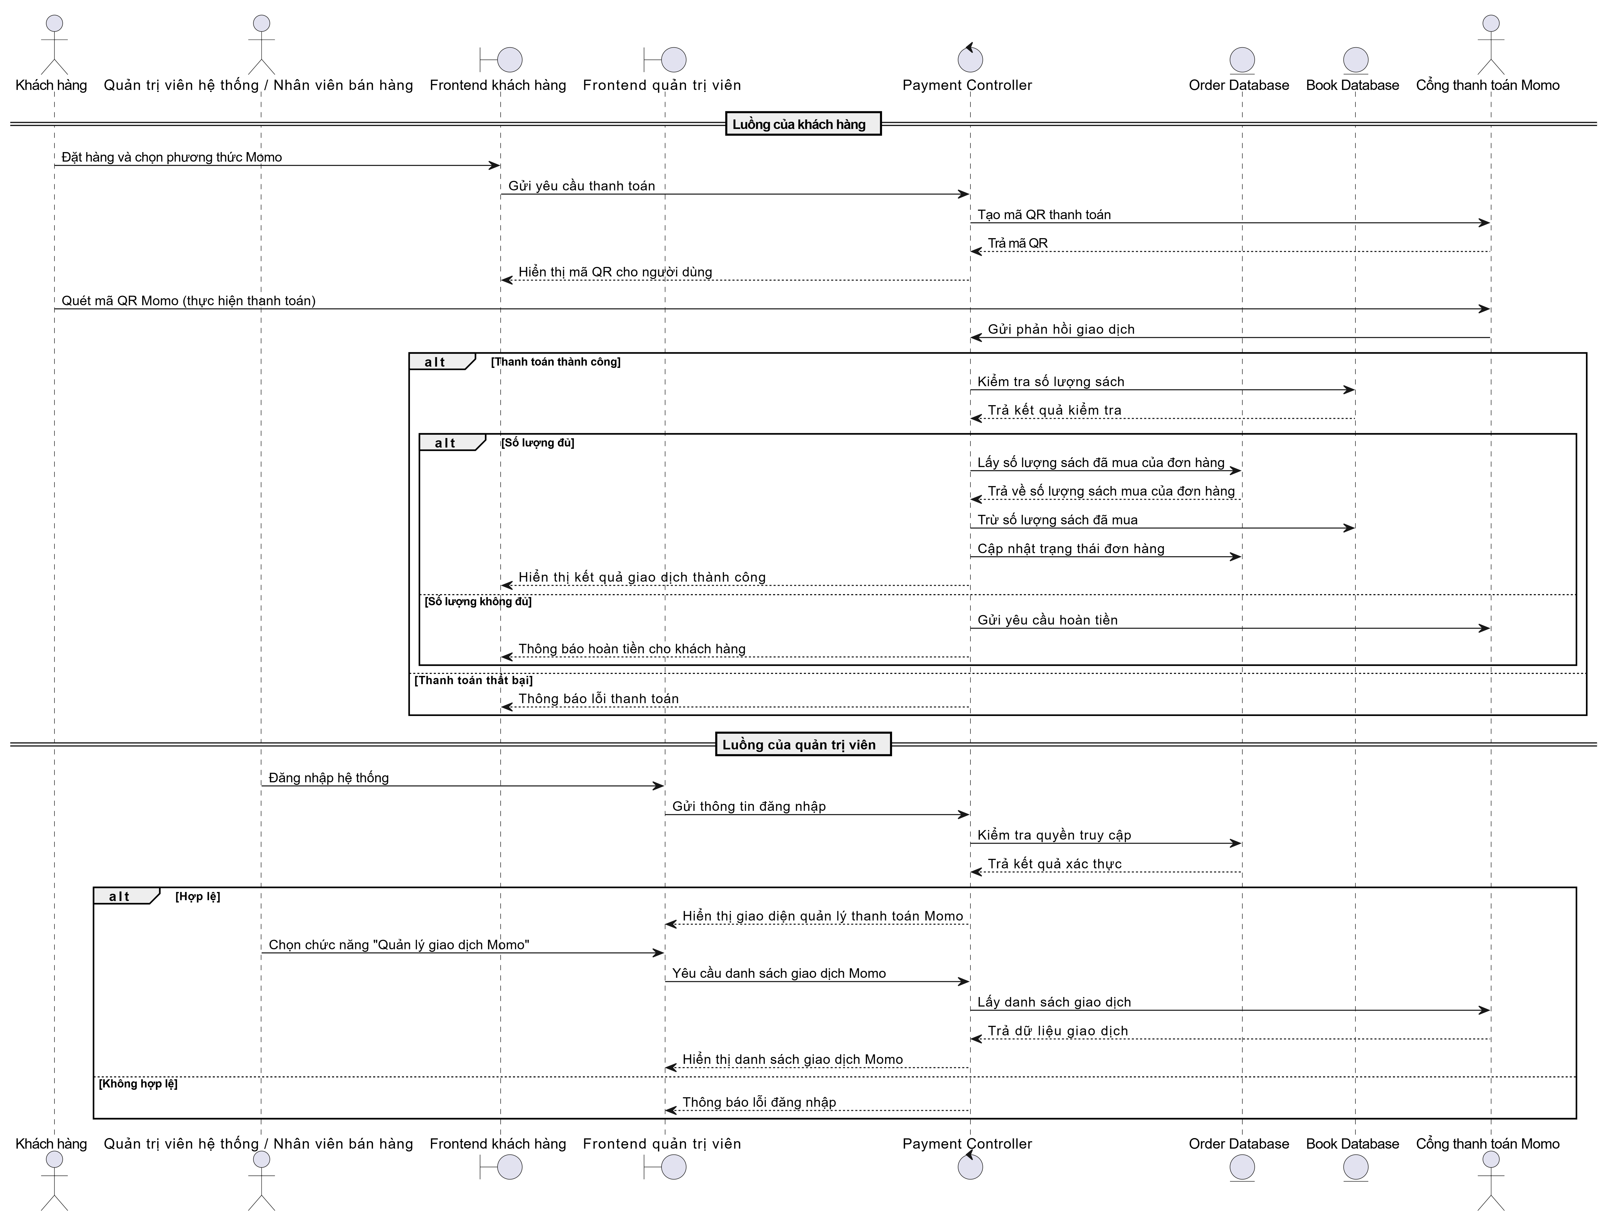Figure 2.42. Payment management sequence diagram.

**Order management**

Customer flow: Customers enter shipping information, choose a payment method, and confirm the order. The system checks the book quantities; if sufficient, the order is created and the customer proceeds with payment; if insufficient, the system displays an error message. Afterwards, customers can view order history.

Administrator flow: After logging in, administrators and sales staff access the Order Management feature to view the list, view details, and update order statuses.

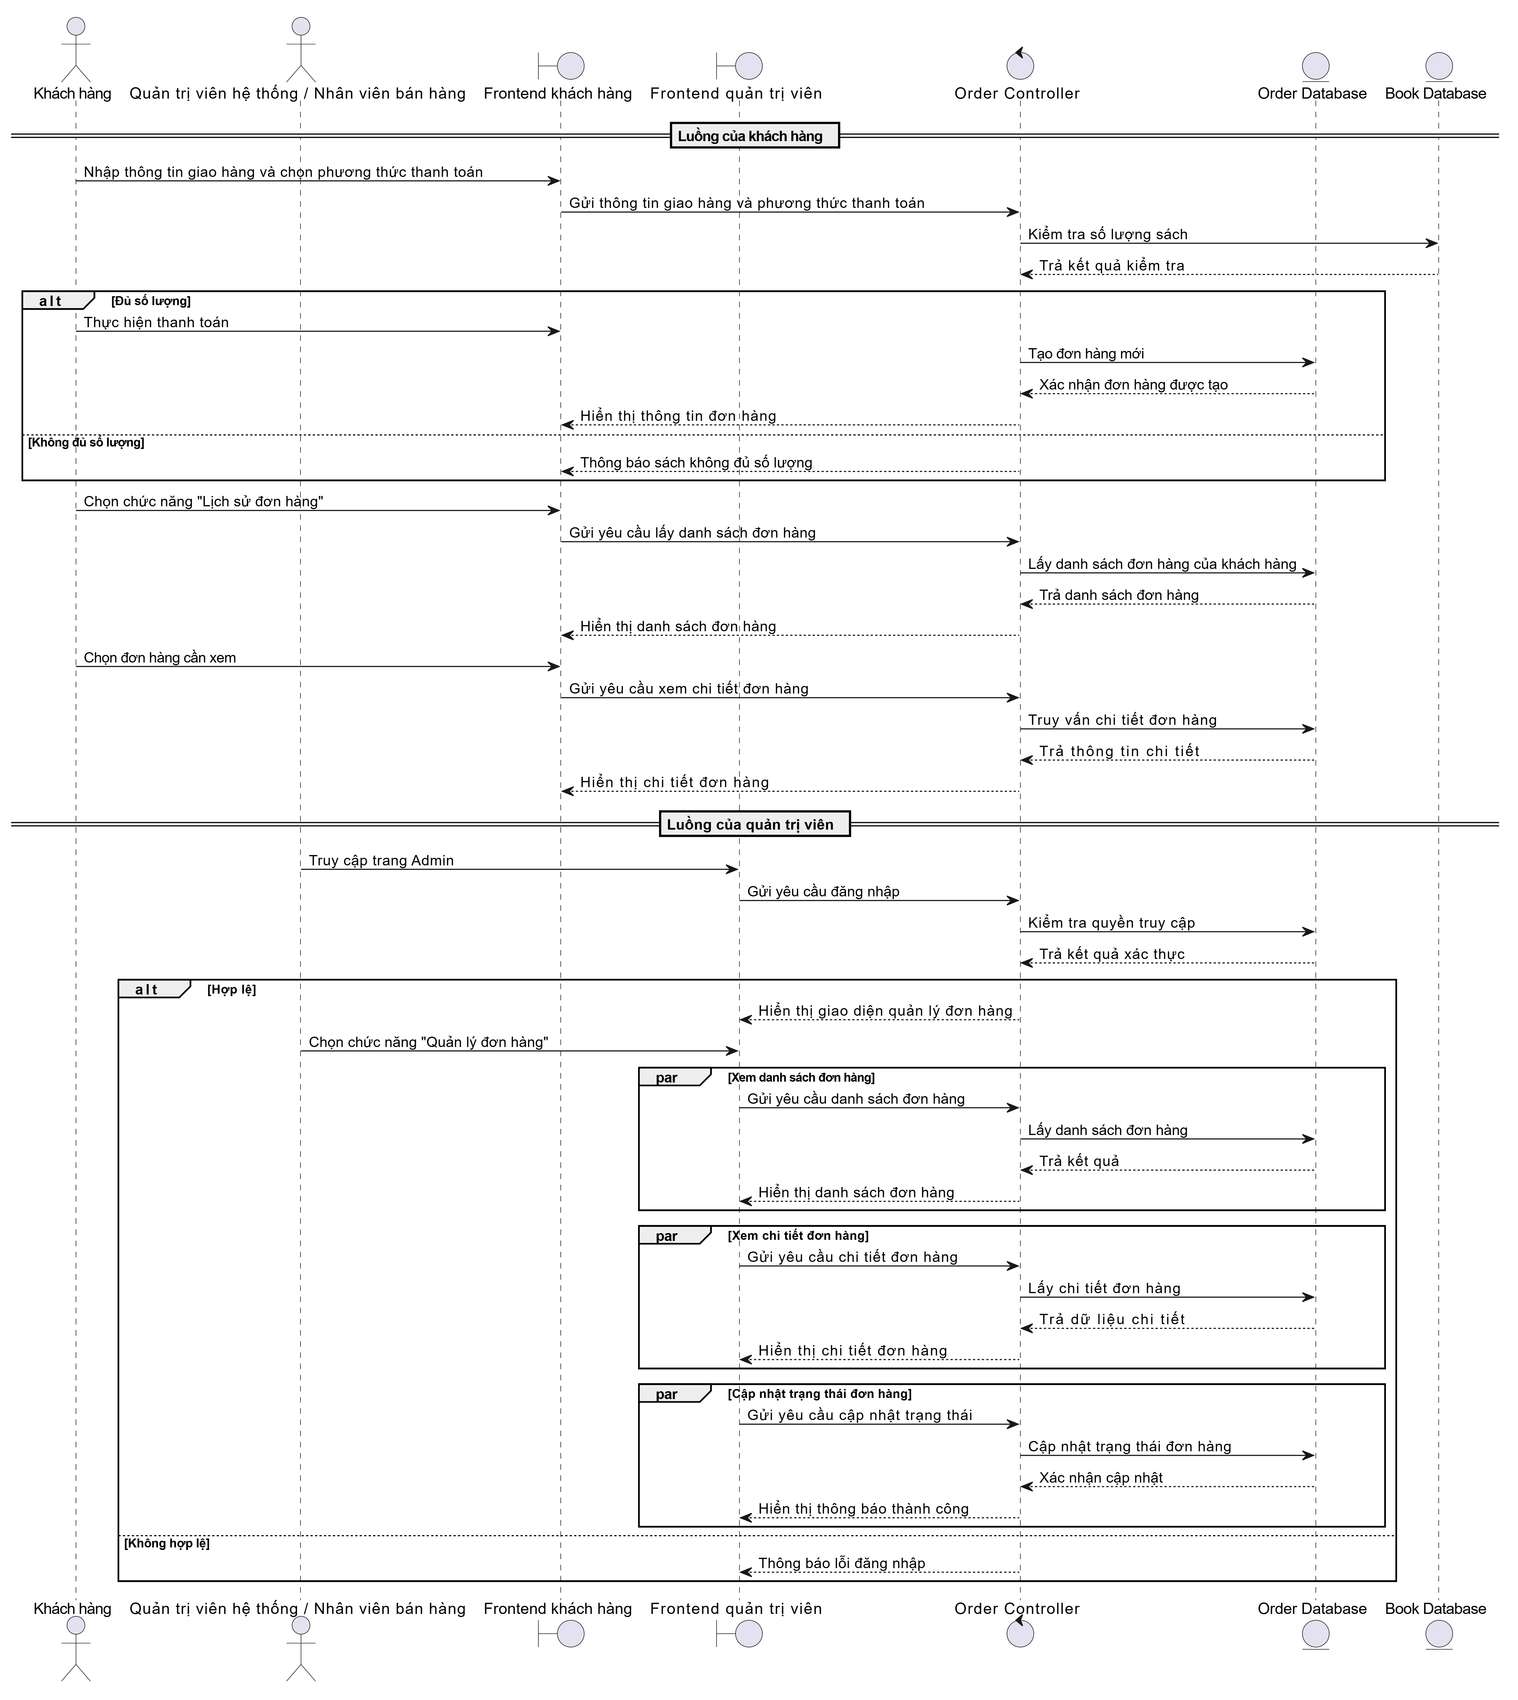

Figure 2.43. Order management sequence diagram.

**Address book management**

When customers log in successfully and navigate to the Address Book interface, they can add, update, or delete addresses.

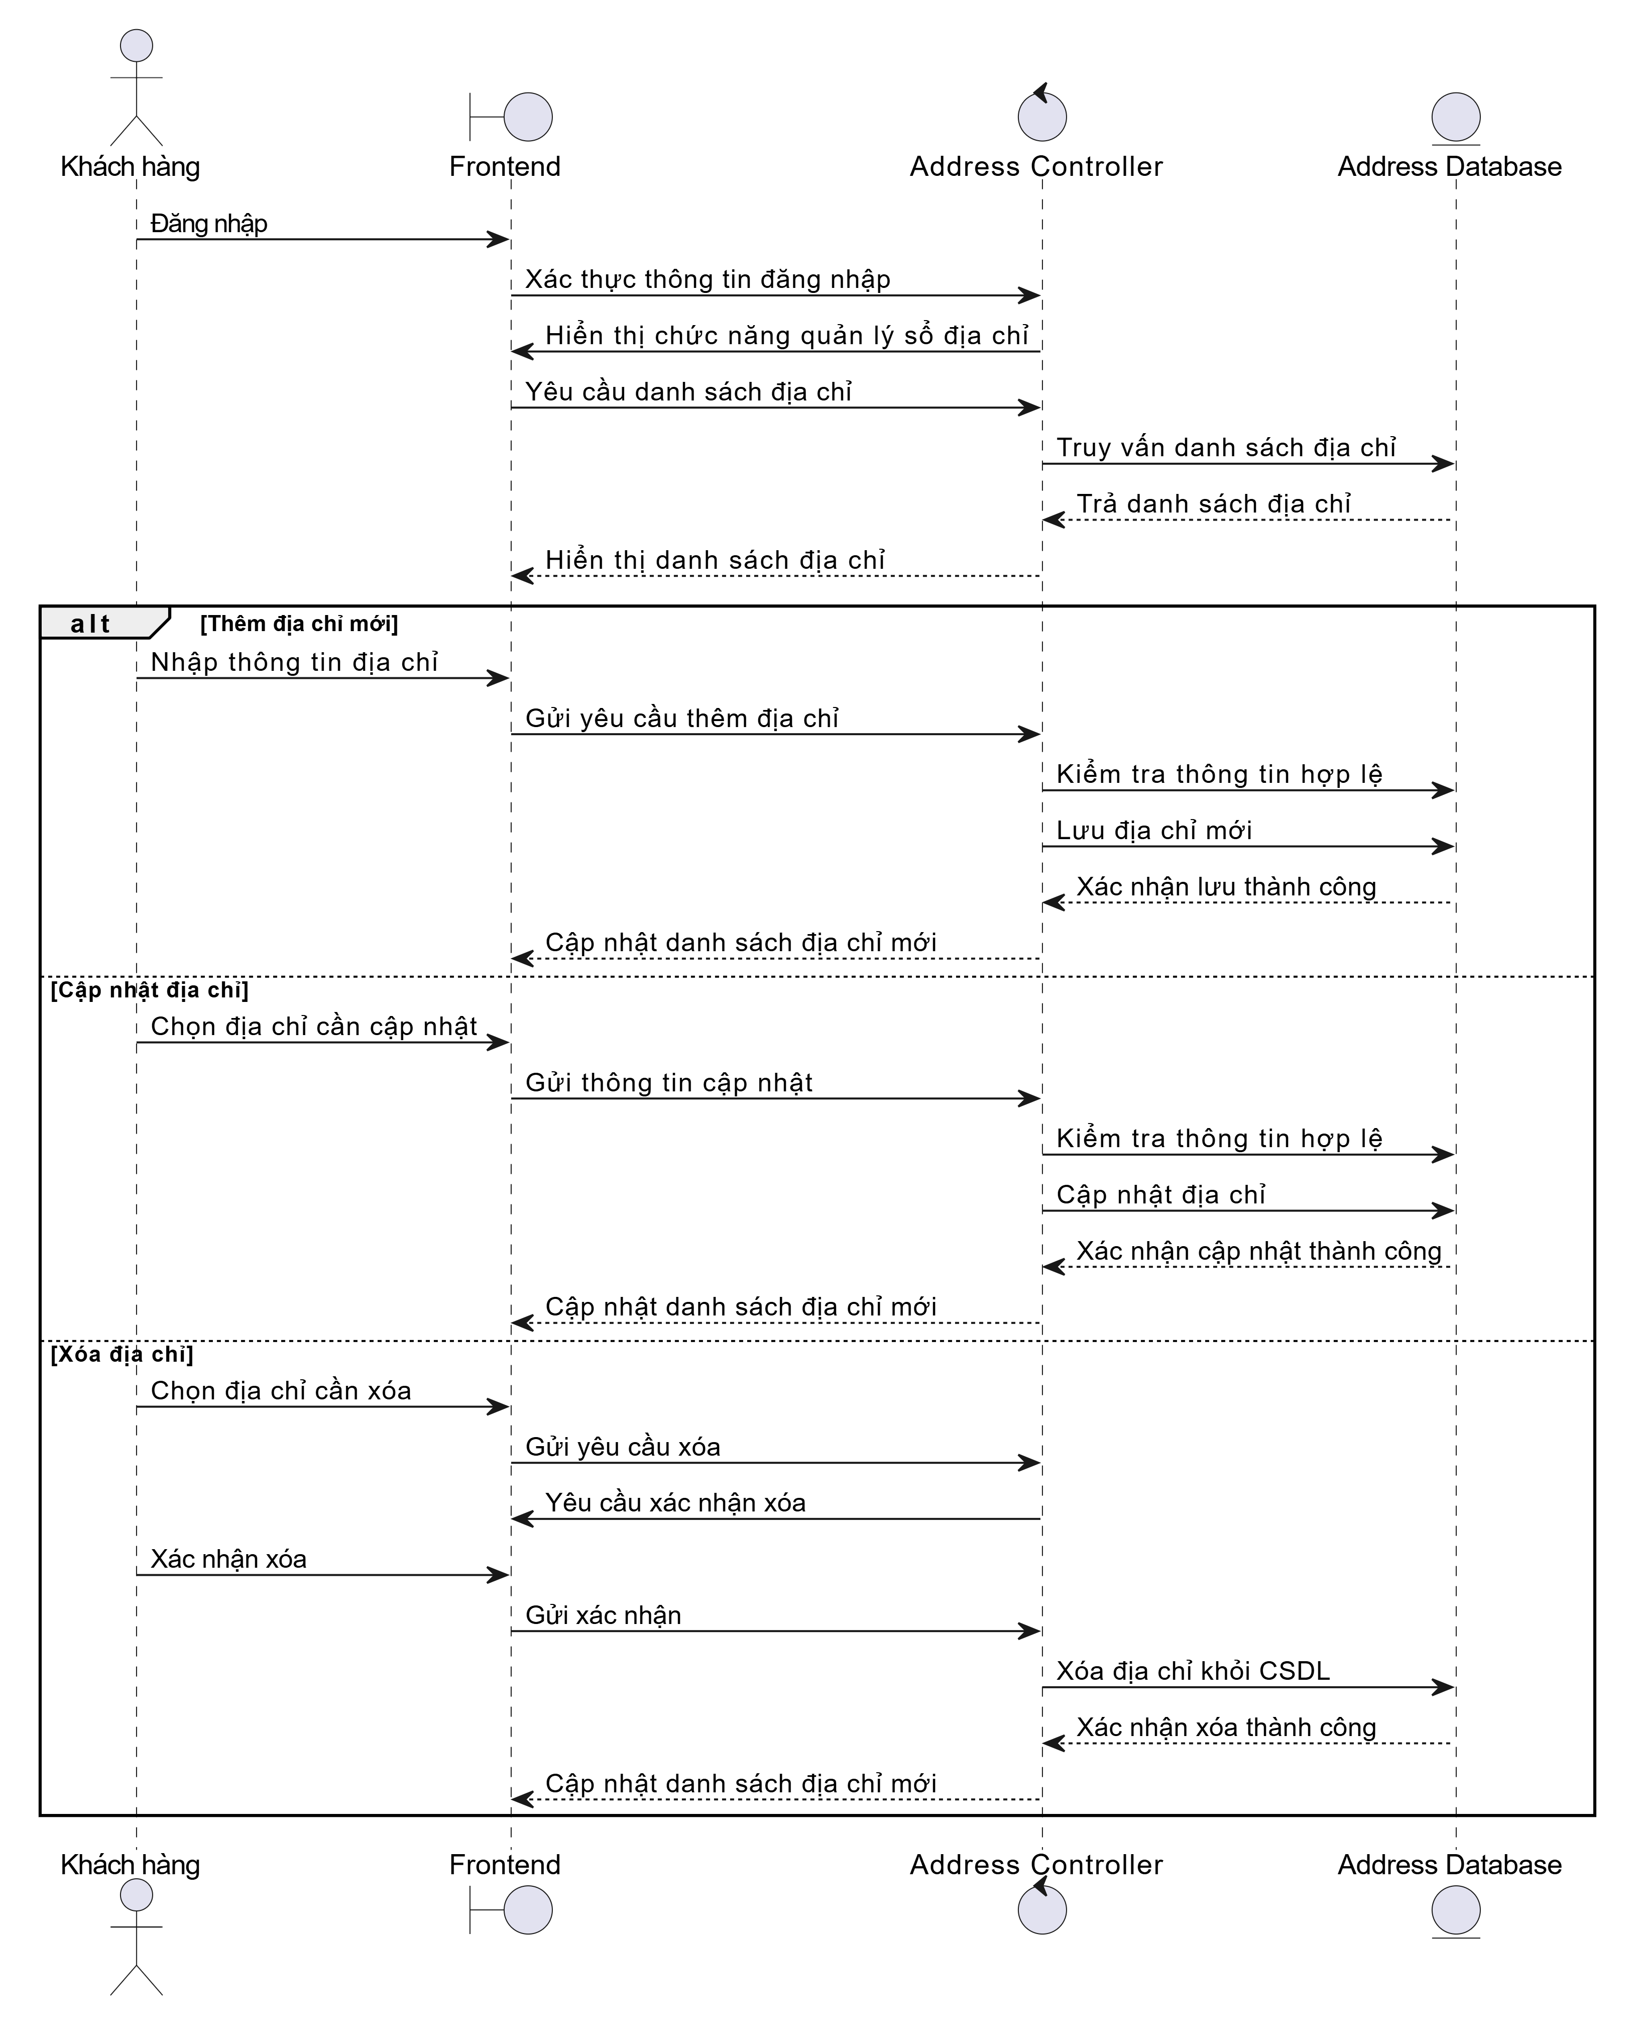

Figure 2.44. Address book management sequence diagram.

**Access control**

Customer flow: After entering email and password, if the information is valid, the system grants access to login-required features; if invalid, the system displays an error message.

Administrator flow: After entering email and password, if the account belongs to a system administrator, the user is granted full access to all features; if the account belongs to a sales staff, the system only allows access to authorized features, excluding user management.

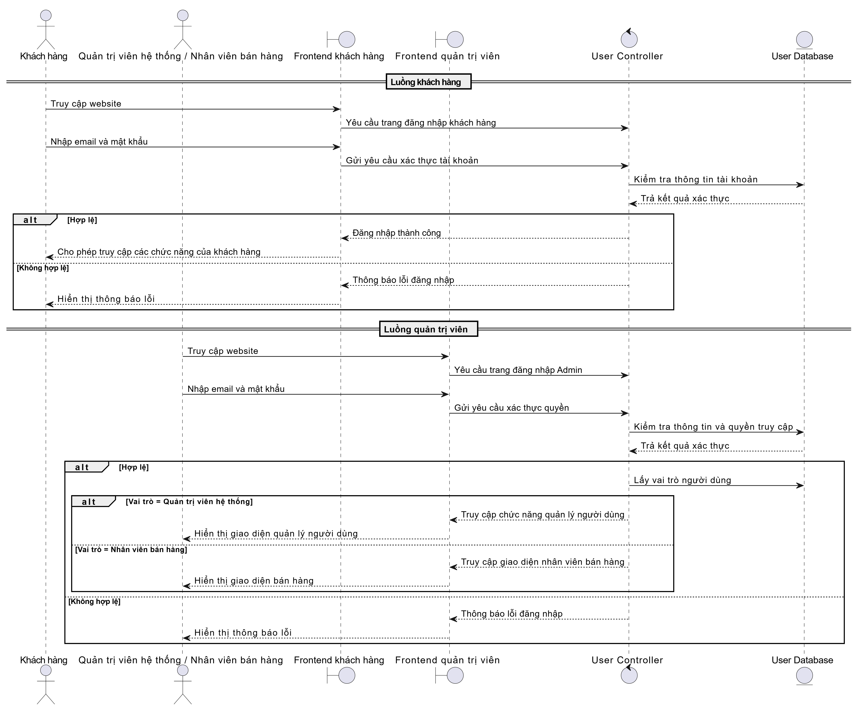

Figure 2.45. Access control sequence diagram.

### **2.2.3. Communication view**

User browsers communicate with the ReactJS Frontend via HTTP (port 5173) using HTML/JSON and authenticate using JWT.

The Frontend (ReactJS SPA) uses Axios and useSWR to call APIs via HTTP (port 8080) to the Spring Boot Backend.

The Backend (Spring Boot) consists of Controller, Service, Repository, and Entity classes that interact with the MySQL database via TCP (port 3306) using MySQL driver/JPA + Hibernate. The backend also connects to the Momo Payment Gateway via HTTPS (port 443) to process transactions.

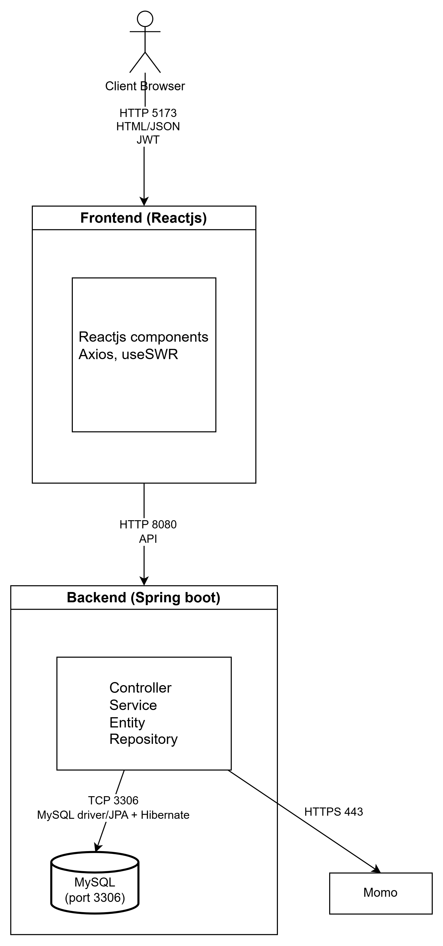

Figure 2.46. Communication view.

### **2.2.4. Deployment view**

User devices use the Chrome browser to display the web interface and send requests to the Web Server via the Internet.

On the Web Server, the Spring Boot backend and MySQL database are hosted. Spring Boot contains Controller, Service, Repository, and Entity classes and uses MySQL Driver/JPA + Hibernate to access the MySQL database via TCP/IP.

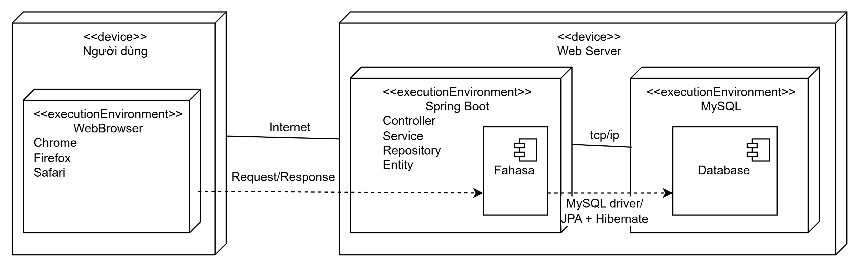Figure 2.47. Deployment view.

# **CHAPTER 3. TEST PLAN**

## **3.1. INTRODUCTION**

### **3.1.1. Purpose**

The test plan for the Fahasa project is established to define the methods, scope, and resources required for testing, ensuring the software fully meets business and technical requirements. The document also helps in early defect detection, improves product quality, guides a consistent test implementation, and provides control over the entire testing process.

### **3.1.2. Scope**

This test plan describes the testing activities for the Fahasa website throughout its development and deployment lifecycle. The scope includes functional testing, unit tests, integration tests, system tests, and acceptance tests, based on the requirements in the SRS document, executed in Development and Production environments according to the schedule.

## **3.2. Test item**

### **3.2.1. Function**

**Access Control**

* Verify that the system allows login for customers and administrators.
* Verify that the system allows account registration for customers.
* Verify that the system allows logout for all logged-in users.
* Verify that the system correctly enforces access permissions, allowing users to access only functions appropriate to their roles.
* Verify that the system allows administrators to manage users with CRUD operations.

**Product Management**

* Verify that the system provides CRUD operations for product management for administrators.
* Verify that the system supports management of related entities such as categories, authors, and publishers.
* Verify that the system allows customers to access and view product lists.
* Verify that the system supports searching, filtering, and sorting products to help customers find desired items easily.
* Verify that the system ensures data consistency and accuracy between the frontend and backend.

**Cart Management**

* Verify that the system provides CRUD operations for cart management for customers.
* Verify that the system automatically updates and displays cart information correctly, including product list, quantity, and total price.
* Verify that the system ensures data consistency in the cart throughout user operations and page navigation.
* Verify that the system enforces business constraints, limiting the purchase quantity of a product based on available stock.
* Verify that the system allows customers to proceed with checkout from the cart.

**Order Management**

* Verify that the system provides full order management for customers, including placing orders, viewing order lists, and viewing order details.
* Verify that the system provides full order management for administrators, including viewing lists, searching, filtering, and updating order statuses.
* Verify that the system supports order processing according to business rules, from order creation to completion or cancellation.
* Verify that the system ensures accuracy and consistency of order data, including order status, product information, and total amount.

**Payment Management**

* Verify that the system provides all payment methods for customers, including Cash on Delivery and Momo payments.
* Verify that the system supports the Momo payment workflow.
* Verify that the system processes Momo payment results accurately, including successful payments, canceled transactions, and expired transactions.
* Verify that the system handles payment errors correctly.
* Verify that the system ensures consistency and accuracy of payment and order data.
* Verify that the system allows administrators to view the list of Momo transactions.

**Address Book Management**

* Verify that the system provides CRUD operations for address book management for customers.
* Verify that the system validates input and displays error messages when required information is missing or incorrect.
* Verify that the system allows customers to select a saved address during order placement and auto-fill shipping information accordingly.

### **3.2.2. Usability**

Verify that the system provides a clear navigation bar, allowing users to access main pages such as Home, Product List, Cart, and Orders.

Verify that users can easily return to the previous page or home page during usage.

Verify that main function buttons are clearly displayed and easy to operate.

### **3.2.3. Compatibility**

Verify that the website interface displays correctly and consistently on popular browsers such as Chrome, Firefox, Safari.

Verify that the system automatically adjusts the interface to fit different screen sizes (Desktop, Tablet, Mobile).

Verify that interface components do not break or misalign when resizing the screen.

Verify that users can fully use all functions on different devices.

### **3.2.4. Interface**

Verify that colors, fonts, and display styles match the design.

Verify that logos, images, and icons are displayed correctly and are not distorted.

Verify that error messages, warnings, and status information are displayed correctly according to the business context.

### **3.2.5. Security**

Verify that the system encrypts user passwords.

Verify that the system enforces role-based access control and does not allow unauthorized access.

Verify that HTTP/HTTPS requests are secured and data is not exposed via the URL.

Verify that the system prevents common attacks such as SQL Injection, CSRF.

Verify that login sessions automatically expire after the specified time or when the user logs out.

### **3.2.6. Database**

Verify that CRUD operations in the system are correctly reflected in the database.

Verify that data is stored with the correct format and data types.

Verify that relationships between tables (FK, PK, constraints) are maintained accurately.

Verify that queries for search, filtering, and reporting return correct and fast results.

### **3.2.7. Performance**

Verify that the system responds quickly under normal load.

Verify that the system remains stable under concurrent user access (load testing).

Verify that the system can handle maximum load without crashing (stress testing).

### **3.2.8. Crowd**

Verify that the system is tested on multiple device types and browsers by different tester groups.

Verify that real users can fully operate all functions without critical errors.

Verify that the system operates consistently and stably across diverse testing environments.

### **3.2.9. Regression**

Verify that existing system functions continue to work correctly after changes.

Verify that API endpoints, UI interfaces, databases, and business processes remain compatible and correct.

Verify that main business flows continue to operate stably.

### **3.2.10. API**

Verify that API endpoints function correctly according to the design.

Verify that API responses are accurate, complete, and follow the required format.

Verify that API access and security are enforced, preventing unauthorized use.

Verify that APIs interact correctly with the database, UI, and other related endpoints.

Verify that main business flows through APIs remain stable after system changes.

## **3.3. Item not tested**

### **3.3.1. Third-party system function**

Internal functions of the Momo payment gateway are not within the testing scope.  
The team only tests the integration flows between the Fahasa system and Momo via API, including sending payment requests and receiving responses.  
Ensuring the stability, performance, and internal security of the Momo system is not part of the project testing scope.

### **3.3.2. Advanced security testing**

Penetration Testing and other advanced security tests are not performed.  
System, infrastructure, and network-level vulnerabilities are out of scope.  
The team only performs basic security testing, focusing on access control and user authorization.

### **3.3.3. Advanced usability testing**

Advanced usability testing (e.g., with real users, UX surveys) is not performed.  
Evaluation of user perception, satisfaction, or behavior is out of scope.  
The team only performs basic usability testing to verify that the system can be operated and used.

## **3.4. Acceptance testing criteria**

### **3.4.1. Test coverage**

At least 95% of the system’s functional requirements must have corresponding test cases designed and executed.

All critical use cases must be tested.

### **3.4.2. Test case pass rate**

100% of Critical and Major test cases must achieve a Pass status.

Overall test case pass rate must be ≥ 98%.

### **3.4.3. Number of test cases**

All test cases at the following levels must be executed:

* Unit Testing
* Integration Testing
* System Testing

### **3.4.4. Defect limit**

No Critical defects are allowed at the acceptance stage.

The number of Major defects must not exceed 2, and agreed-upon solutions must be in place.

Minor defects do not affect the main functionality of the system.

### **3.4.5. Unit test density**

Unit test density must reach at least 80 Unit Test Cases per 1000 lines of code (80 UTC/KLOC).

### **3.4.6. Code coverage**

Code coverage metrics must achieve:

* Statement Coverage ≥ 90%
* Branch Coverage = 100%
* Path Coverage = 100%

### **3.4.7. CI/CD process**

The GitHub Actions CI/CD pipeline must complete successfully.

No test failures are allowed in the automated pipeline.

## **3.5. Testing strategy**

### **3.5.1. Testing approach**

The project adopts the V-Model in software testing, where testing activities are conducted in parallel with development stages. Each development phase corresponds to a specific testing level, ensuring software quality throughout the development lifecycle.

Specifically, the project implements the following testing levels: Unit Testing, Integration Testing, System Testing, and Acceptance Testing. Test cases are designed based on the system’s functional requirements and use cases.

In addition, the project applies automated testing through the CI/CD pipeline using GitHub Actions, aiming to automate the Build, Test, and Deploy steps.

### **3.5.2. Type of testing**

|  |  |  |  |
| --- | --- | --- | --- |
| **Type** | **Purpose** | **Technique** | **Acceptance Criteria** |
| Functional Testing | Ensure that the system’s business functions operate correctly according to requirements | Manual test case design; Automated functional testing: unit tests with JUnit & Mockito, integration tests with Spring Boot Test, MockMvc and H2, system tests with Selenium | All functional test cases pass and no critical/blocker defects |
| Interface Testing | Ensure the user interface displays correctly in layout, content, and responds accurately to user interactions | Basic Selenium checks on selected pages; Manual testing on browsers and devices | Interface displays correctly across all screen sizes, devices, and browsers |
| Compatibility Testing | Verify the website works stably across multiple browsers and devices | Manual testing on different browsers and devices | System operates and displays correctly on all defined platforms |
| Security Testing | Detect obvious vulnerabilities such as unauthorized access, incorrect permissions, input security issues | Permission and authentication testing, input validation during integration tests | No common security vulnerabilities; unauthorized access prevented |
| Performance Testing | Ensure the system responds quickly, handles concurrent users stably, and withstands high load | Load testing, stress testing using K6 | Response time ≤ predefined limit; system handles maximum load without crashing; no critical errors under high load |
| Crowd Testing | Identify errors, compatibility issues, and real user experience problems through multiple testers | Manual testing on various devices and browsers, collect real user feedback | Real users can perform all functions without critical errors; system remains stable and consistent across diverse environments |
| Usability Testing | Evaluate user experience, ease of use, navigation, and operation | Manual testing by a separate tester group | Users can operate the system easily, accurately, and comfortably |
| Regression Testing | Ensure that previously stable functions are not affected after updates, bug fixes, or new features | Automated testing integrated with CI/CD and Selenium | Regression test case pass rate ≥ 98%; GitHub Actions pipeline completes successfully |
| API Testing | Evaluate correctness and stability of APIs, including return data, status codes, and request/response validity | Using Postman | Correct status codes; returned data is valid and accurate |

### **3.5.3. Testing level**

|  |  |  |  |
| --- | --- | --- | --- |
| **Level** | **Purpose** | **Technique** | **Method** |
| Unit Testing | Verify correctness of functions/methods | White-box | Automated testing using JUnit and Mockito in the Development environment |
| Integration Testing | Verify interactions between functional modules | White-box | Automated testing using Spring Boot Test, MockMvc, and H2 in the Development environment |
| System Testing | Verify business workflows and user interface | Black-box | Automated testing using Selenium (UI, E2E) and K6 (performance) in the Development environment |
| Acceptance Testing | Verify and accept the product | Black-box | Manual testing in the Production environment |

|  |  |  |  |  |
| --- | --- | --- | --- | --- |
| **Type** | **Testing level** | | | |
| **Unit testing** | **Integration testing** | **System testing** | **Acceptance testing** |
| Functionality | x | x | x | x |
| Interface |  |  | x | x |
| Database | x | x |  |  |
| Compatibility |  |  | x | x |
| Security | x | x | x |  |
| Performance |  |  | x |  |
| Usability |  |  | x | x |
| Crowd |  |  | x | x |
| Regression | x | x | x |  |
| API | x | x |  |  |

## **3.6. Resource**

### **3.6.1. Human resource**

|  |  |  |
| --- | --- | --- |
| **Person** | **Role** | **Specific Tasks** |
| Lâm Diệu Quang | Tester / Developer | Test planning, system testing, CI/CD implementation in GitHub Actions, test documentation |
| Nguyễn Hoàng Hiếu | Tester / Developer | Test case design, unit and integration testing, review checklist preparation, test documentation |
| Dr. Đỗ Như Tài | Product Owner | Acceptance testing |

### **3.6.2. Test schedule**

|  |  |  |  |
| --- | --- | --- | --- |
| **Task** | **Responsible Person** | **Start Date** | **End Date** |
| Test Planning | Lâm Diệu Quang | 01/10/2025 | 12/10/2025 |
| Test Case Design | Nguyễn Hoàng Hiếu | 13/10/2025 | 22/10/2025 |
| Review Checklist Preparation | Nguyễn Hoàng Hiếu | 23/10/2025 | 31/10/2025 |
| Unit and Integration Testing | Nguyễn Hoàng Hiếu | 01/11/2025 | 15/11/2025 |
| System Testing | Lâm Diệu Quang | 16/11/2025 | 20/11/2025 |
| CI/CD Pipeline Implementation in GitHub Actions | Lâm Diệu Quang | 21/11/2025 | 25/11/2025 |
| Test Documentation | Nguyễn Hoàng Hiếu, Lâm Diệu Quang | 26/11/2025 | 16/12/2025 |
| Acceptance Testing | Dr. Đỗ Như Tài | 21/11/2025 | 26/11/2025 |

## **3.7. Environment**

### **3.7.1. Hardware**

|  |  |  |
| --- | --- | --- |
| **Purpose** | **Component** | **Use** |
| Development | Personal computer | Programming, unit testing, and integration testing |
| Devices | Desktop, Android, iOS | Interface testing and compatibility testing |

### **3.7.2. Software**

|  |  |  |
| --- | --- | --- |
| **Purpose** | **Component** | **Use** |
| Development | VSCode, IntelliJ, JDK 17+, ReactJS, Local MySQL | Programming, unit testing, and integration testing |
| Browser | Chrome, Firefox, Safari | Interface testing and compatibility testing |

### **3.7.3. Infrastructure**

|  |  |  |
| --- | --- | --- |
| **Purpose** | **Component** | **Use** |
| Production | Frontend and Backend deployed on Render; MySQL hosted on Aiven | Actual software deployment, system testing, and acceptance testing |
| CI/CD | GitHub Actions | Automate the Build, Test, and Deploy process |

## **3.8. Handover documentation**

Word documents: Includes Architecture Design, Database Design, Test Plan, Software Requirements Specification, Bug Report, and overall software and testing report.

Excel documents: Includes all UI documentation, Use Case specifications, Review Checklist, Test Report, Test Cases, and Test Design.

Source code: Stored on GitHub, including unit tests, integration tests, system tests, and the CI/CD pipeline configuration (.github/workflows/ci-cd.yml).

# **CHAPTER 4. TEST DESIGN**

## **4.1. Introduction**

This chapter presents the process and results of designing detailed test cases based on the V-Model strategy, utilizing the documentation from Chapter 1, Chapter 2, and Chapter 3.

## **4.2. Test design process according to the V-Model**

The team’s test design process is entirely based on the V-Model, which emphasizes the symmetry and interrelation between development activities and testing activities.

In the V-shaped structure, each analysis and design phase on the left branch has a corresponding testing activity on the right branch, ensuring that every requirement can be verified through specific test cases.

### **4.2.1. Requirement Analysis - 1a**

At the initial stage, the team collects, analyzes, and clarifies the business requirements of the online book-selling system. The goal of this step is to ensure that all requirements are fully described, within scope, and testable. The team prepares the Software Requirement Specification (SRS) document as the foundation for all subsequent testing activities.

From the analysis process, the team identifies two main user types (Customer and Administrator) and decomposes the system into six functional modules: Product Management, Shopping Cart, Orders, Payment, Access Control, and Address Book.

The results of requirement analysis directly support the creation of acceptance test cases. The requirements are translated into acceptance criteria, ensuring that every expected user function can be verified through testing.

### **4.2.2. System design - 2a**

Once the requirements are clearly defined, the team performs system-level design. The design content includes descriptions of main functions, business workflows, use case diagrams, and relationships between actors interacting with the system.

Information from this phase is used to construct system testing scenarios. The functions described in use case diagrams become the testing targets, ensuring that the system operates correctly according to overall business workflows.

### **4.2.3. Thiết kế kiến trúc - 3a**

During the architecture design phase, the team applies the C4 Model (Context – Container – Component – Code) to decompose the system from the contextual level down to the component level. The purpose is to clearly define communication between layers, responsibility separation, and data flow among components in the overall architecture.

The results of architecture design provide the basis for integration testing. Communication points between modules – such as between APIs and the database, or between backend and frontend – are listed and analyzed to design test cases that evaluate the accuracy of data exchange between components.

### **4.2.4. Module design - 4a**

In the module design step, the team analyzes and designs each system module. Class diagrams are used to describe data structures, attributes, methods, and relationships between classes.

Documentation from this step is used to construct unit test cases. Key classes and methods of each module are identified for automated testing, helping detect errors at the lowest level before modules are integrated into the system.

### **4.2.5. Unit testing - 1b**

Based on module design, the team develops and executes unit test cases to evaluate the correctness of individual methods, functions, or classes.

The goal of unit testing is to ensure that each smallest component works correctly according to the design specifications, thereby minimizing the risk of defects propagating to the integration and deployment stages.

Unit test cases are implemented with JUnit combined with Mockito to mock dependent objects, isolating the test logic from external components such as databases or other services. Using Mockito allows the team to test each function accurately, especially in scenarios that require simulating complex data or behavior.

All unit tests are integrated into the CI/CD pipeline via GitHub Actions, allowing tests to run automatically whenever the source code is updated. This helps the team detect errors early and maintain software quality throughout the development process.

|  |  |  |  |
| --- | --- | --- | --- |
| **Name** | **Objective** | **Input Conditions** | **Expected Result** |
| testGetAddressesByUserId_Success | Verify retrieval of addresses by user ID | UserId = "user123", AddressRepository returns 1 address | Returns a list containing 1 address; repository verify called correctly |
| testCreateAddress_Success | Create a valid address | Valid DTO, existing User, phone number in correct format | Returns Address with ID = "addr1"; verify repository save is called |

### **4.2.6. Integration testing - 2b**

After each module has stabilized through unit testing, the team conducts integration testing to evaluate the interactions between components within the system. Integration testing focuses on verifying data transmission across APIs, communication layers between Controller – Service – Repository, and the compatibility between the backend and the database.

The team uses Spring Boot Test combined with MockMvc to perform API integration testing in a simulated environment that closely resembles production. MockMvc allows sending requests, receiving responses, and validating the entire processing flow without running the application on an actual server.

Additionally, the database used during testing is replaced with an H2 in-memory database to ensure isolated, repeatable tests that do not affect real data.

Integration test cases are designed based on the identified communication points during the Architecture Design phase, ensuring that the testing process aligns with the system structure and covers all critical interaction flows.

|  |  |  |  |
| --- | --- | --- | --- |
| **Name** | **Objective** | **Input Conditions** | **Expected Result** |
| findByEmail_shouldReturnUser | Verify querying User by email | User saved in H2: admin1@example.com | Returns an Optional<User> that exists, fullname = "Admin One" |
| findByRoleInAndStatus_shouldReturnMatchingUsers | Verify query with role and status conditions, with pagination | User admin1: role=1, status=1; admin2: role=1, status=0 | Returns only 1 User (admin1), email = "admin1@example.com" |

### **4.2.7. System testing - 3b**

At a higher level, the team conducts system testing to evaluate the overall operation of the software as a complete system. System testing is performed manually based on the Test Cases developed during the test design phase, covering all scenarios according to use cases and the main business workflows of users.

System testing activities include:

* Functional testing: Verifying end-to-end business workflows such as login, purchasing, payment, etc.
* Interface testing: Ensuring the interface is intuitive, consistent, and meets display standards.
* Basic security testing: Verifying login flow, permissions, and access control.

The results of system testing reflect the overall quality of the software before moving to the acceptance phase.

### **4.2.8. Acceptance testing - 4b**

Acceptance testing is the final stage of the testing process, aimed at evaluating the system from the perspective of actual end-users. At this stage, the team compares the acceptance criteria with the SRS document to ensure that the system fully meets customer requirements.

After completing internal system testing, the software is handed over to the Product Owner for acceptance testing. The Product Owner acts as the end-user, simulating real-world scenarios and providing feedback on usability, stability, business suitability, and overall requirement fulfillment.

The results of acceptance testing serve as a critical basis for making the final decision on deploying the system to the production environment.

## **4.3. Test design techniques**

### **4.3.1. Black-box testing**

Black-box testing is used to verify the functionality of the system based on business requirements, without considering the internal structure of the software.

In this project, this method is applied for system testing and acceptance testing, aiming to ensure that the software works as expected from the end-user’s perspective and meets the acceptance criteria.

Using black-box testing allows the team to simulate real-world scenarios and check the entire business workflow from start to finish, making it suitable for both manual execution and automation at the user interface level.

Example: For the Access Control test cases, the team used techniques such as Equivalence Partitioning, State Transition Testing, Decision Table Testing, and Use Case Testing.

**Equivalence partitioning:**

In the Access Control test cases, input data is divided into valid and invalid classes based on the account status and the validity of user information. Specifically:

* Login functionality:
  + Valid class: Correct Email and Password, account active
  + Invalid class: Incorrect password or account locked
* Registration / Adding new user:
  + Valid class: New Email, all required fields completed
  + Invalid class: Email already exists or required fields (e.g., email) left blank

This technique is applied in test cases such as:

* TC_AC_001, TC_AC_002: Valid login
* TC_AC_003, TC_AC_004: Invalid login
* TC_AC_005, TC_AC_006, TC_AC_013, TC_AC_014: Valid and invalid user registration / addition

State Transition Testing:  
In the Access Control module, important states include:

* User account status: Normal and Locked
* Session status: Logged in and Logged out

Test cases are designed to verify:

* State transitions from Logged In → Logged Out
* Account status changes from Normal → Locked → Unlocked
* System behavior after state changes

Example test cases:

* TC_AC_007: Successful logout
* TC_AC_017: Lock user account
* TC_AC_018: Attempt login with a locked account
* TC_AC_019: Unlock user account

Decision Table

Step 1: Identify Conditions.

|  |  |  |
| --- | --- | --- |
| Symbol | Condition | Values |
| C1 | Valid login information | Y / N |
| C2 | Account locked | Y / N |
| C3 | User role | Customer / System Administrator / Sales Staff |
| C4 | Page being accessed | Regular user page / Administrator page (any /admin/* page) |

Step 2: Identify Actions.

|  |  |
| --- | --- |
| Symbol | Action |
| A1 | Allow login |
| A2 | Allow page access |
| A3 | Display error message |

Step 3: Calculate the Number of Rules.

2 x 2 x 3 x 2 = 24 rules

Each rule represents a possible combination of condition sets.

Step 4: Full Decision Table.

(N: No, Y: Yes, DC: Don’t Care, KH: Customer, QTV: Administrator)

|  |  |  |  |  |  |  |  |  |
| --- | --- | --- | --- | --- | --- | --- | --- | --- |
| Rule | R1 | R2 | R3 | R4 | R5 | R6 | R7 | R8 |
| C1: Valid Login | N | N | N | N | Y | Y | Y | Y |
| C2: Account Locked | DC | DC | DC | DC | Y | Y | N | N |
| C3: Role | DC | DC | DC | DC | KH | QTV | KH | QTV |
| C4: Page | Public | QTV | Public | QTV | Public | QTV | QTV | QTV |
| A1: Login Successful | N | N | N | N | N | N | Y | Y |
| A2: Access Allowed | N | N | N | N | N | N | N | Y |
| A3: Error Occurred | Y | Y | Y | Y | Y | Y | Y | N |

DC (Don’t Care): The condition does not affect the result.

* If the login information is invalid → always denied (R1–R4)
* If the account is locked → login fails (R5–R6)
* If a Customer accesses the Admin page → denied (R7)
* If an Administrator accesses the Admin page → allowed (R8)

Step 5: Reduce the Decision Table.

|  |  |  |  |  |
| --- | --- | --- | --- | --- |
| Rule | R1 | R2 | R3 | R4 |
| Valid Login | N | Y | Y | Y |
| Account Locked | DC | Y | N | N |
| Role | DC | DC | Customer | Administrator |
| Page | DC | DC | Administrator | Administrator |
| Result | Denied | Denied | Denied | Allowed |

Mapping Decision Table → Test Case

|  |  |
| --- | --- |
| Rule | Test case |
| R1 | TC_AC_003 |
| R2 | TC_AC_004, TC_AC_018 |
| R3 | TC_AC_008 |
| R4 | TC_AC_009 |

### **4.3.2. White-box testing**

White-box testing is used to examine the internal logic of the code, data flow, decision branches, and loops, helping to detect errors at the module or individual method level.

In this project, this method is applied for **unit testing** and **integration testing**, aiming to ensure that each component functions correctly according to the design and that modules interact properly.

Using white-box testing allows the team to detect errors early, reduce integration risks, and facilitate automated testing.

Example: For the Address Management module, testing the deleteAddress function.

**Source Code (with node numbering):**

public void deleteAddress(String id) {

// [Node 1] Check condition

if (!addressRepository.existsById(id)) {

// [Node 2] True branch: Throw error

throw new EntityNotFoundException("Address not found");

}

// [Node 3] False branch: Perform deletion addressRepository.deleteById(id);

// [Node 4] End }

**Control Flow Graph (CFG)**

Based on the code above, the edges are as follows:1 -> 2 (Nếu không tồn tại)

* 1 → 2 (if the address does not exist)
* 1 → 3 (if the address exists)
* 2 → End (ends due to Exception)
* 3 → 4 (successful completion)

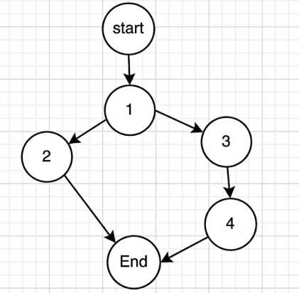

Figure 4.1. Control flow graph.

**Cyclomatic Complexity**

* Number of edges (E): 4
* Number of nodes (N): 4
* Number of connected components (P): 1

M = E - N + 2P = 4 - 4 + 2(1) = 2

Therefore, there are 2 independent paths (corresponding to a minimum of 2 test cases).

**Basis Paths**

1. Path 1 (Error): 1 → 2 → End (Address does not exist)
2. Path 2 (Success): 1 → 3 → 4 (Address exists)

**Test Case**

|  |  |  |  |  |
| --- | --- | --- | --- | --- |
| **Test Case ID** | **Input** | **Mock condition** | **Expected output** | **Path** |
| TC_DEL_01 | "missing" | existsById = false | EntityNotFoundException | Path 1 |
| TC_DEL_02 | "addr1" | existsById = true | Calls deleteById, void | Path 2 |

**Present the source code**

Testing the updateAddress

public Address updateAddress(String id, AddressDTO dto) {

// [Node 1] Validate the phone number

if (!ValidationUtils.validatePhone(dto.getPhone())) {

// [Node 2] Invalid phone -> Error

throw new IllegalArgumentException(...);

}

// [Node 3] Find Address by ID

Optional<Address> opt = addressRepository.findById(id);

// [Node 4] Check whether the Address exists

if (opt.isEmpty()) {

// [Node 5] Not found -> Error

throw new EntityNotFoundException(...);

}

// [Node 6] (Trong map) Update the basic fields

Address existing = opt.get();

existing.setFullname(...); ...

// [Node 7] Check whether the userId has been updated

if (dto.getUserId() != null) {

// [Node 8] Find new User

Optional<User> userOpt = userRepository.findById(dto.getUserId());

// [Node 9] Check whether the new User exists

if (userOpt.isEmpty()) {

// [Node 10] User not found -> Error

throw new EntityNotFoundException(...);

}

// [Node 11] Set new User

existing.setUser(userOpt.get());

}

// [Node 12] Save Address and end

return addressRepository.save(existing);}

**Đồ thị dòng điều khiểm (CFG)**

Start -> 1

1 -> 2 (Invalid phone) -> End

1 -> 3 (Valid phone) -> 4

4 -> 5 (Address null) -> End

4 -> 6 (Address OK) -> 7

7 -> 12 (UserId is null – Keep old User)

7 -> 8 (UserId != null) -> 9

9 -> 10 (new User not found) -> End

9 -> 11 (new User ok) -> 12

12 -> End

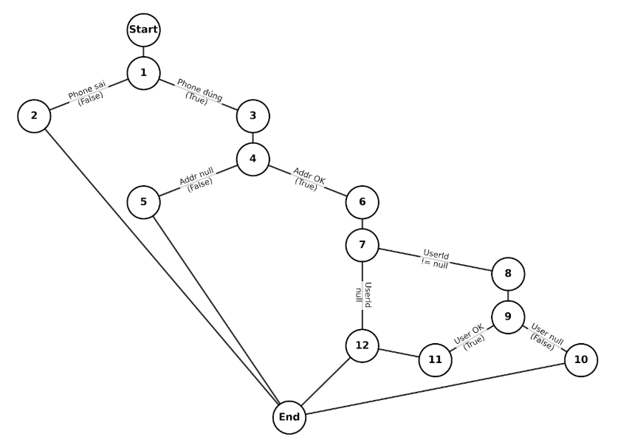Figure 4.2. Control flow graph.

**Cyclomatic Complexity**

M = (Number of decision nodes) + 1 = 4 + 1 = 5

Therefore, 5 test cases are needed to cover all the logic.

**Basic path set**

Based on the control flow graph, we can list 5 independent paths:

1. Path 1 (Phone wrong): 1 -> 2 -> End
2. Path 2 (Addr wrong): 1 -> 3 -> 4 -> 5 -> End
3. Path 3 (No User Update): 1 -> 3 -> 4 -> 6 -> 7 -> 12 -> End
4. Path 4 (User Update Fail): 1 -> 3 -> 4 -> 6 -> 7 -> 8 -> 9 ->10 -> End
5. Path 5 (Full Success): 1 -> 3 -> 4 -> 6 -> 7 -> 8 -> 9 -> 11 -> 12 -> End

**Thiết kế Test Case**

|  |  |  |  |  |
| --- | --- | --- | --- | --- |
| **ID** | **Input Data** | **Path** | **Scenario description** | **Test code status** |
| TC_UP_01 | phone="invalid" | Path 1 | Phone validation fails, throws Exception | Missing (Needs to be added) |
| TC_UP_02 | id="missing" | Path 2 | Address ID does not exist in the database | Implemented (testUpdateAddress_NotFound) |
| TC_UP_03 | userId=null | Path 3 | Normal update, User is not updated | Missing (Need to add test case for null userId) |
| TC_UP_04 | userId="fake" | Path 4 | Attempts to update User, but User ID does not exist | Missing (Needs to be added) |
| TC_UP_05 | userId="user1" | Path 5 | Successfully updates all information + new User | Implemented (testUpdateAddress_Success) |

## **4.4. Test design method**

### **4.4.1. Manual testing**

The project applies manual testing for the acceptance testing phase. This method is used to evaluate the system from the end-user’s perspective, verify the main business workflows, and confirm the system’s compliance with the specified requirements.

Manual test cases are executed based on the designed Test Cases and Review Checklists. The testing results are recorded and compared with the expected outcomes before proceeding with the system acceptance.

### **4.4.2. Automation testing**

The project applies automated testing by integrating a CI/CD pipeline using GitHub Actions to automate the process of building, testing, and deploying the system. Automated testing is used for white-box tests, including unit testing, integration testing, and system testing.

Whenever there is a change in the source code pushed to the GitHub repository, the CI/CD pipeline automatically triggers a test job. This job performs the steps of building the project and running all the automated test suites that have been implemented.

* If the test job fails, the pipeline automatically creates an Issue on GitHub to record the encountered errors, supporting the development team in tracking and resolving them promptly.
* If the test job succeeds, the pipeline automatically closes any Issues related to previous test failures, ensuring that the system’s status is always accurately updated.

When the source code is merged into the main branch, the CI/CD pipeline triggers a deploy job, which calls the Render platform to redeploy the system.

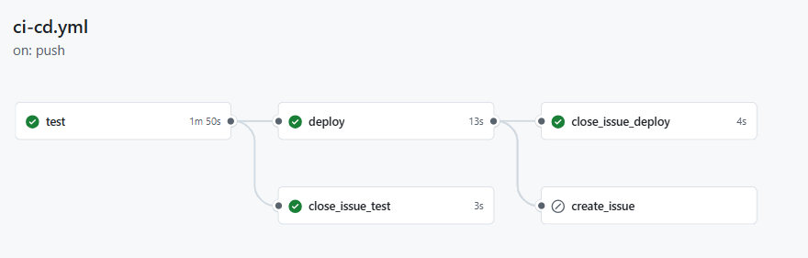Figure 4.3. Pipeline CI/CD of GitHub Actions.

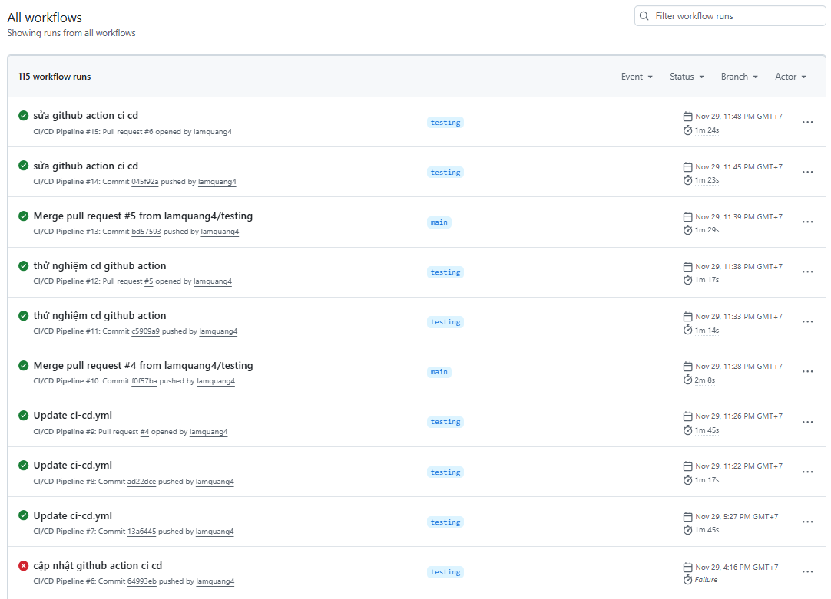

Figure 4.4. List of GitHub Actions Runs.

## **4.5. Application of GenAI in Test Case generation**

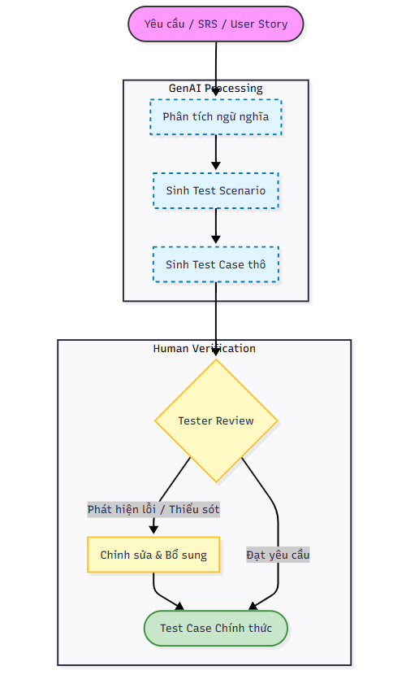

Figure 4.5. Test Case Generation Process with GenAI.

In this project, Generative AI (GenAI) was used as a support tool during the test case design phase. GenAI does not replace the tester’s role; instead, it assists in analyzing requirements and suggesting initial test scenarios, thereby improving efficiency and test coverage.

### **4.5.1. GenAI input**

The inputs to GenAI include documents such as the System Requirements, SRS, and User Stories. These documents provide information about the system’s functions, business logic, and constraints.

### **4.5.2. GenAI processing stage**

During the processing stage, GenAI performs the following steps:

* Requirement semantics analysis: Understand the functional and business objectives of the system.
* Generate test scenarios: Based on main and alternate flows of each function.
* Generate raw test cases: Including basic test cases, boundary cases, and error cases.

### **4.5.3. Test Case finalization**

After review and refinement, the test cases that meet requirements become official test cases and are used in the test execution process, either manually or automatically.

# **CHAPTER 5. TESTING REPORT**

## **5.1. Overview of the testing process**

After completing the test design phase in Chapter 4, the team conducted testing for the Fahasa system according to the planned schedule. The testing process was carried out over 6 weeks and included the following stages: unit testing, integration testing, system testing, and acceptance testing.

The team focused on thoroughly testing all the main business functions of the system. Test Cases were executed carefully and in detail, with all results fully documented in the handover reports.

## **5.2. Test case report**

### **5.2.1. Introduction**

The test cases are categorized into two groups: Positive (testing expected system behavior) and Negative (testing error handling, exceptions, and invalid conditions).

The test suite covers 6 main functional modules of the system: Access Control, Product, Shopping Cart, Order, Payment, and Address Book, with a total of 72 test cases.

|  |  |  |  |  |
| --- | --- | --- | --- | --- |
| **Module** | **Code** | **Number** | **Description** | **Result** |
| Access control | AC | 21 | Test login and registration processes, and add/edit/delete user operations | 21 Pass  1 Fail |
| Product | PM | 16 | Test product display, search, filter for customers; add/edit/delete for admins | 16 Pass  0 Fail |
| Cart | CART | 12 | Test add/edit/delete operations and quantity check when adding products | 12 Pass  0 Fail |
| Order | ORD | 9 | Test customer order placement and admin order status management | 8 Pass  1 Fail |
| Payment | PAY | 7 | Test payment methods (COD and MoMo) and transaction result scenarios | 7 Pass  0 Fail |
| Address book | ADD | 7 | Test add/edit/delete address operations for customers | 7 Pass  0 Fail |

### **5.2.2. Coverage scope**

The team created 72 Test Cases, covering 100% of the system’s main functional features. The coverage for non-functional requirements is 0%.

### **5.2.3. Execution results**

The pie chart displays the percentage of execution for all Test Cases.

A total of 72 Test Cases were executed, including 70 passed and 2 failed.

Breakdown by percentage:

* 97.2% Passed
* 2.8% Failed
* 0% Blocked
* 0% Not Run

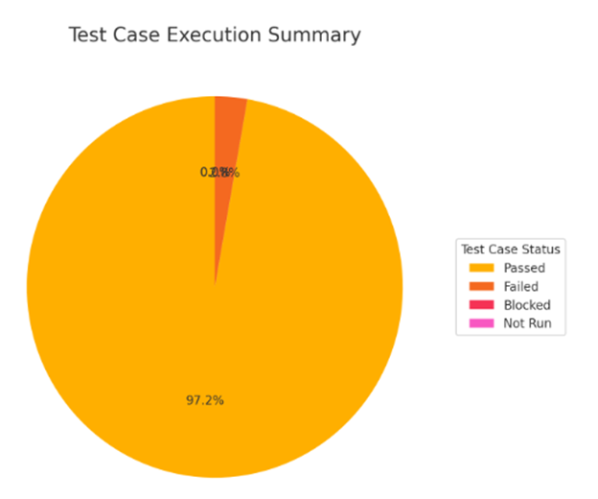

Figure 5.1. Pie chart of Test Case execution percentage.

## **5.3. Error report**

### **5.3.1. Error classification by severity**

During the Test Case testing, the team detected and recorded 2 errors, classified by severity as follows:

Severity 3 – Medium: 1 error related to the system. This error does not disrupt the main functionality but causes incorrect data or user experience issues. It occurred in the Access Control module with Test Case TC_AC_006 (error due to duplicate email).

Severity 4 – Low: 1 minor error related to the user interface, preventing proper interaction with the Order module in Test Case TC_ORD_005 (missing order status filter function in the admin interface).

During CI/CD testing in GitHub Actions, the team detected and recorded 11 errors, classified by severity as follows:

Severity 3 – Medium: 7 errors related to testing in the CI/CD job, occurring when one or more automated tests failed due to incorrect source code formatting according to Google Java Spotless standards.

Severity 2 – High: 4 errors related to compilation issues caused by incorrect class names in the source code.

### **5.3.2. Error statistic**

The bar chart displays the number of errors in Test Cases by severity.

A total of 2 errors were detected, including:

* 50% (1 error) at medium severity
* 50% (1 error) at low severity
* 0 errors at critical or high severity

The number of fixed errors includes:

* 1 medium severity error
* 1 low severity error

The number of remaining unresolved errors is 0 at all severity levels.

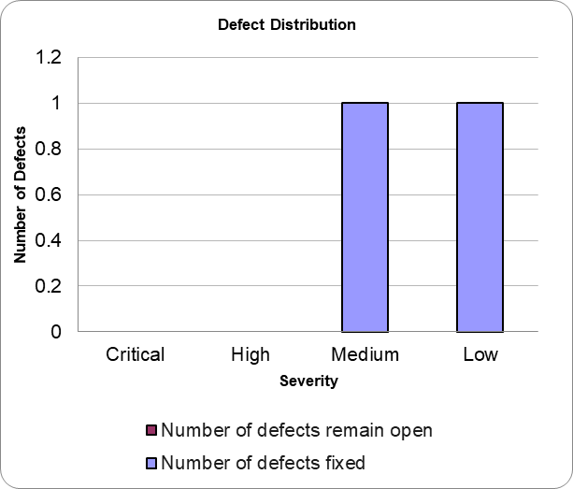

Figure 5.2. Bar chart of error count by test case severity.

In the GitHub Actions CI/CD pipeline, a total of 11 errors have been closed, meaning they have been fixed, including:

* 64% (7 errors) at medium severity
* 36% (4 errors) at high severity

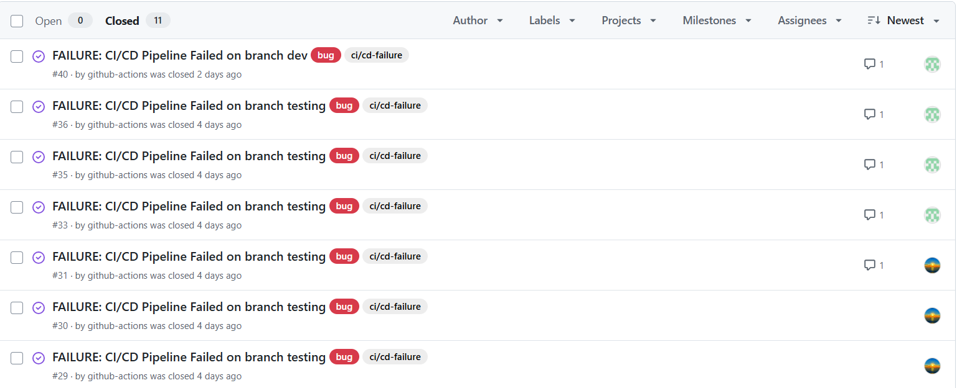Figure 5.3. Pipeline CI/CD GitHub Actions.

### **5.3.3. Error handling process**

The error handling process follows standard steps to ensure that all detected errors are properly recorded, classified, and addressed promptly in the project. The steps are as follows:

**Step 1: Error Recording**  
During testing, all detected errors are documented with details including: error description, related module, Test Case/Test Script, severity level, the person who discovered the error, and the time of detection.

**Step 2: Error Classification**  
The testing team classifies errors according to severity:

* Classification helps the development team prioritize error resolution based on importance.

**Step 3: Error Assignment**  
Errors are assigned to the developer or development team responsible for the related module. Each error is given a status (**Assigned**) and an assigned person responsible for fixing it.

**Step 4: Error Fixing**  
The development team resolves errors according to the identified cause:

* **Data errors**: Adjust processing logic or validate input data.
* **UI errors**: Adjust the interface or add missing functionality.
* **CI/CD errors**: Fix class names or correct code formatting according to Google Java standards using Spotless.

**Step 5: Retesting**  
After the error is fixed, the testing team retests to confirm the issue has been resolved. If the error persists, return to Step 3 for further fixing.

**Step 6: Closing Errors**  
An error is marked **Closed** when:

* The issue has been completely resolved and successfully retested.
* It no longer affects other system functions.

All closed errors are documented in the final summary report.

**Step 7: Error Reporting and Monitoring**  
The testing team compiles errors by severity, processing status, and related Test Case/Test Script.  
This report is used to evaluate software quality and improve the testing process in subsequent phases.

# **APPENDIX**